Task:
A time machine has enabled you to travel back in time and you are now a resident of Ancient Egypt. You have been employed by the central government to promote tourism as an industry. One of your first tasks is to design a tri-fold travel brochure. This brochure will be distributed along the trade route linking the Indus Valley with Cairo in Egypt. Your brochures will be distributed in large numbers in Cairo and will include pictures and images that will appeal to the eyes of traveling consumers.

Preparing Information:

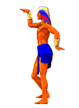
Review library and Internet resources about the civilization of Ancient Egypt. Extend your knowledge of the region and the culture by carrying out this research. Arrange your information according to topics based on the assignment.
Examples:
- Gather all information collected about living accommodations a visitor might expect to find in Egypt
- The kinds of terrain a traveler might expect to pass through while traveling
- Modes of transportation used in Ancient Egypt
- Gifts tourists can expect to buy in the ancient city;
- Entertaining things to see and do in Ancient Egypt

Tips for Designing a Brochure:
- Create a colorful and eye-catching cover for your brochure

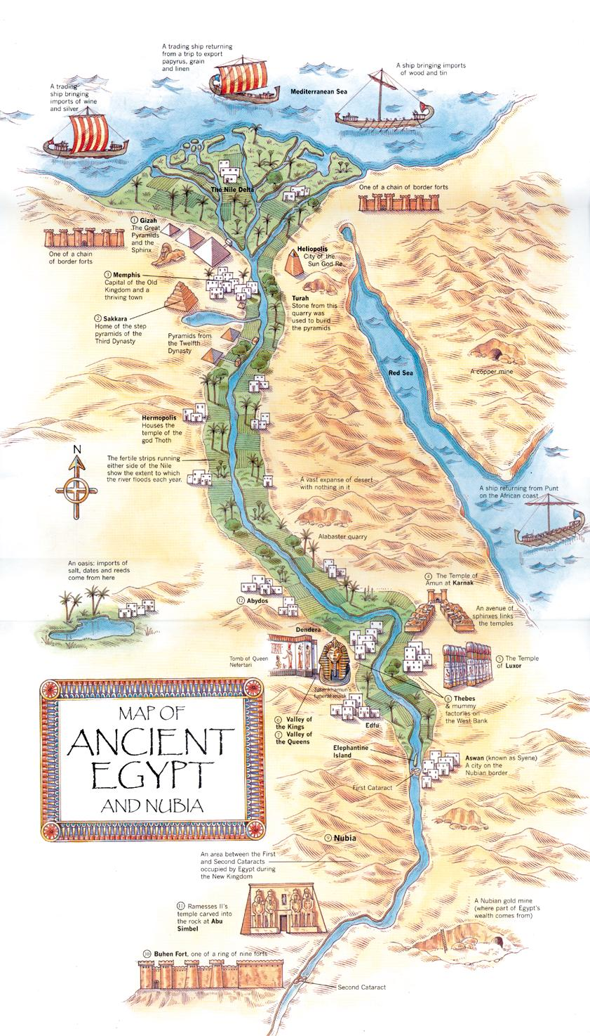
- Remember you want to attract visitors; you will want to present hardship and danger on the journey as excitement and adventure.
- Make your brochure as attractive, appealing, and informative as you can.
- Balance text with illustrations, graphics and color.
Brochure Requirements:
Each brochure is required to include the following:
- Detailed map of Ancient Egypt
- List of major cities in Ancient Egypt
- Information about language(s) spoken
- Facts about the government
- Information about the culture of Ancient Egypt
- Types of transportation a visitor would see
- How natural geography played an important role in the lives of people
- A hieroglyphic message to be decoded using a hieroglyphic decoder such as the Hieroglyphic Alphabet or Hieroglyphic Decoder
