Sample Questions on Aldehyde and Ketone Nomenclature from Old Exams
Answers appear at the end of the page.
Provide the IUPAC name corresponding to each of the structures given below.
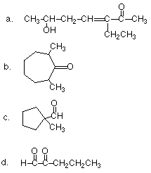
Provide the structure of the compound corresponding to each of the following names:
2-hydroxy-5-methylhexanal
4-hydroxy-2-methyl-3-hexanone
1-cyclopentenecarboxaldehyde
3-ethyl-6-hydroxy-3-hepten-2-one
3-oxo-4-cyclopentylhexanal
ANSWERS
IUPAC names:
3-ethyl-6-hydroxy-3-hepten-2-one
2,7-dimethylcycloheptanone
1-methylcyclopentanecarboxaldehyde
2-oxopentanal

Draw the structures: