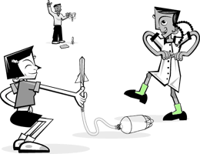
Problem: You will design, build, and launch an air rocket. After building it, you will compete with fellow students to see whose rocket can fly the furthest and measure the average speed. You must consider fins for stability, a nose cone to reduce air resistance, the size of bottle you use to control pressure and force, and the length of the body of your rocket.

Materials:
Different size Coke bottles (2-liter, 20 ounce, 16 ounce, etc.)
PVC pipe, Paper Towel roll, or anything similar to this shape
Duct Tape
Notebook Paper
Scissors
Duct Tape
Stop Watch
Measuring Stick or Tape

Procedure:
1. Place the PVC pipe on top of the 2-liter bottle over the opening..

2. Duct tape the pipe onto the neck of the bottle so that no air will leak out.

3. Wrap the paper around the pipe one time and cut off the excess paper. Tape the piece of paper around the pipe.

5. Use tape to completely seal off the top of the rolled piece of paper so that no air can leak out.

6. Test your air rocket by quickly squeezing the 2-liter bottle. If the paper rocket does not slide off the PVC pipe, check for leaks.

7. Now that you have the body of the rocket built, add a nose cone and fins to make your rocket fly the furthest.

Hypothesis:
1. Cardstock Versus Regular

2. Long body versus Short

3. Straight fins versus Tilted fins

Data Table
Distance Distance
Trial 1 _______ _______

Trial 2 _______ _______

Trial 3 _______ _______

Conclusion

1. What were the different factors that affected your distance?

2. Why do you think the team that won had the rocket that went the furthest? What did they do different than you? What would you change if you could redo this assignment?

3. Why only change one variable at a time?

