Rockets – Projectile Motion
- Roll the paper around the air rocket shaft and tape the rocket body into place so that it will not unroll.
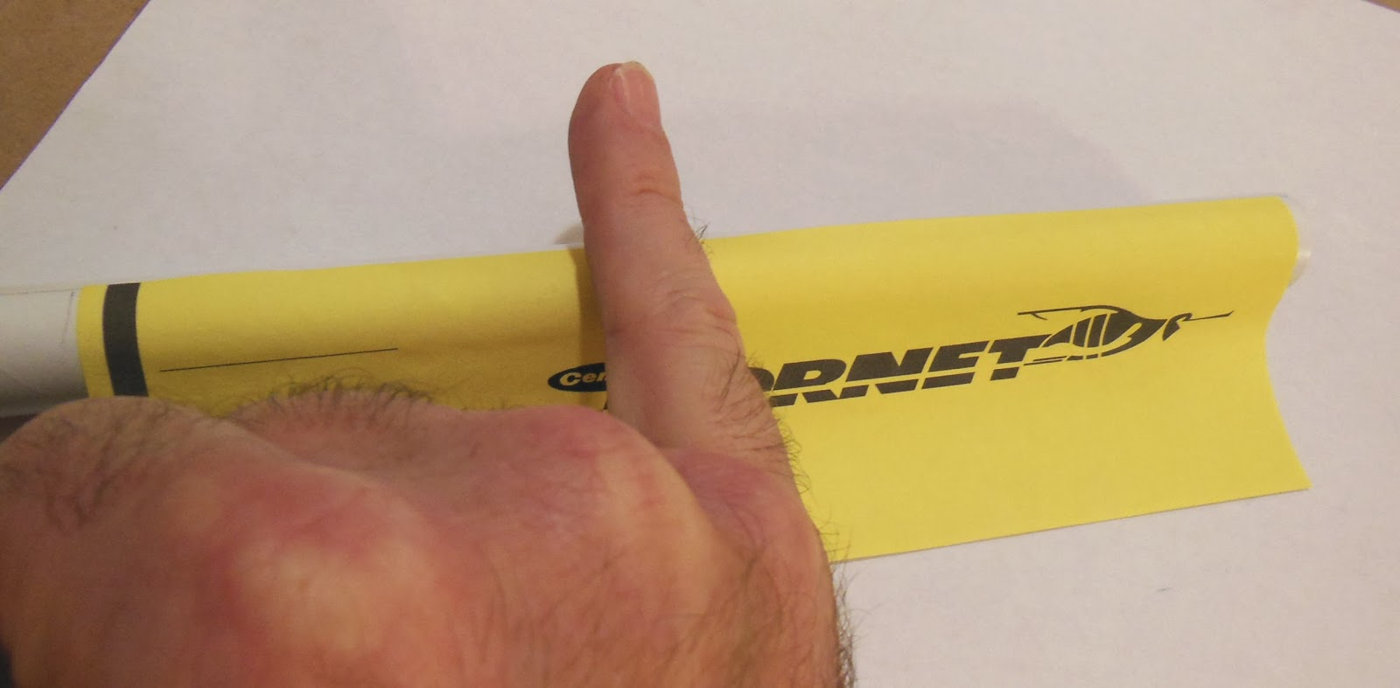
- Cut out a circle and put a cut halfway through. Twist the circle into a point and tape it on the rocket. The size of the circle used will determine the length of the nose cone. If you want a long, pointy nose cone then use a very large circle. If you want a short, pointy nose, then use a smaller circle.

- Cut out 3 to 4 fins. You need them to be less flimsy so use cardstock on this step. You might want to use 2 layers of cardstock for each fin to make them extra sturdy. Tape the two layers together. Fold down the edge of the fin (see picture below – the grey area is folded).

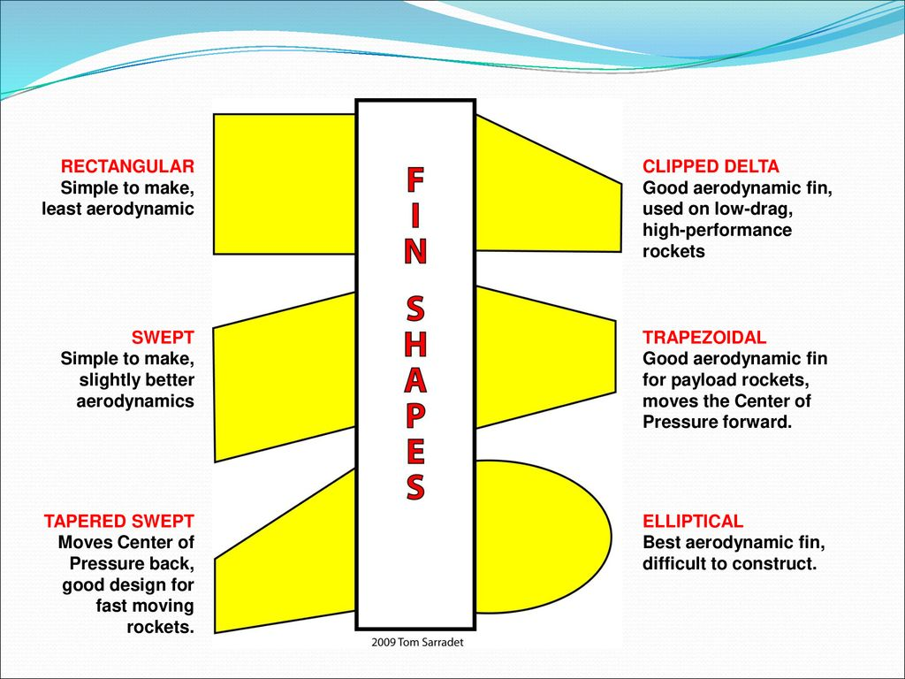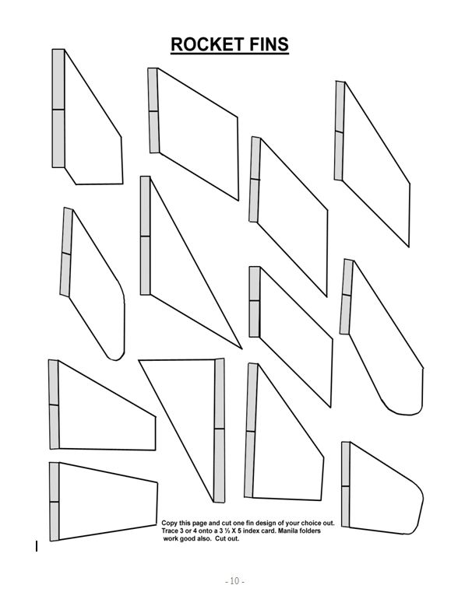

- Tape the fins to the rocket. It is very important that the fins are evening spaced apart. Use the picture below. Put your rocket body in the circle. Mark on your rocket where the lines are (use the dotted lines for 3 fins and the solid lines for 4 fins). Tape your fins to your rocket body.
