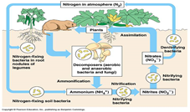
Activity: Nitrogen Cycling in Ecosystems – Game

Analysis Questions:
- In the course of the nitrogen cycle, are nitrogen atoms themselves… (Explain why or why not.)
  - Ever created?

  - Ever destroyed?

  - Ever changed into other kinds of atoms?

  - Ever changed into other compounds?

- Discuss what moves on the game board represented the following processes of the nitrogen cycle: Nitrogen Fixation, Nitrification, Ammonification, Assimilation, and Denitrification.

- Identify what other gases, besides N₂, can be produced during denitrification. For each gas you identify, describe what human activities facilitate the production of these gases.

- Discuss why a natural ecosystem (assuming no anthropogenic interaction) is not polluted by nitrogenous wastes from various organisms.

- Draw & Label the Nitrogen Cycle

