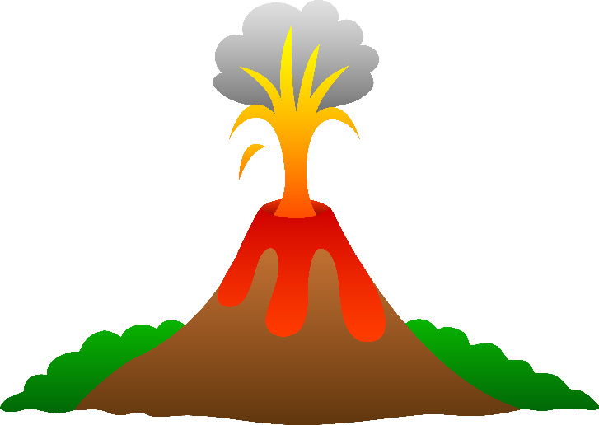
Activity: Mystery of the Mega Volcano
NOVA

Materials:

- Volcanic Suspects Chart
- copy of the "Volcanic Identification"
- copy of the "Volcano Suspects: Location"
- copy of the "Volcano Suspects: Description"
- copy of the "Volcano Suspects: Ash Composition"
- access to Internet U.S. map resources

Background:
Supervolcanic eruptions are extremely large eruptions that produce at least 1,000 cubic kilometers of magma and pyroclastic material (a hot, dry, fast-moving mixture of ash, pumice, rock fragments, and gas). These eruptions could destroy virtually all life within a radius of hundreds of kilometers from the site and could bury areas as far away as 1,500 kilometers in meters of ash. Very large-scale explosive eruptions of this type produce calderas, large depressions formed by the collapse of the summit or flanks of a volcano.

Volcanic ash consists of rock, mineral, and glass fragments smaller than two millimeters in diameter. Ash is formed by the catastrophic drop in pressure on magma brought about by the volcanic eruption (breaking up of volcanic edifice results in atmospheric pressure inside volcano). This causes gases in the magma to expand violently, fragmenting the magma into tiny pieces, which instantly solidify on ejection into the atmosphere (lower temperature compared to magmatic temperatures).

Ash from a particular volcano has its own unique characteristics, much like a person's fingerprints. These characteristics include chemical composition, and the size and shape of crystals and glass shards. They can be used to determine not only the particular volcano that produced the ash, but the particular eruption from that volcano as well.

The characteristics, along with the age of the ash, help scientists identify the source of material. Volcanic rocks are typically divided into four basic types—basalt, andesite, dacite, and rhyolite—according to the average concentration of major compounds in the rock. These compounds include silicon dioxide (SiO2), titanium dioxide (TiO2), aluminum oxide (Al2O3), iron oxide (FeO or Fe2O3), manganese oxide (MnO), magnesium oxide (MgO), calcium oxide (CaO), sodium oxide (Na2O), potassium oxide (K2O), and phosphorous pentaoxide (P2O5).

In 1971, Michael Voorheis, a paleontologist at the University of Nebraska State Museum, made a startling discovery at a farm in northeastern Nebraska. He uncovered the bones of 200 fossilized rhinos, together with the prehistoric skeletons of camels, lizards, horses, and turtles. They had been killed millions of years ago by suffocating amounts of volcanic ash (the site later became known as Ashfall). But there are no volcanoes in Nebraska, nor had there ever been. In fact, there are no volcanoes in the continental United States east of Colorado. So where did the ash come from?

Scientists discovered that the ash originated in an extremely explosive eruption approximately 10 million years ago. By analyzing and comparing ash samples from the Ashfall site to those produced by volcano eruptions of the same age, the scientists were able to identify the source of the eruption as the Bruneau-Jarbridge volcano in southwestern Idaho, some 1,500 kilometers away.

In this activity, YOU will use real volcanic data to identify the likely source of volcanic ash found in an area of Nebraska.

Part 1: Brainstorm
- Brainstorm with your group about the possible types of information you might need to identify a source of volcanic ash. What did your group come up with?

Part 2: Initial Observations
- Pick up your "Volcanic Identification" handout (class set)

- Use the information on the "Volcanic Identification" handout to identify…
  - Type of ash at the Ashfall Fossil Beds site?

  - Type of eruption most likely to have created Ashfall?

  - Type of Volcano form most likely to have created Ashfall?

Part 3: Gathering Data
NOTE: You will be provided with three sets of REAL volcanic data, ONE at a time. For each data set, you will analyze the information and— based on that data—eliminate "suspect" volcanoes you think least fit the profile for the Ashfall event.

- Pick up the Handout #1 (Volcano Suspects: Location)
  - Fill our your Volcanic Suspects CHART – “Location” row ONLY
**Use a computer to help you determine distances!
  - Which volcano is located closest to the Ashfall site?

  - Which volcanoes are farthest away?

  - Chart, mark the “Volcano or volcanoes you feel is/are the least likely suspect based on the data.
  - At the end of the row, rate your confidence level in your answer(s).

- Pick up the Handout #2 (Volcano Suspects: Description
  - Fill our your Volcanic Suspects CHART – “Description” row ONLY
  - The eruptive volume corresponds to the explosiveness of a volcano. Which volcano had the most explosive eruption?

  - Which volcano had the least explosive eruption?

  - Does there seem to be a relationship between the size of a volcano’s crater/caldera and an eruption’s explosiveness? Why or why not?

  - On your chart, mark the “Volcano or volcanoes you feel is/are the least likely suspect based on the data.
  - At the end of the row, rate your confidence level in your answer(s).

- Pick up the Handout #3 (Volcano Suspects: Ash Composition)
  - Fill our your Volcanic Suspects CHART – “Ash Composition” row ONLY
  - For EACH suspect volcano, would you characterize the magma that produced the ash sample as mafic, intermediate, or felsic? Why?

  - Which ash seems to be most similar in composition to the Ashfall sample?

  - On your chart, mark the “Volcano or volcanoes you feel is/are the least likely suspect based on the data.
  - At the end of the row, rate your confidence level in your answer(s).

Part 4: - Class Discussion
- After you have completed all three handouts and filled out your "Volcano Suspects Chart," answer the following questions.
  - Which volcano do you think is responsible? Why?

  - Did your opinions change as you got more data? Why or why not?

  - Which data were most relevant?

  - Which were least relevant?

Part 4: Analysis
- Most of the listed “suspect” volcanoes have calderas, which are large depressions formed by the collapse of the summit or flanks of a volcano during a large-scale, highly explosive eruption. Why would a caldera-forming eruption be the most likely source of the ash found in Nebraska?

- The most explosive volcanoes have magma with a very high silica (SiO2) content. Based on this information, which of the suspect volcanoes is most likely to have had the most explosive eruption?

- Which volcano do you think was the most likely source of the eruption that killed the animals in Nebraska?

- Should you be concerned about living in an area where supervolcanic eruptions might have occurred? Why or why not?

