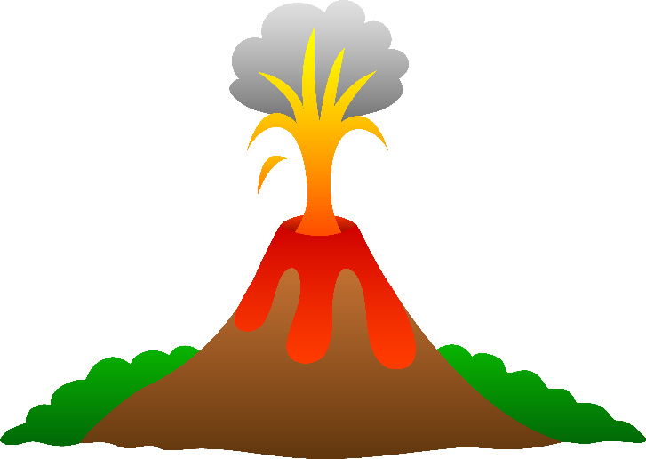
Activity: Mystery of the Mega Volcano
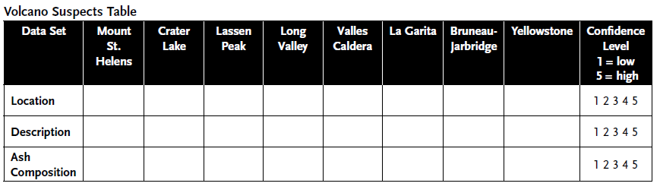
NOVA

