Activity 1.2.3 – Perspective Sketches

Introduction
If you can stand on a straight road and look down the road, it appears to you the sides of the road begin to look as if they are narrowing to one point and the center of the road vanishes when the road meets the horizon. If the road is straight enough and long enough, the sides of the road not only look like they are converging to a single point, but the road seems to appear to vanish as it meets the horizon. A similar effect happens if you stare upward from the base of a tall building. The vertical edges of the building will appear to angle in toward each other. This effect is called perspective.

The human eye sees the world in perspective. Objects that are further away from the eye appear smaller, and edges appear to recede into the distance. Perspective sketches depict objects in much the same way that the human eye sees the world.

There are three different types of perspective drawings: one-point, two-point, and three-point perspective. The different types of sketches are frequently used by architects, industrial designers, and illustrators when representing large scale objects or environments in which the effect of distance must be taken into consideration.

Equipment
- Engineer’s notebook
- Number 2 pencil
- Various objects

Procedure
In this activity, you will practice your sketching skills by generating a one-point, two-point, and three-point perspective of a given object. You will then apply your skills by creating either a one-point, two-point, or three-point perspective of an object you randomly choose.

Study the objects in Figures 1 and 2. Use lightly drawn points and construction lines to layout a one-point perspective sketch of the object within the given box. The perspective sketch must show the object in a top, left side, front view orientation. Delineate the visible edges of the sketch with object lines. DO NOT ERASE YOUR POINTS AND CONSTRUCTION LINES. Add tonal shading to the sketch when finished.

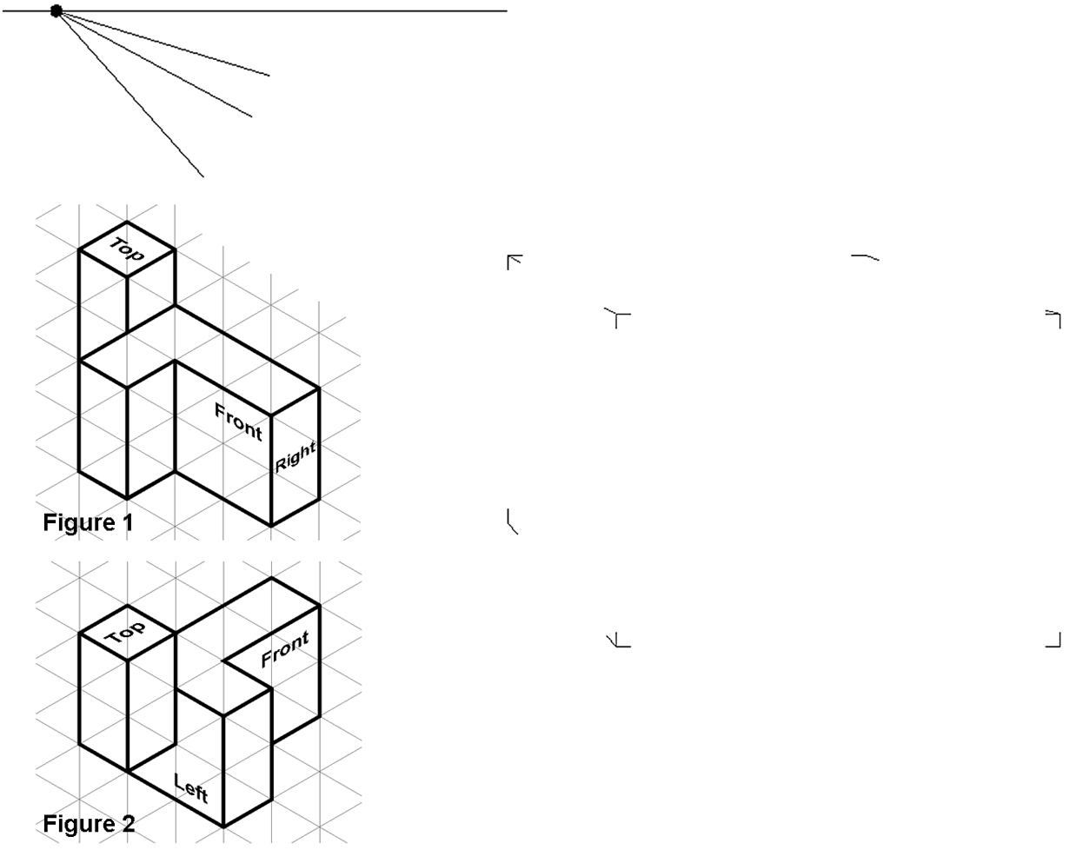

Study the objects in Figures 3 and 4. Use lightly drawn points and construction lines to layout a two-point perspective sketch of the object within the given box. The perspective sketch must show the object in a top, front, right side view orientation. Delineate the visible edges of the sketch with object lines. DO NOT ERASE YOUR POINTS AND CONSTRUCTION LINES. Add tonal shading to the sketch when finished.

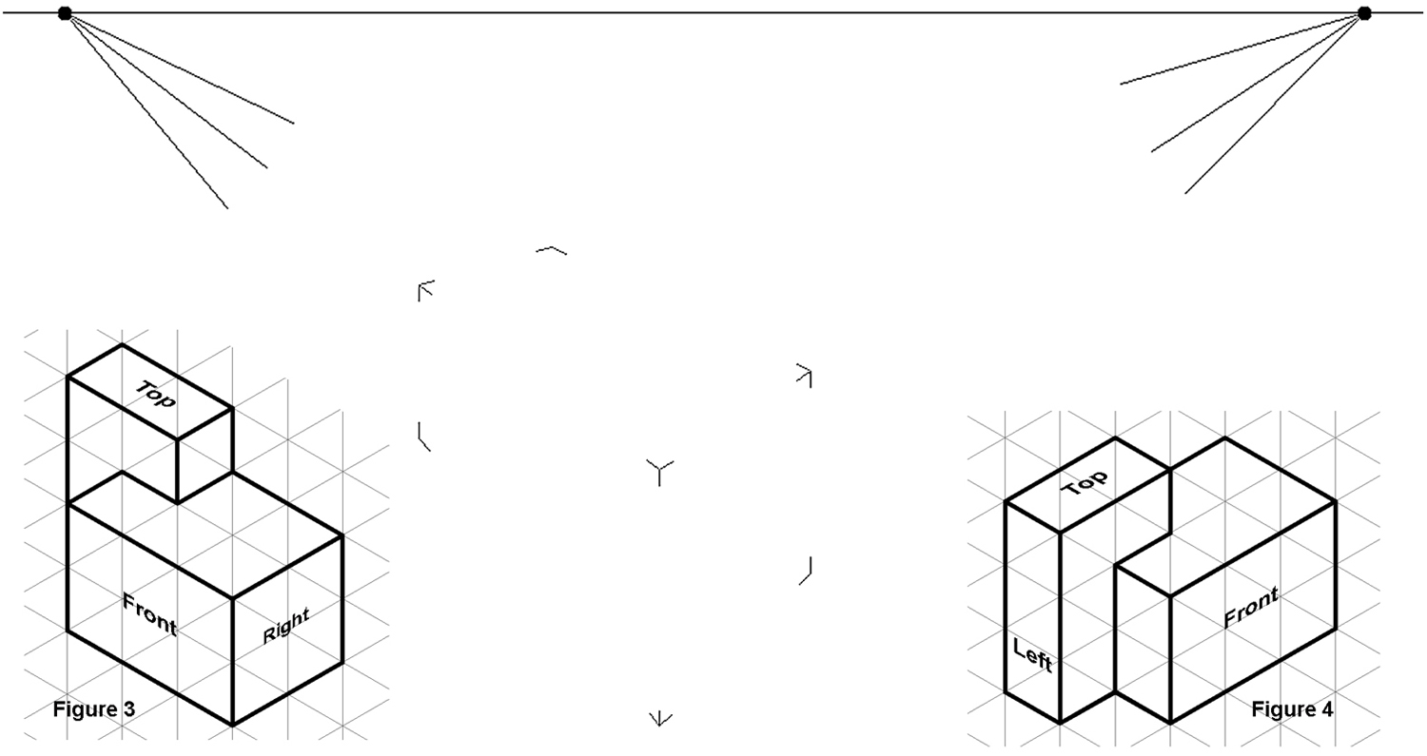

Study the pictorial in Figure 5. Use lightly drawn points and construction lines to layout a three-point perspective sketch of the object within the given box. The perspective sketch must show the object in a top, front, right side view orientation. Delineate the visible edges of the sketch with object lines. DO NOT ERASE YOUR POINTS AND CONSTRUCTION LINES. Add tonal shading to the sketch when finished.

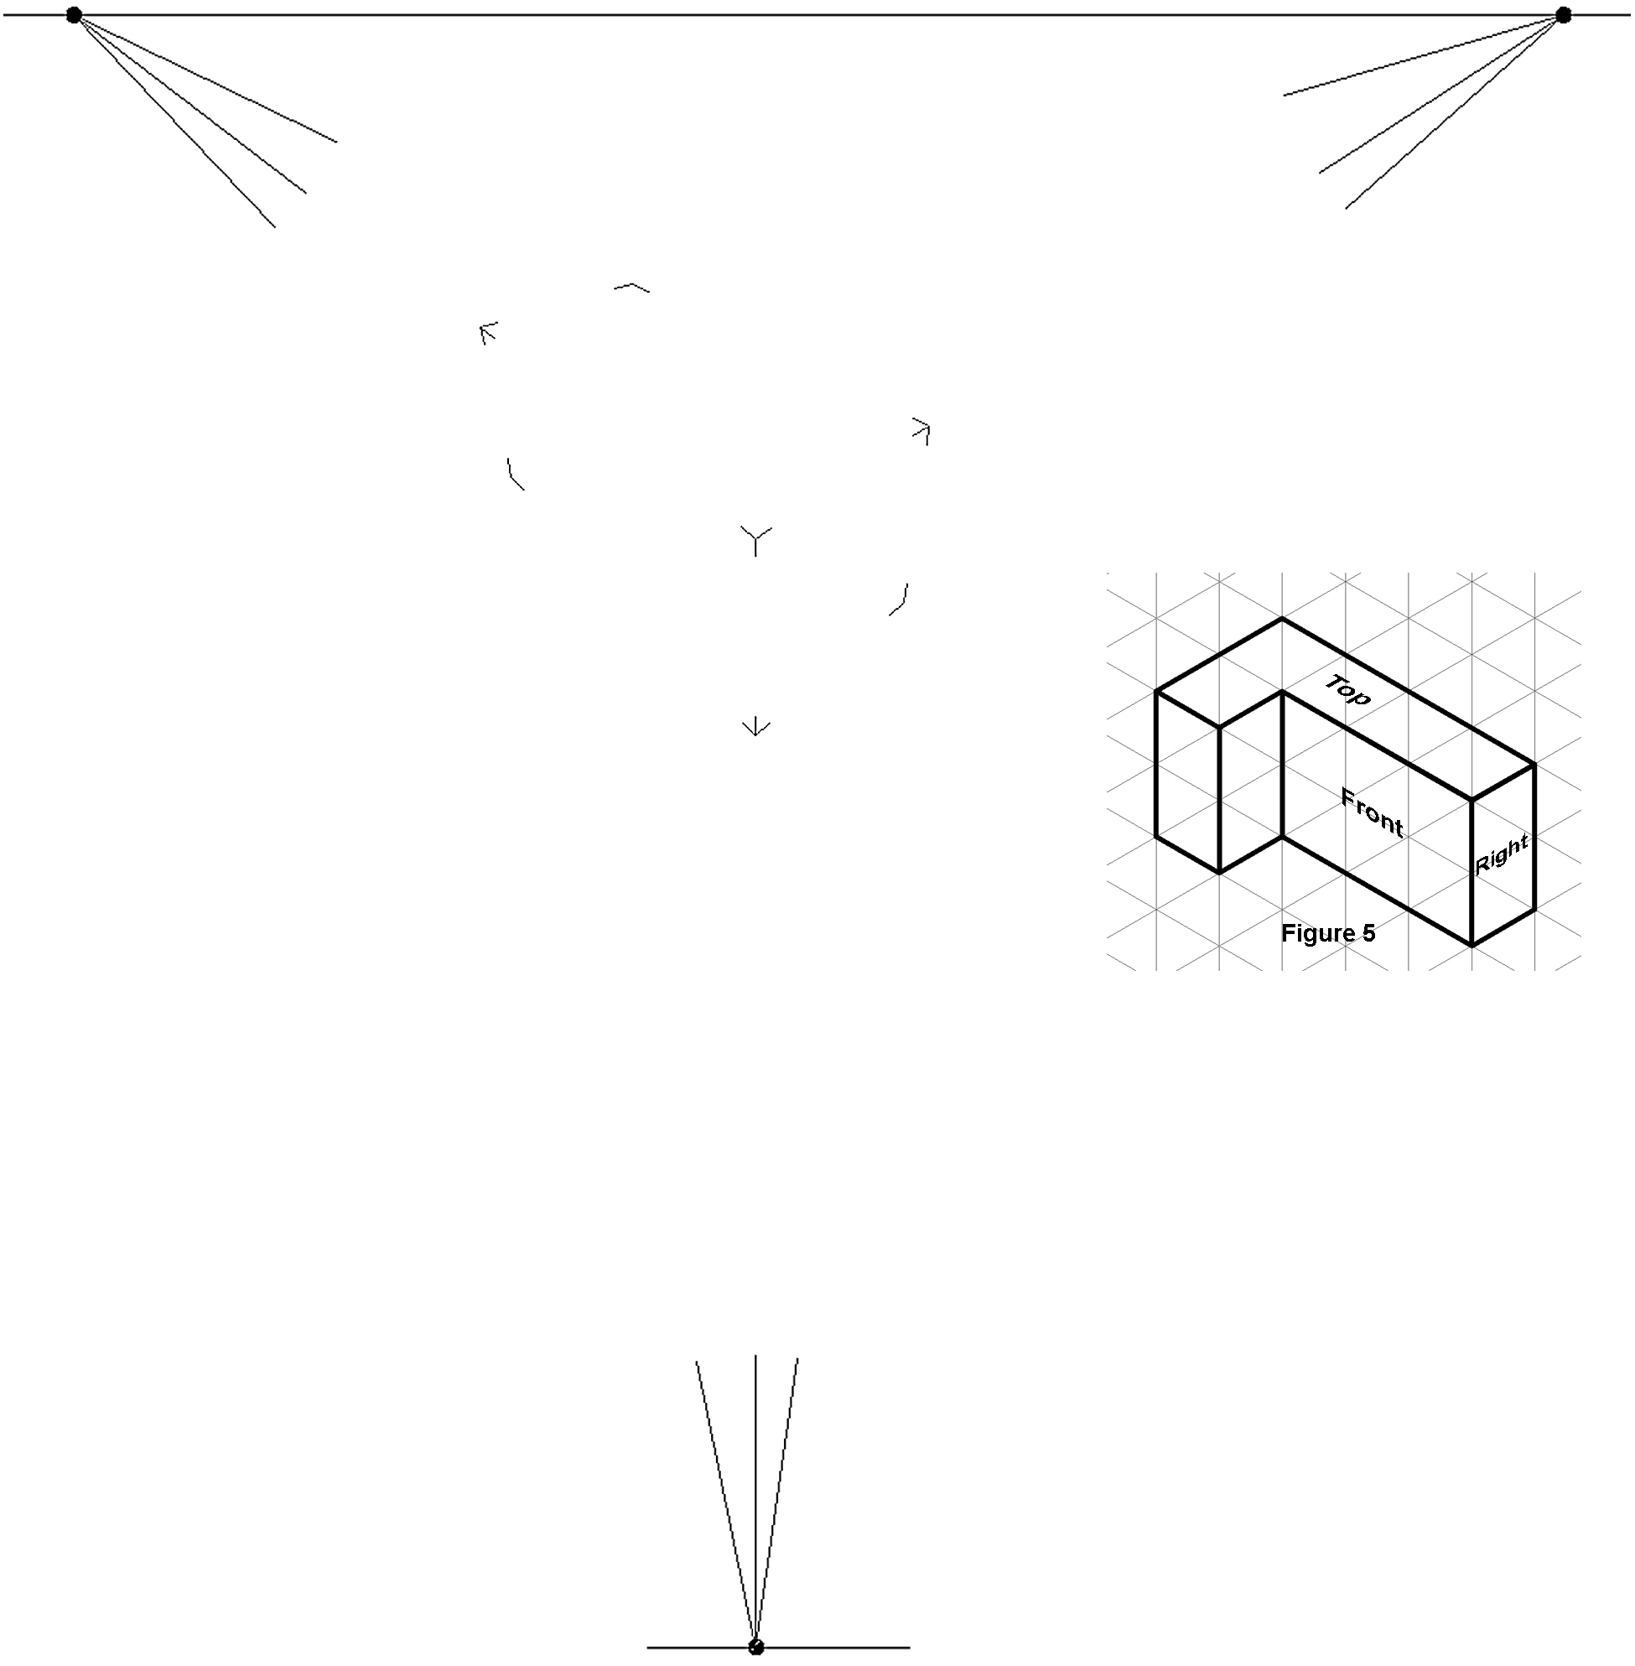

Conclusion
- What is a vanishing point?

- Aside from the number of vanishing points, what is the difference between a one-point, two-point, and three-point perspective sketch?

