Activity 1.2.4 – Multiview Sketches

Introduction
It’s a very common occurrence to see a product advertisement and think, “I thought of an idea for something like that just a few months ago.” People spend a lot of time in their various interest areas and envision ideas for making things work better. Spend some time with someone who has a permanent disability and see how many product ideas come to mind that would provide a degree of freedom to a person who has lost a physical capability years ago. Coming up with wonderful ideas are only the first step in developing solutions to problems. At some point, ideas must be built.

You’ve practiced different techniques for sketching objects so that they appear to have a three-dimensional quality. These techniques are excellent for quickly communicating ideas to both technical and non-technical people. Those who make their living building ideas require a different type of drawing format. A multiview sketch, also referred to as an orthographic projection sketch, is the standard sketch format used by engineers to communicate ideas to professionals in the building trades.

However, pictorials do not provide accurate information about the true size and shape of an object and all of its features. It is often the case that engineered objects have features and edges that are obscured by the standard surface views of a multiview drawing. These views require hidden lines. When engineers create drawings of cylindrical objects, or objects that have holes, they must represent their axes and axes points with centerlines.

Knowing how to sketch and interpret multiviews is an important skill for any engineer.

Equipment
- Number 2 pencil
- Engineer’s notebook

Procedure
In this activity, you will develop your ability to see and sketch objects as a series of related two-dimensional views. Understanding and using the different line conventions, discussed earlier in this lesson, will help when creating these views.

Study the image below. The various surfaces of the object are identified by letters on the isometric drawing and by numbers on the multiview drawing. In the table, write the number that corresponds with the lettered surface in each of the top, front, and right side views.

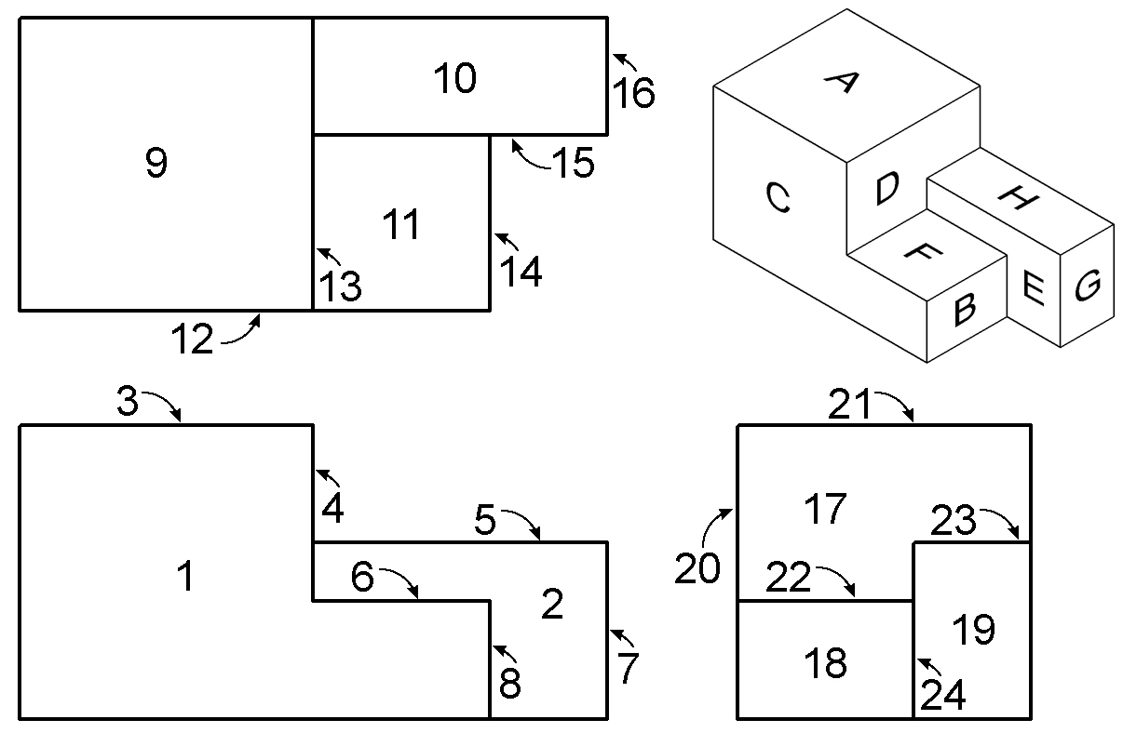 |  | Top | Front | Side
 | A | 9 | 3 | 21
 | B
 | C
 | D
 | E
 | F
 | G
 | H

Study the images below. Use points, construction lines, hidden lines, center lines and object lines where applicable to sketch the missing view. DO NOT ERASE YOUR POINTS AND CONSTRUCTION LINES.

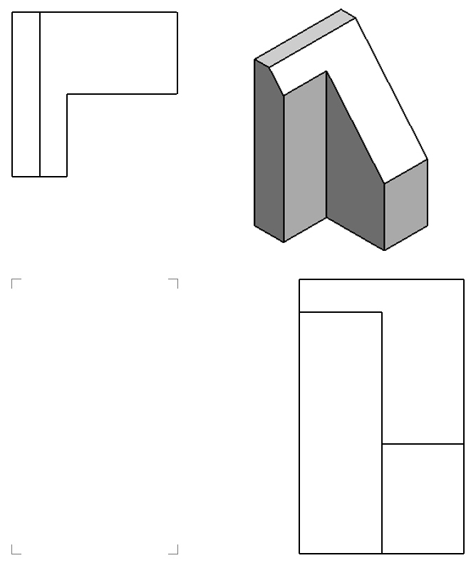

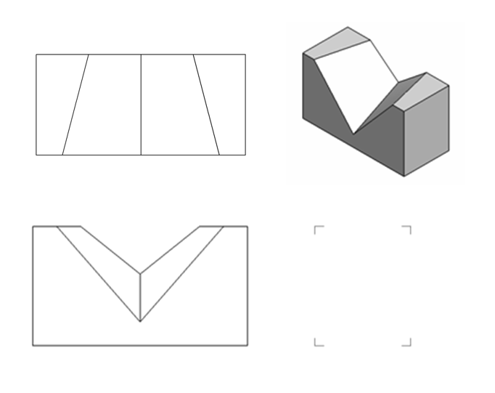

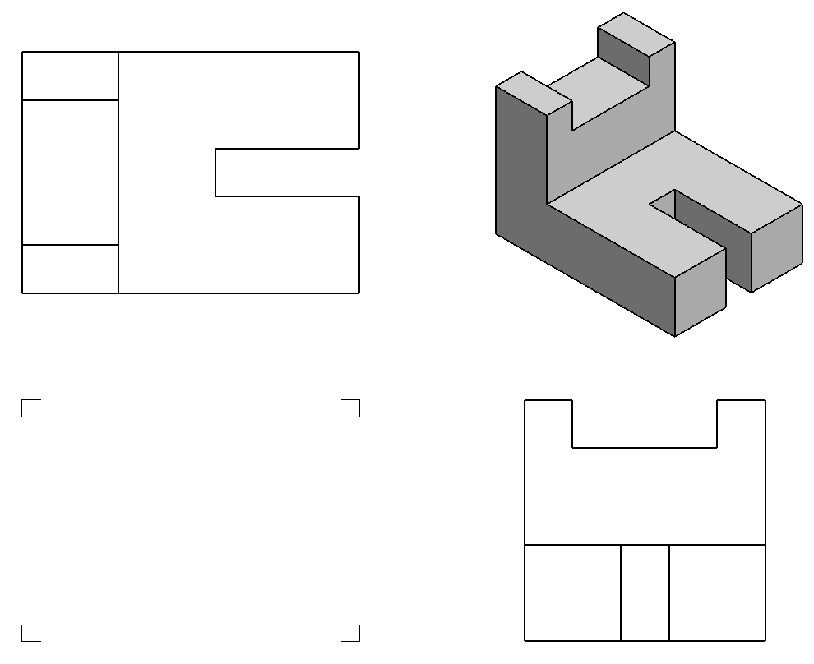

Extending Your Learning
The following problems have students sketching the missing views, and allowing them to experiment with sketching other types of line conventions.

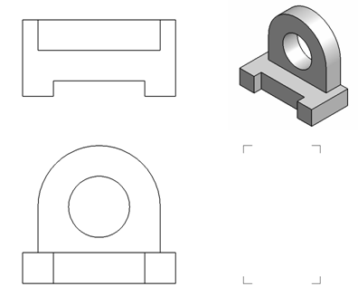

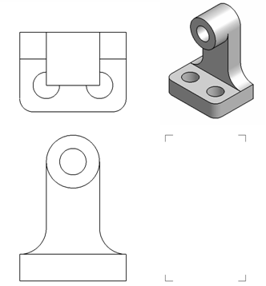

Study the isometric views in the next four pages. Use points, hidden lines construction lines, and object lines to sketch the three common views used to explain the object. The scale is 1:1 which means each grid line on the isometric view represents a grid line on the orthographic grid. DO NOT ERASE YOUR POINTS AND CONSTRUCTION LINES.

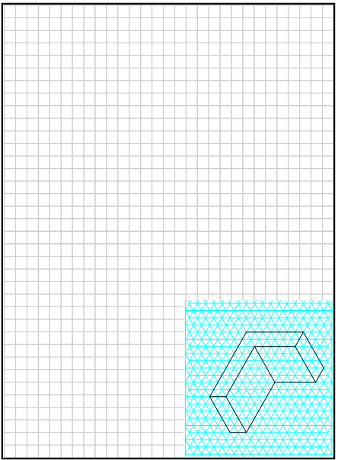

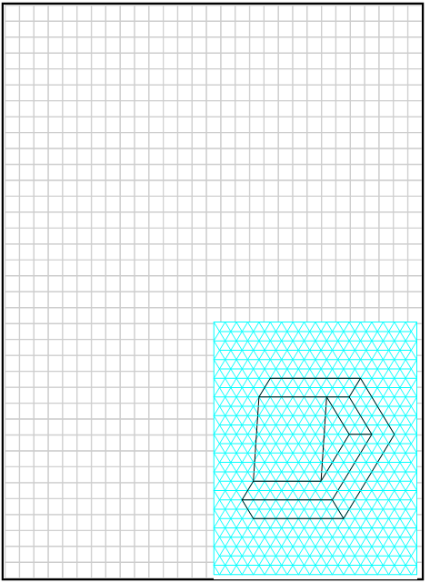

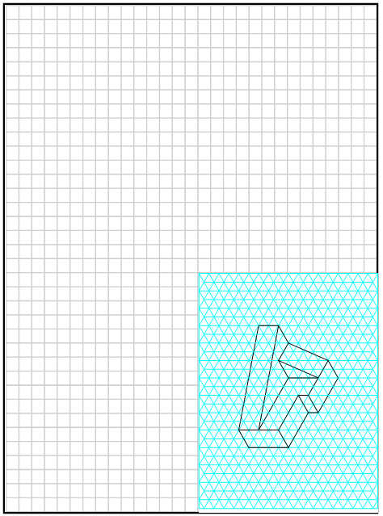

Extending Your Learning- Part II
The following problem has students sketching the missing views, and allowing them to experiment with sketching other types of line conventions.
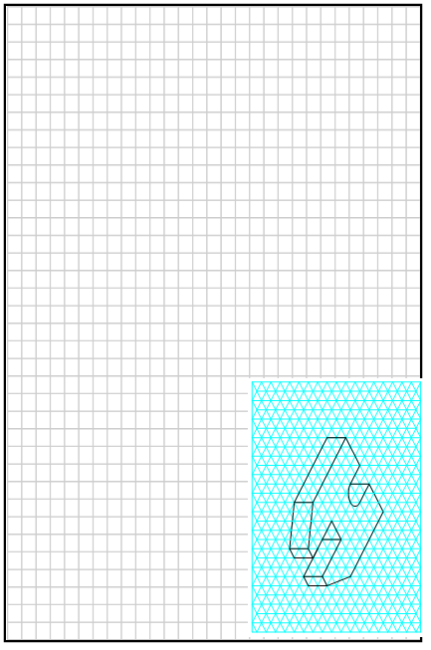
Conclusion
- Why would building professionals, such as machinists and contractors, prefer multiview drawings over pictorial drawings?

- How would you describe the geometric relationship that exists between the adjacent views of a multiview drawing?

- Why is it important to layout a multiview sketch with points and construction lines before drawing object lines?

- What is the purpose of hidden lines and center lines?

