AP Physics – ElectroMagnetic - 9

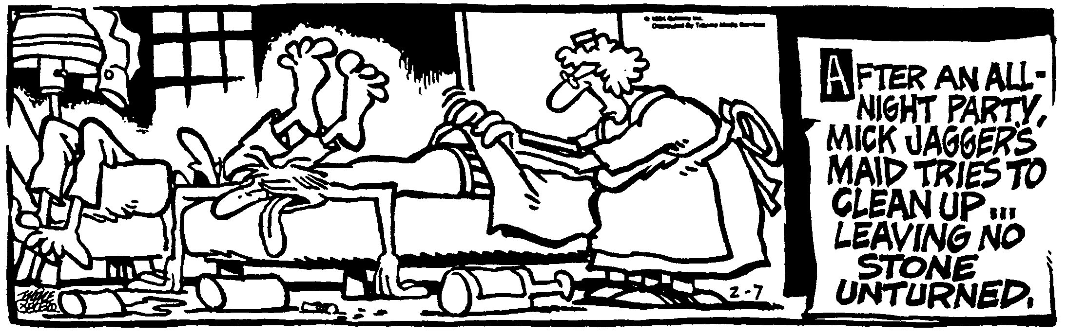
Be-who __________________________________________________________________Per__
You cannot reason a person out of a position he did not reason himself into in the first place. - Jonathan Swift
- A square loop of wire measures 2.00 cm on each side. It is attached to a cart that is moving at a constant speed of 15.0 m/s into a uniform magnetic field of 56.0 T. (a) What is the induced emf after it has traveled 1.00 cm into the field? (b) What is the direction of the current, clockwise or counterclockwise? (c) If the resistance of the loop is 1.60 Ω, what is the current in the loop?

- What is the wavelength of a radio wave that has a frequency of 1270 kHz?

- A rectangular conducting loop of width w, height h, and resistance R is mounted vertically on a nonconducting cart as shown in the drawing. The cart is placed on the inclined portion of a track and released from rest at position P₁ at a height of y₀ above the horizontal portion of the track. It rolls with negligible friction down the incline and through a uniform magnetic field B in the region above the horizontal portion of the track. The conducting loop is in the plane of the page, and the magnetic field is directed into the page. The loop passes completely through the field with a negligible change in speed. Express your answers in terms of the given quantities and fundamental constants.
- Find the speed of the cart when it reaches the horizontal portion of the track.

(b) Determine the following for the time at which the cart is at position P₂ with one third of the loop in the magnetic field.
- The magnitude of the emf induced in the conducting loop.

- The magnitude of the current induced in the conducting loop.

(c) On the following diagram of the conducting loop, indicate the direction of the current when it is within the magnetic field.

(d) Using the axes below, sketch a graph of the magnitude of the magnetic flux φ through the loop as a function of the horizontal distance x traveled by the cart, letting x = 0 be the position at which the front edge of the loop just enters the field. Label appropriate values on the vertical axis.

(e) Using the axis below, sketch a graph of the the current induced in the loop as a function of the horizontal distance x traveled by the cart, letting x = 0 be the position at which the front edge of the loop just enters the field. Let the counterclockwise current be positive and label appropriate values on the vertical axis.

- A 825 kg bomb free falls from a B-17. The bomber is traveling at a speed of 345 km/h. The bomb travels a horizontal distance of 8.23 km before it hits the ground. Ignoring friction, find the following: (a) The kinetic energy of the bomb before it is released, (b) the time it takes the bomb to fall, (c) the height of the bomber, (d) the total energy of the bomb just before it hits and (e) the vertical velocity of the bomb just before it hits the ground.

- An electron is released from rest in a uniform electric field, E = 5.70 x 10⁵ V/m. It is directed along the y axis. It is displaced a distance of 0.250 m in the direction of the field. (a) What is the change in electrical potential? (b) What is the change in electrical potential energy for the electron? (c) What is its velocity after it traveled the 0.250 m?

