Mutations & Cancer Regents Questions:

- Researchers have found that formaldehyde and asbestos can alter DNA base sequences. Based on this research, the use of these chemicals has been greatly reduced because they

(1) may act as fertilizers, increasing the growth of algae in ponds
(2) have been replaced by more toxic compounds
(3) are capable of causing mutations in humans
(4) interfere with the production of antibiotics by white blood cells

- Genetic researchers have discovered a number of different gene mutations that have led to the development of cancer. These mutations affect how frequently a cell reproduces. Which process would be directly influenced by these mutations?

(1) differentiation of cells in an embryo (2) meiotic cell division
(3) division of sperm and egg cells (4) mitotic cell division

- It is recommended that people avoid excessive use of tanning beds. Exposure to the radiation emitted by tanning beds can cause skin cancer. This cancer is the direct result of a

(1) change in a starch molecule (2) mutation in the genetic material
(3) mutation in a protein (4) change in a fat molecule

The graph shows the level of gene expression of five different genes in normal and cancerous cells.

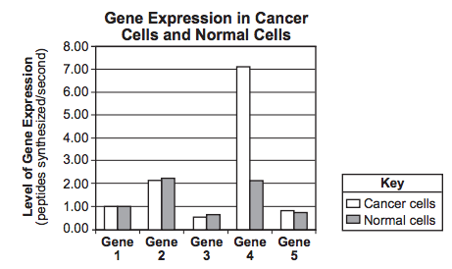
- Which statement is a valid inference that can be made based on the data in this graph?

(1) The change in the level of gene expression in gene 4 could indicate it plays a major role in the development of cancer.
(2) Slight decreases in gene expression will always result in the formation of cancer cells.
(3) Cells will develop cancer if the gene expression of these five genes remains below four peptides per second. (4) An increase in the level of gene expression in these five genes is necessary for cancer to develop in cells.

- Which situation would most likely produce a gene mutation in a squirrel?

(1) The squirrel stops using its claws for digging.
(2) The squirrel is exposed to radiation for several days.
(3) Oak trees gradually become less common.
(4) The weather becomes wetter for a short period of time.

