AP Physics – Work/Energy – 6

Who you may be _______________________________________________________Per___

I think, therefore I am. -- Rene Descartes

I think, therefore I thtay away from water becauth I can’t thwim.. -- Babette Bingo
1. A 0.50 kg cart moves on a straight horizontal track. The graph of velocity V_{x} versus time t for the cart is given below.
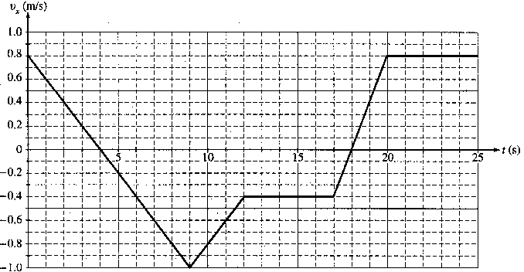

- Indicate every time t for which the cart is at rest.

(b) Indicate every time interval for which the speed (magnitude of velocity) of the cart is increasing.

- Determine the horizontal position x of the cart at t = 9.0 s if the cart is located at x = 2.0 m at t = 0.

- On the axes below, sketch the acceleration a versus time t graph for the motion of the cart from t = 0 to t = 25 s
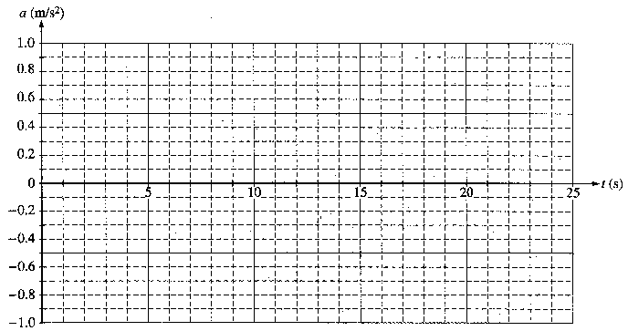
(e) From t = 25 s until the cart reaches the end of the track, the cart continues with constant horizontal velocity. The cart leaves the end of the track and hits the floor, which is 0.40 m below the track. Neglecting air resistance, determine each of the following.

i. The time from when the cart leaves the track until it first hits the floor
ii. The horizontal distance from the end of the track to the point at which the cart first hits the floor
iii. The kinetic energy of the cart immediately before it hits the floor

2. A spring that can be assumed to be ideal hangs from a stand, as shown.
- You wish to determine experimentally the spring constant k of the spring.
- What additional, commonly available equipment would you need?
- What measurements would you make?
- How would k be determined from these measurements?

- A 154 kg bear runs up a hill that has a slope of 15.0° to the horizontal. The critter travels 1200 m in 125 seconds. (a) How much work did the bear do on itself? (b) How much power did the bear develop?

- A spring is compressed 3.25 cm by a 105 N force. (a) What is the spring constant? (b) How much potential energy is stored in the spring?

- One end of a spring is attached to a solid wall while the other end just reaches to the edge of a horizontal, frictionless tabletop, which is a distance h above the floor. A block of mass M is placed against the end of the spring and pushed toward the wall until the spring has been compressed a distance X, as shown. The block is released, follows the trajectory shown, and strikes the floor a horizontal distance D from the edge of the table. Air resistance is negligible.

Determine expressions for the following quantities in terms of M, X, D, h, and g. Note that these symbols do not include the spring constant.

- The time elapsed from the instant the block leaves the table to the instant it strikes the floor.
b. The horizontal component of the velocity of the block just before it hits the floor
c. The work done on the block by the spring
d. The spring constant

