AP Physics – Last of the Optical Stuff - 6

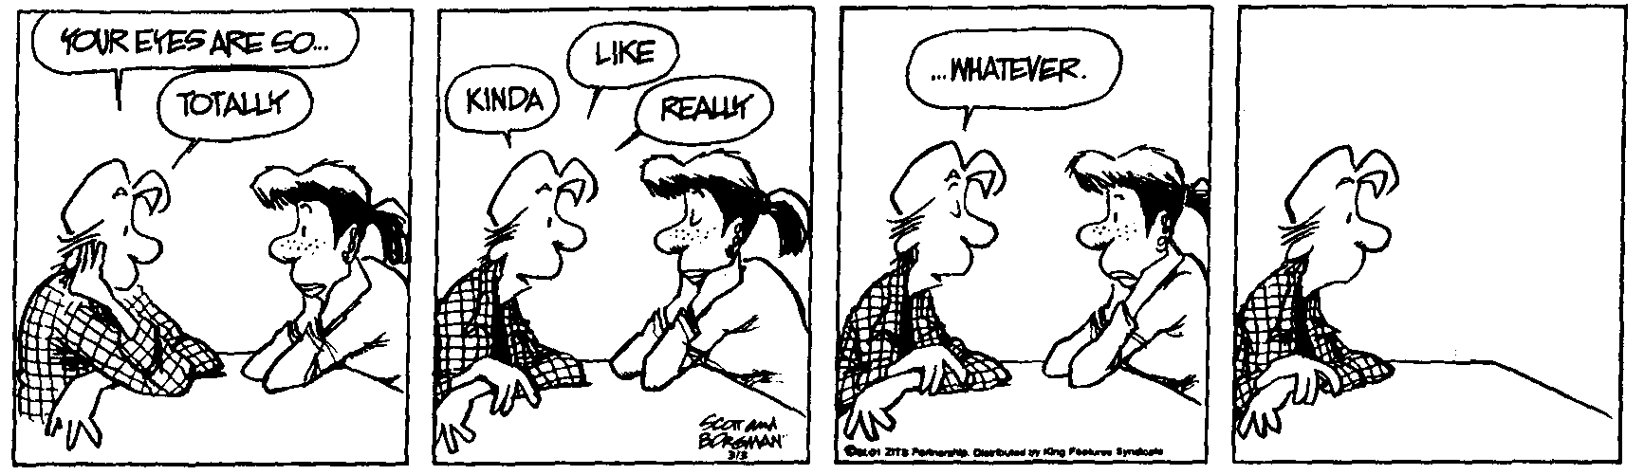
Yadda yadda______________________________________________________________Per___
Emotional sickness is avoiding reality at any cost. Emotional
health is facing reality at any cost. -- M. Scott Peck
- The distance between two slits is 0.0500 mm and the distance to the screen is 2.50 m, find (a) the spacing between the first-order and second-order bright fringes for yellow light with a wavelength of 580.0 nm wavelength. (b) the frequency of the light.

- A thin layer of oil (n = 1.32) spills onto the surface of a nearby lake. It produces maximum reflection for orange light (580.0 nm wavelength in air). Assuming the maximum occurs in the first order, determine the thickness of the oil slick.

- Find the minimum film thickness for destructive interference in reflected light for a thin film. Figure on a first minima deal. The film’s index of refraction is 1.25. It is illuminated by light that has wavelength of 625 nm.

- 497 nm light hits a slit (note, just the one slit) that is 0.300 mm in width. The observing screen is 2.50 m away. Find (a) the position of the first dark fringe and (b) the width of the central bright fringe.

- A beam of light from a light source on the bottom of a swimming pool 3.0 m deep strikes the surface of the water 2.0 m to the left of the light source as shown. Find (a) The angle of reflection made by the ray, (b) the angle made by the emerging ray with the normal to the surface, (c) the minimum water depth for which the light that strikes the surface of the water 2.0 m to the left of the light source will be refracted into the air.

- Construct the image on the drawing below via ray tracing.

- Construct the image on the drawing below via ray tracing.

- The glass prism shown below has an index of refraction that depends on the wavelength of the light that enters it. The index of refraction is 1.50 for red light of wavelength 700 nanometers (700 x 10⁻⁹ meter) in vacuum and 1.60 for blue light of wavelength 480 nanometers in vacuum. A beam of white light is incident from the left, perpendicular to the first surface, as shown in the figure, and is dispersed by the prism into its spectral components.
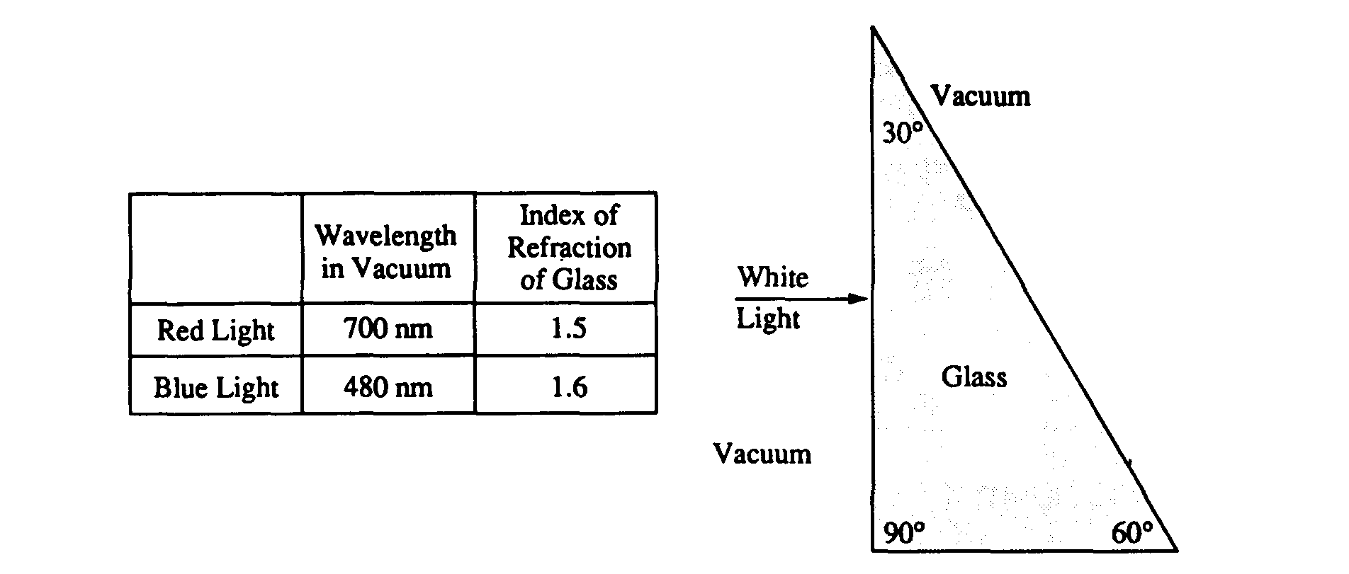

a. Determine the speed of the blue light in the glass.

b. Determine the wavelength of the red light in the glass.

c. Determine the frequency of the red light in the glass.

d. i. What is the angle of refraction for the blue and red light incident on the front surface? ii. Calculate the angle of refraction for the blue and red light incident on the far surface. iii. On the figure above, sketch the approximate paths of both these rays as they pass through the glass and back out into the vacuum. Ignore any reflected light. Clearly show the change in direction of the rays, if any, at each surface and be sure to distinguish carefully any differences between the paths of the red and the blue beams.

- Coherent monochromatic light of wavelength  in air is incident on two narrow slits, the centers of which are 2.00 mm apart. The interference pattern observed on a screen 5.00 m away is represented by the drawing below.
(a) What property of light does this interference experiment demonstrate?

(b) At point P in the diagram, there is a minimum in the interference pattern. Determine the path difference between the light arriving at this point from the two slits.

(c) Determine the wavelength, λ, of the light.

(d) Briefly and qualitatively describe how the interference pattern would change under each of the following separate modifications and explain your reasoning.
i. The experiment is performed in water, which has an index of refraction greater than 1.

ii. One of the slits is covered.

iii. The slits are moved farther apart.

