AP Physics – Electric Current - 6

What R you?________________________________________________________________Per___
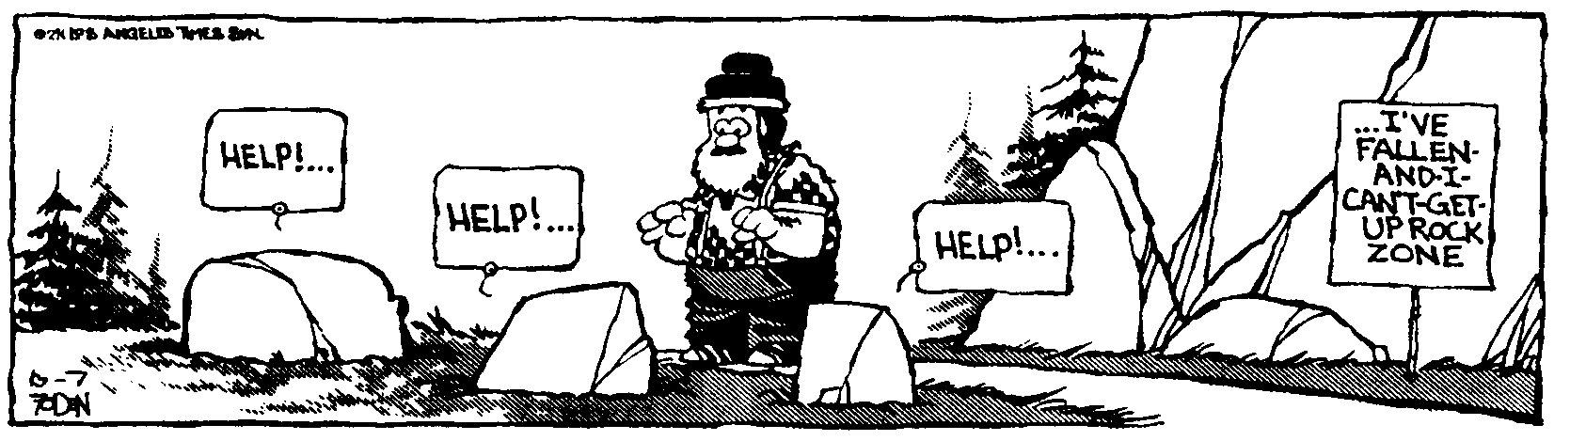
A woman has two smiles that an angel might envy, the smile that accepts a lover before
words are uttered, and the smile that lights on the first born babe, and assures it of a
mother's love. --Thomas C. Haliburton
- A circuit is set up as shown. Determine (a) the total resistance, (b) the total current, and (c) the amount of power dissipated by the 20.0 Ω resistor.

- A 2.55 m length of copper wire has a diameter of 0.550 mm. 1.34 x 10¹⁸ e⁻ flow past a point on the wire in 0.850 s. 3.50 cm of the wire pass through a uniform magnetic field of 2.67 T. Find: (a) the resistance of the wire, (b) the current passing through the wire, and (c) the maximum force exerted on the wire by the magnetic field.

- If the battery in this circuit produces 12.0 W, what must the value of R₅ be?

- A proton is moving perpendicular to a uniform magnetic field as shown. The direction of the field is into the paper. (a) Draw the direction of the force onto the picture. (b) Draw in the path the proton will take. (c) The field strength is 2.35 T, the velocity of the proton is 4.55 x 10⁶ m/s. Find the force acting on the particle. (d) What is the radius of its path?

- A long wire has a current of 1.25 A. What is the magnetic field strength at a distance of 2.50 cm?

- A magnetic field is as shown, it is directed into the page. Draw in the direction of the force acting on a current carrying conductor with the indicated current direction.

- A mass spectrometer is a piece of gear that is used to separate matter particles from one another based on their mass. The picture shows a simplified version on once such device. Source molecules are ionized and accelerated through a potential difference. They are then projected into a uniform magnetic field. In the field they follow a circular path as shown. The radius of the path is a function of their charge and their mass. In the drawing two particles are shown. Assume both have the same charge, + 1. If r₁ is 21.0 cm and r₂ is 20.0 cm, find the ratio of the two masses, m₁ and m₂. Assume they are both single ionized atoms with the same initial velocity.

