AP Physics – Thermo’Duh’Fermo - 5

Co’Co’Cuh’Chew! _______________________________________________________________Per__
The true measure of a man is what he would do if he knew he would never be caught. Lord Kelvin
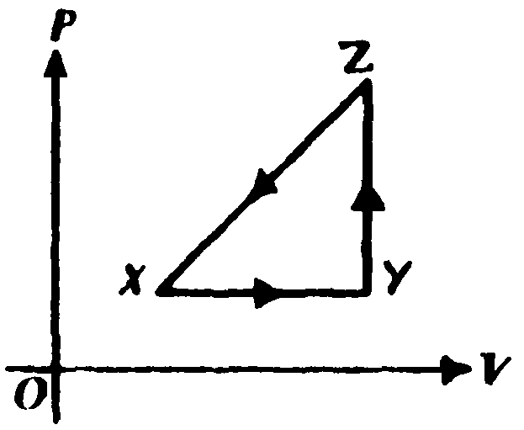
- A thermodynamic system is taken from an initial state X along the path XYZ X as shown in the PV-diagram to the right.

a. For the process X → Y , ΔU is greater than zero and

(A) Q < 0 and W = 0
(B) Q < 0 and W > 0
(C) Q > 0 and W < 0
(D) Q > 0 and W = 0
(E) Q > 0 and W > 0

b. For the process Y → Z , Q is greater than zero and

(A) W < 0 and ΔU = 0
(B) W = 0 and ΔU < 0
(C) W = 0 and ΔU > 0
(D) W > 0 and ΔU = 0
(E) W > 0 and ΔU > 0

- A piece of metal with a mass of 1.20 kilograms, specific heat of 390 J/kg · C°, and initial temperature of 87 °C is dropped into an insulated jar that contains 4.5 kg of water at 20.0°C. The metal is removed after 12 seconds, at which time its temperature is 35 °C. Neglect any effects of heat transfer to the air or to the insulated jar. What is the temperature of the liquid after the metal is removed?

- A steam engine operates on a warm 28.0 °C day. If the ideal efficiency for this engine is 24%, what is the high temperature for the engine?

- What is the average velocity of the particles of nitrogen at 22.0°C?

- A gas undergoes a thermodynamic expansion process as shown. Process ab represents the output work, process bc represents input work, all three processes involve heat transfer. (a) what is the work accomplished along path ca? (b) What is the work along path ab, (c) What is the work along path bc? (d) What is the net work for the entire thermo cycle?

- A heat engine makes use of 785 kJ of heat to produce 245 kJ of work. It operates at a temperature of 285°C. It exhausts heat to the 22.5°C atmosphere. What is (a) its ideal efficiency and (b) its actual efficiency? (c) Why are these two quantities so different?

- A circuit exists as shown below – the three resistors are immersed in a tank of water. The battery is connected to the resistors for 12.0 min. (a) How much heat is generated in the 35.0 s? (b) The water in the tank has a mass of 1.25 kg and a beginning temperature of 24.0°C, so what is the final temperature of the water if all the heat goes into it?

