AP Physics – Modern Stuff - 5

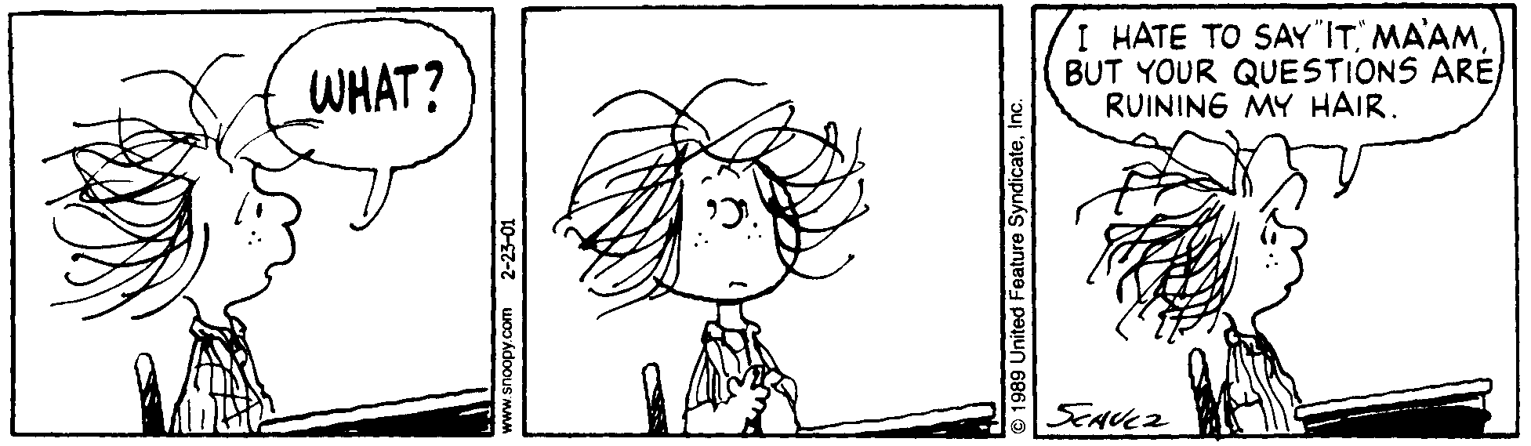
Hoodoo_____________________________________________________________________Per__
Every novel idea in science passes through three stages.
First people say it isn't true.
Then they say it's true, but not important.
And finally they say it's true and important, but not new. -- Anonymous
- An atom absorbs light of wavelength 415 nm. Two of the spectral lines given off have wavelengths of 415 nm and 525 nm. (a) Determine the energy levels involved and draw them onto the energy diagram. (b) The ground state for the atom is –7.20 eV. What other wavelengths of light could be given off?

- What is the energy in eV of a photon of light that has a frequency of 3.5 x 10¹⁵ Hz?

- In a certain metal, the stopping potential is found to be 4.00 V. When 235 nm light is incident on the metal, electrons are emitted. (a) What is the maximum kinetic energy given to the electrons in eV and J? (b) What is the work function of the metal?

- The work function for cesium is 1.96 eV. (a) Find the cutoff wavelength for the metal, (b) what is the maximum kinetic energy for the emitted electrons when 425 nm light is incident on the metal?

- A 2.50 g sample of U-235 undergoes fission. For each decaying nuclei, 208 MeV is released. How many joules of energy in total would be released?

- A Beryllium-7 nucleus has a mass of 7.016 928 u. A neutron has a mass of 1.008 665 u and a proton has a mass of 1.007 276 u. Calculate the binding energy and the mass defect for Be-7.

- A granite cylinder that has a diameter of 89.0 cm and stands 2.15 m tall is sitting on a flat tile deck. What is the pressure exerted on the deck by the stone cylinder?

- What is the force exerted on the surface of a spherical fishnet float that has a diameter of 56.0 cm immersed in seawater to a depth of 1 255 m?

- An electric circuit has two 45.0 Ω resistors in parallel with one another. They in turn are in series with a single 24.0 Ω resistor. The current through one of the 45.0 Ω resistors is 0.450 A and the voltage source is a single battery. What is (a) the voltage provided by the battery? (b) the power dissipated by the 24.0 Ω resistor? And (c) the power dissipated by one of the 45.0 Ω resistors?

- What is: (a) the buoyant force acting on a cube of copper that measures 2.00 cm on its each side if it is immersed in water and (b) the apparent weight of the cube?

- A beam of light, wavelength 685 nm in air, is incident on a block of crown glass at an angle of 33.5°. Find (a) the speed of light in the glass (b) the angle of refraction and (c) the wavelength of the light in the glass.

- A proton is accelerated from rest through a potential difference of 12.0 V. Find (a) the energy of the particle, and (b) the speed of the particle.

