AP Physics – Work/Energy – 5

Who you think you are __________________________________________________________Per___
The difference between stupidity and ignorance is that ignorance is curable. – Robert Heinlein
- A spring with a spring constant value of 125 N/m is compressed 12.2 cm by pushing on it with a 215 g block. When the block is released, what velocity will the block have when it leaves the spring (we’re ignoring friction here)?

- A woman lifts a 12.5 kg bucket up a well. She does 5.50 kJ of work. How deep is the well?

- A 48.0 kg telephone repairperson climbs up one of them power pole deals. She is carrying 7.85 kg of tools and things. If she generates 0.765 hp, how much time does it take her to climb the 3.20 m tall pole?

- A 25.0 kg block slides down a ramp that is elevated at 36.0° a distance of 5.00 m. The coefficient of kinetic friction is 0.220. (a) What is the potential energy of the block before it begins to slide? (b) What is the work done by friction as the block slides down the ramp (said energy being converted into heat)? (c) What is the speed of the block when it reaches the bottom?

- A 12.6 kg monkey sitting on a branch grabs a 25.0 m long vine and swings outward. Initially the vine made an angle of 28.0° to the vertical. How fast will the monkey be traveling when she reaches the bottom of her swing?

- A dart gun consists of a spring (k = 367 N/m) and a 25.0 g dart. When the dart is loaded into the gun, the spring is compressed 7.0 cm. The gun is aimed straight up and fired. How high does the dart go, ignoring air resistance of course?

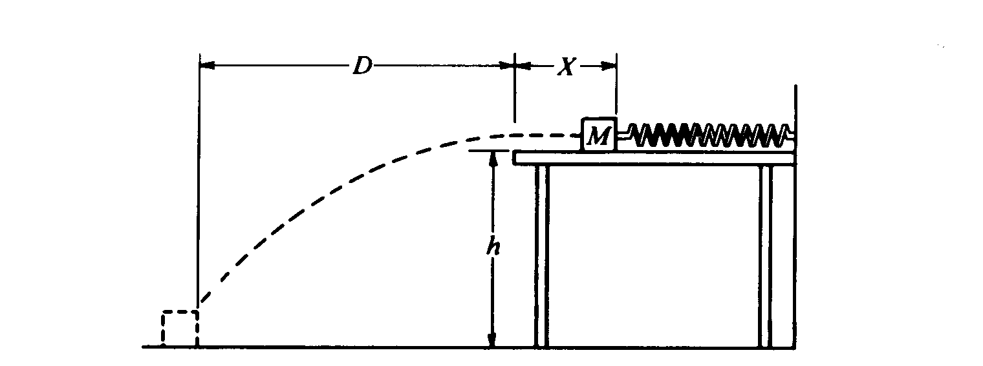
- One end of a spring is attached to a solid wall while the other end just reaches to the edge of a horizontal, frictionless tabletop, which is a distance h = 0.89 m above the floor. A 3.5 kg block is placed against the end of the spring and pushed toward the wall until the spring has been compressed a distance of 18 cm, as shown below. The block is released, follows the trajectory shown, and strikes the floor a horizontal distance of 1.2 m from the edge of the table. Air resistance is negligible.

Determine the following :
  - The time elapsed from the instant the block leaves the table to the instant it strikes the floor.
  - The horizontal component of the velocity of the block just before it hits the floor.
  - The work done on the block by the spring.
  - The spring constant.

