AP Physics – Them Laws – 5
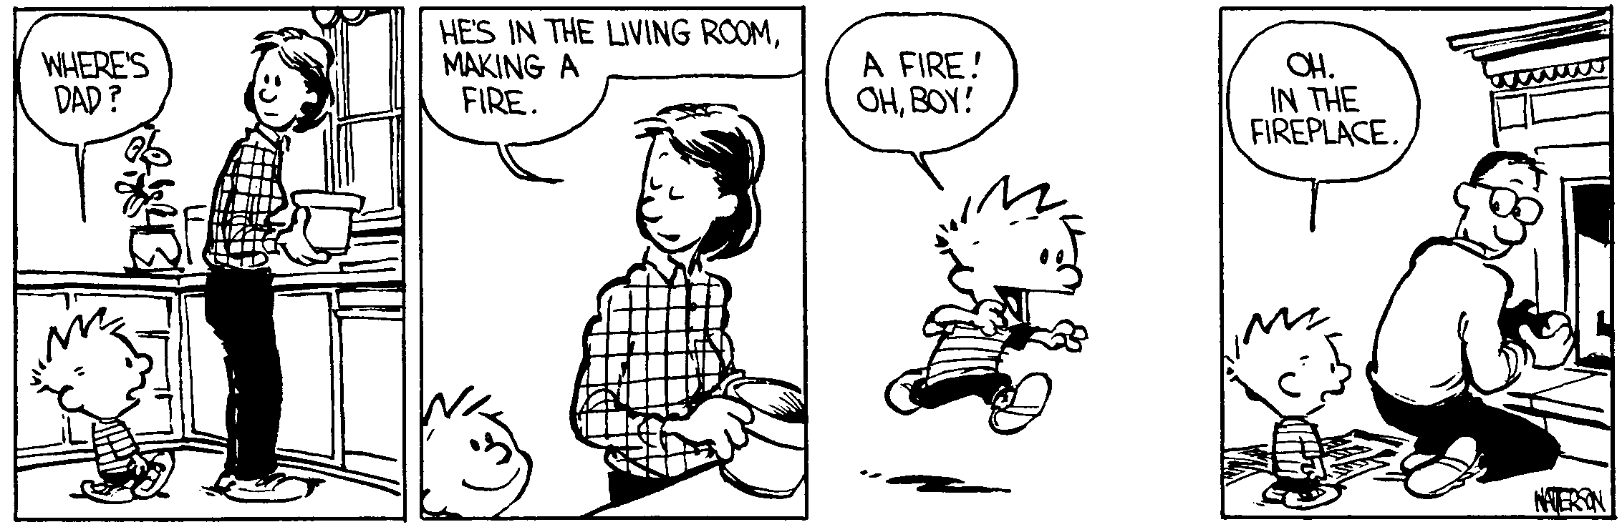
Who you is __________________________________________________________________Per___
In the end, we will remember not the words of our enemies, but the
silence of our friends. -- Martin Luther King, Jr.
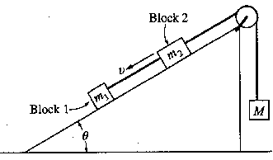1. Blocks 1 and 2 of masses m₁ and m₂, respectively, are connected by a light string, as shown above. These blocks are further connected to a block of mass M by another light string that passes over a pulley of negligible mass and friction. Blocks 1 and 2 move with a constant velocity v down the inclined plane, which makes an angle e with the horizontal. The kinetic frictional force on block 1 is f and that on block 2 is 2f. (year 2000 AP Exam Quest)

(a) On the figure below, draw and label all the forces on block m₁.
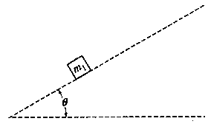

Express your answers to each of the following in terms of m₁, m₂, g, θ, and f

- Determine the coefficient of kinetic friction between the inclined plane and block 1.

- Determine the value of the suspended mass M that allows blocks 1 and 2 to move with constant velocity down the plane.

- The string between blocks 1 and 2 is now cut. Determine the acceleration of block 1 while it is on the inclined plane.

- Two 10.0 kg masses are hanging from the ceiling of an elevator that is accelerating upward at 2.00 m/s². What is the tension in each rope?

- A 250.0 kg crate is being pulled across the floor with a rope that makes an angle of 22.0° to the horizontal. If the force applied is equal to 875 N, what is the coefficient of kinetic friction?

- In the ramp system shown, a 7.00 kg mass is attached to a 6.50 kg mass by a light string that is threaded through a low friction pulley. The 7.00 kg mass accelerates up the ramp when the 6.50 kg mass is released. (a) Draw a FBD for each object and (b) find the acceleration of the system if the coefficient of kinetic friction between the 7.00 kg mass and the plane is 0.280.

