AP Physics – Oh my the Homework - 5

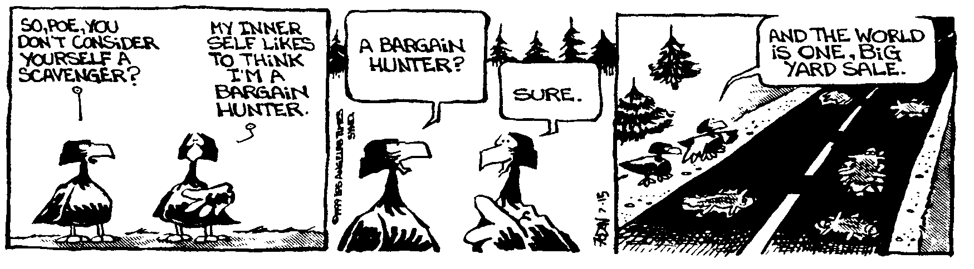
Human nomenclature__________________________________________________________ Per __
These several facts prove nothing, for one cannot deduce a principle from so few examples, but they do at least indicate that the ability to learn to spell correctly is a gift; that it is born in a person, and that it is a sign of intellectual inferiority. By parity of reasoning, its absence is a sign of great mental power. -- Mark Twain,
- An athlete covers a distance of 1250.0 m in 5 min and 35.2 sec. What was the athlete's average velocity?

- Your odometer reads 23 552.6 mi when you begin a trip at 0817.0 hours. If your average speed is 58.4 mi/hour and you travel until 1522.8 hours, what does the odometer now read?

- It takes you 12.2 seconds to accelerate from rest to a speed of 125 km/h. (a) What distance do you travel in this time? (b) What is your average speed for this time interval?

- You walk east for 12 km and then travel south for 15 km. What is your final displacement?

- You travel down the highway, starting from rest. You travel for 2.0 h at a speed of 70 mi/h. Then you stop and eat your lunch for 45.0 min. Then you travel for 30 min at 70 mi/h. Then you discover that your meeting is an hour earlier than you thought, so you speed up to 85 miles an hour and travel for 1.0 hour. Make a distance vs time graph of this motion.

- A cart travels along a straight section of road. A velocity vs time graph illustrating its motion is graphed to the right.

- Indicate every time t for which the cart is at rest.

- Indicate every time interval for which the speed (magnitude of velocity) of the cart is increasing.

- What is the acceleration from a – b?

- What is the acceleration from b – c?

- What is the acceleration from d – e?

- What is the acceleration from e – g?

- You are on top of a building that is 55.0 m tall. You toss a ball straight up. It travels 35.0 m up before it stops and begins to fall back down. (a) What was the ball’s initial velocity? It goes up and then falls down to the ground below. (b) How much time is it in the air?

- A ball rolls down a ramp and travels a distance of 3.00 m in 2.05 seconds. Find (a) what is the ball’s acceleration? (b) what is the ball’s final speed at the bottom of the ramp? And (c) what is the ball’s average speed going down the ramp?

