AP Physics – Electric Fields – 5

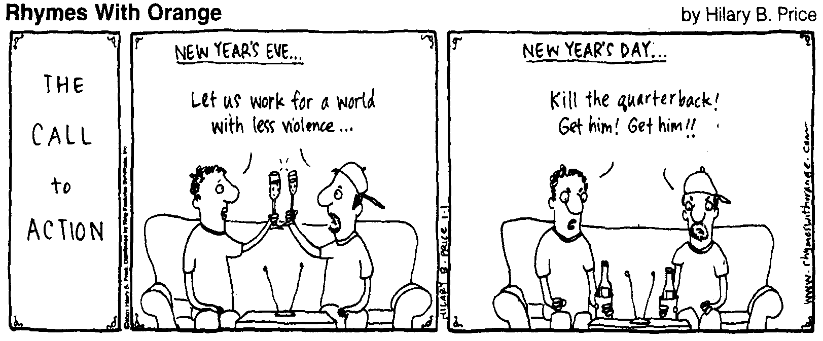
Who be thee?_________________________________________________________________Per__
If we discovered that we had only five minutes left to say all that we wanted to say, every telephone booth would be occupied by people calling other people to stammer that they loved them. -- Christopher Morley
- If a metal sphere is given a positive charge, does its mass change? What would happen? Why?

- A balloon is vigorously rubbed with a piece of fur so that it gains a charge. You place it against the wall and it sticks. Does the wall therefore have a positive charge? Explain your answer.

- A 125 kg 4.00 m plank sticks out from the wall. A cable is hooked to the end of it and ties into the wall above. It makes a 62.0° angle with the plank. A barrel of nails with a total weight of 545 N sits on the plank, 1.10 m from the outside end. Find the tension in the cable and the components of the force exerted by the wall on the plank.

- Find the force between charges of +100.0 μC and -75.0 μC. They are 13.5 cm apart.

- Three charges are arranged as shown. Find the force acting on the center charge.

- How does an electrophorus work?

- A charge of 15.5 μC is placed 12.8 cm from a second charge. If the force between the charges is 22.5 N, what is the magnitude of the second charge?

- Three charges are arranged as shown. (a) find the electric potential at P. (b) how much work would it take to bring in a charge of 1.25 μC from infinity to point P?

- A proton is accelerated from rest through a potential difference of 9.0 V. Find (a) the energy of the particle, and (b) the speed of the particle.

