AP Physics – Modern Stuff - 5

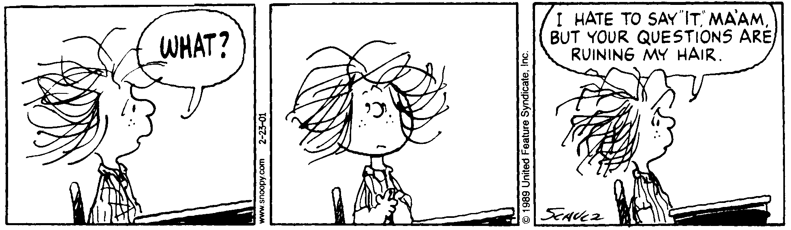
Hoodoo_____________________________________________________________________Per__
Every novel idea in science passes through three stages.
First people say it isn't true.
Then they say it's true, but not important.
And finally they say it's true and important, but not new. -- Anonymous
- An atom absorbs light of wavelength 415 nm. Two of the spectral lines given off have wavelengths of 415 nm and 525 nm. (a) Determine the energy levels involved and draw them onto the energy diagram. (b) The ground state for the atom is –7.20 eV. What other wavelengths of light could be given off?

- Zinc is irradiated by 215 nm light. What is the maximum kinetic energy of the emitted electrons?

- In a certain metal, the stopping potential is found to be 4.00 V. When 235 nm light is incident on the metal, electrons are emitted. (a) What is the maximum kinetic energy given to the electrons in eV and J? (b) What is the work function of the metal?

- The work function for cesium is 1.96 eV. (a) Find the cutoff wavelength for the metal, (b) what is the maximum kinetic energy for the emitted electrons when 425 nm light is incident on the metal?

- A 2.50 g sample of U-235 undergoes fission. For each decaying nucleus, 208 MeV is released. How many joules of energy in total would be released?

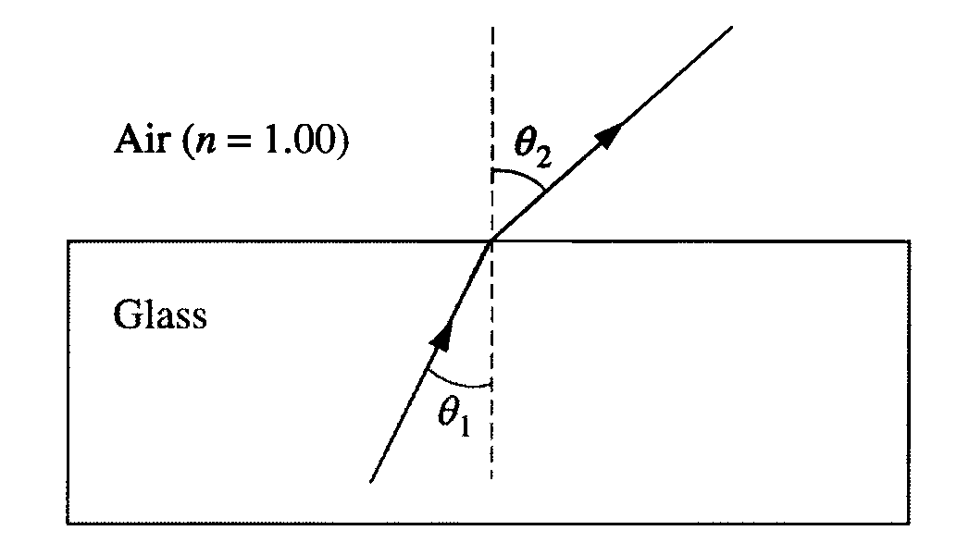
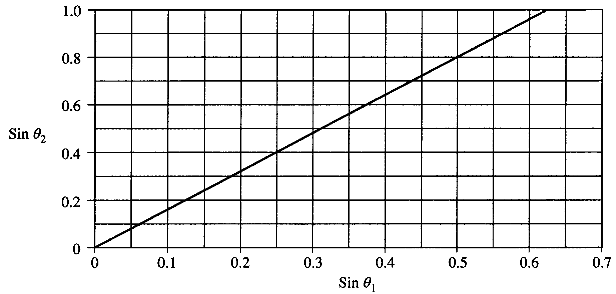
- In an experiment a beam of red light of wavelength 675 nm in air passes from glass into air, as shown above. The incident and refracted angles are θ ₁ and θ ₂, respectively. In the experiment, angle θ ₂ is measured for various angles of incidence θ ₁, and the sines of the angles are used to obtain the line shown in the following graph. (a) Assuming an index of refraction of 1.00 for air, use the graph to determine a value for the index of refraction of the glass for the red light. Explain how you obtained this value. For this red light, determine the following. (b) The frequency in air, (c) The speed in glass, (d) The wavelength in glass.

The index of refraction of this glass is 1.66 for violet light, which has wavelength 425 nm in air. (e) Given the same incident angle θ ₁, show on the ray diagram above how the refracted ray for the violet light would vary from the refracted ray already drawn for the red light. (f) Sketch the graph of sin θ ₂ versus sin θ ₁ for the violet light on the figure on the previous page that shows the same graph already drawn for the red light.
(g) Determine the critical angle of incidence θ _{C}, for the violet light in the glass in order for total internal reflection to occur.

- Coherent monochromatic light of wavelength  in air is incident on two narrow slits, the centers of which are 2.00 mm apart. The interference pattern observed on a screen 5.00 m away is represented by the drawing below.
(a) What property of light does this interference experiment demonstrate?

(b) At point P in the diagram, there is a minimum in the interference pattern. Determine the path difference between the light arriving at this point from the two slits.

(c) Determine the wavelength, λ, of the light.

(d) Briefly and qualitatively describe how the interference pattern would change under each of the following separate modifications and explain your reasoning.
i. The experiment is performed in water, which has an index of refraction greater than 1.

ii. One of the slits is covered.

iii. The slits are moved farther apart.

