AP Physics – Kinematic Wrap Up

So what do you need to know about this motion in two-dimension stuff to get a good score on the old AP Physics Test?

First off, here are the equations that you’ll have to work with:

Note: this is the same as:

That’s it. That’s all you get.

Here’s the stuff that you have to be able to do or talk about:

- You should know how to deal with displacement and velocity vectors so you can:

- Relate velocity, displacement, and time for motion with constant velocity.

Okay, this is easy stuff. We did us a bunch of problems and stuff on this. Basically you use the equation. Note that you don’t seem to have it in the list above. But you do! It’s the one. See, the acceleration is zero because you have a constant velocity, so all the terms with acceleration in them cancel out. becomes if the initial displacement is zero, then we get okay?

- Calculate the component of a vector along a specified axis, or resolve a vector into components along two specified mutually perpendicular axes.

We did a bunch of this. We learned how to use the sine and cosine function to resolve a vector into its components.

- Add vectors in order to find the net displacement of a particle that undergoes successive straight-line displacements.

This is another skill that you have worked hard to develop. Resolve the vectors into components, add up the x and y components and then solve for the resultant vector. You probably got sick of doing problems like this. Usually, in the test, this will be part of a question that is really dealing with something else. For example, you might have to find two electric force vectors and then add them up to find the resultant.

- Subtract displacement vectors in order to find the location of one particle relative to another, or calculate the average velocity of a particle.

This sounds horribly difficult, but it’s just a simple business with adding vectors.

- You should understand the motion of projectiles so you can:

- Write down expressions for the horizontal and vertical components of velocity and position as functions of time, and sketch or identify graphs of these components.

No doubt you came to love doing the projectile motion problems. The Physics Kahuna was proud to show you how to do them. We did bunches of stuff on this.

- Use these expressions in analyzing the motion of a projectile that is projected above level ground with a specified initial velocity.

This is a standard projectile motion problem. You learned how to do them in your sleep. Or maybe it just seemed like that. No doubt, having worked so hard to master them, you dreamed of projectile problems.

There aren’t many free response questions that are just about projectile motion or velocity or acceleration. These concepts are tested, but the questions are usually nested away in a question on something else. Typical kind of thing would be a question about conservation of momentum or the energy in a spring where you figure out how fast something is moving after a collision or after it’s been launched by a compressed spring. The thing is on a smooth table that is a certain distance above the deck and you will be asked how far it will land from the edge of the table when it slides off the table top. That sort of deal.

Here’s an example. This is the first question from the 1998 AP Physics test:

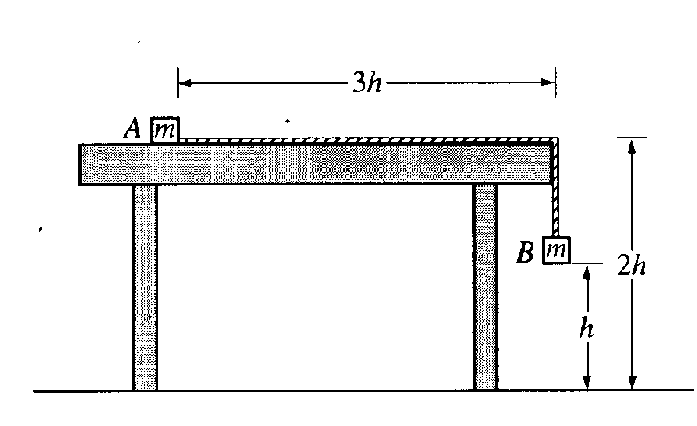
- Two small blocks, each of mass m, are connected by a string of constant length 4h and negligible mass. Block A is placed on a smooth tabletop as shown below, and block B hangs over the edge of the table. The tabletop is a distance 2h above the floor. Block B is then released from rest at a distance h above the floor at time t = 0.
  - Determine the acceleration of block B as it descends.

  - Block B strikes the floor and does not bounce. Determine the time t₁ at which block B strikes the floor.
  - Describe the motion of block A from time t =0 to the time when block B strikes the floor.

  - Describe the motion of block A from the time block B strikes the floor to the time block A leaves the table.

  - Determine the distance between the landing points of the two blocks.

The main thrust of the question is to look at Newton’s laws (which we will soon get into). You use Newton’s laws and forces to figure out the acceleration in part a.

Part b does deal with the stuff you’ve learned. You use to figure out the time.
Part c is another application of Newton’s laws. Have to wait a bit for this one.

Part d is yet another Newton’s law deal. We’ll learn to do this later.

Part e you can do, block B falls straight down, block A slides off the table with some horizontal velocity. When it slides off the table it is a projectile and you can easily figure out the horizontal distance.

Here’s how we do part b:

In part a the acceleration was found to be (you’ll learn how to solve this part soon enough):

Using this acceleration, we can easily find the time the block takes to fall:

Now let’s take a shot at part e:

- Determine the distance between the landing points of the two blocks.

We know the acceleration of the system, we know that block A gets accelerated a distance of 3 h, so we can find its speed when it reaches the end of the table:

We know that the block will fall a distance of 2 h, so we can figure out how long it will take for it to fall to the deck.

The 1994 AP test has a free response two dimensional motion problem. We basically did it in a quiz.

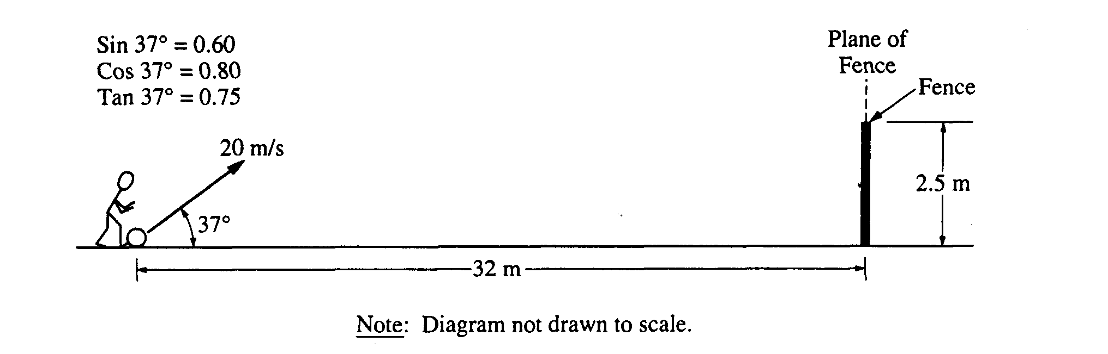
- A ball of mass 0.5 kilogram, initially at rest, is kicked directly toward a fence from a point 32 meters away, as shown below. The velocity of the ball as it leaves the kicker's foot is 20 meters per second at an angle of 37° above the horizontal. The top of the fence is 2.5 meters high. The kicker's foot is in contact with the ball for 0.05 second. The ball hits nothing while in flight and air resistance is negligible.
  - Determine the magnitude of the average net force exerted on the ball during the kick.
This is stuff you don’t know how to do yet (but you will).
  - Determine the time it takes for the ball to reach the plane of the fence.

This part we can do. We know that the horizontal velocity is constant.

  - Will the ball hit the fence? If so, how far below the top of the fence will it hit? If not, how far above the top of the fence will it pass?

To determine if the ball will hit the fence, we need to find its vertical position after 2.0 seconds have elapsed, this is the time it takes to reach the plane of the fence from part b above:

Since the ball has a height of 4.4 m and the fence is 2.5 m tall, clearly the ball will pass over the fence.

The height of the ball over the fence is simply the height of the ball minus the height of the fence:

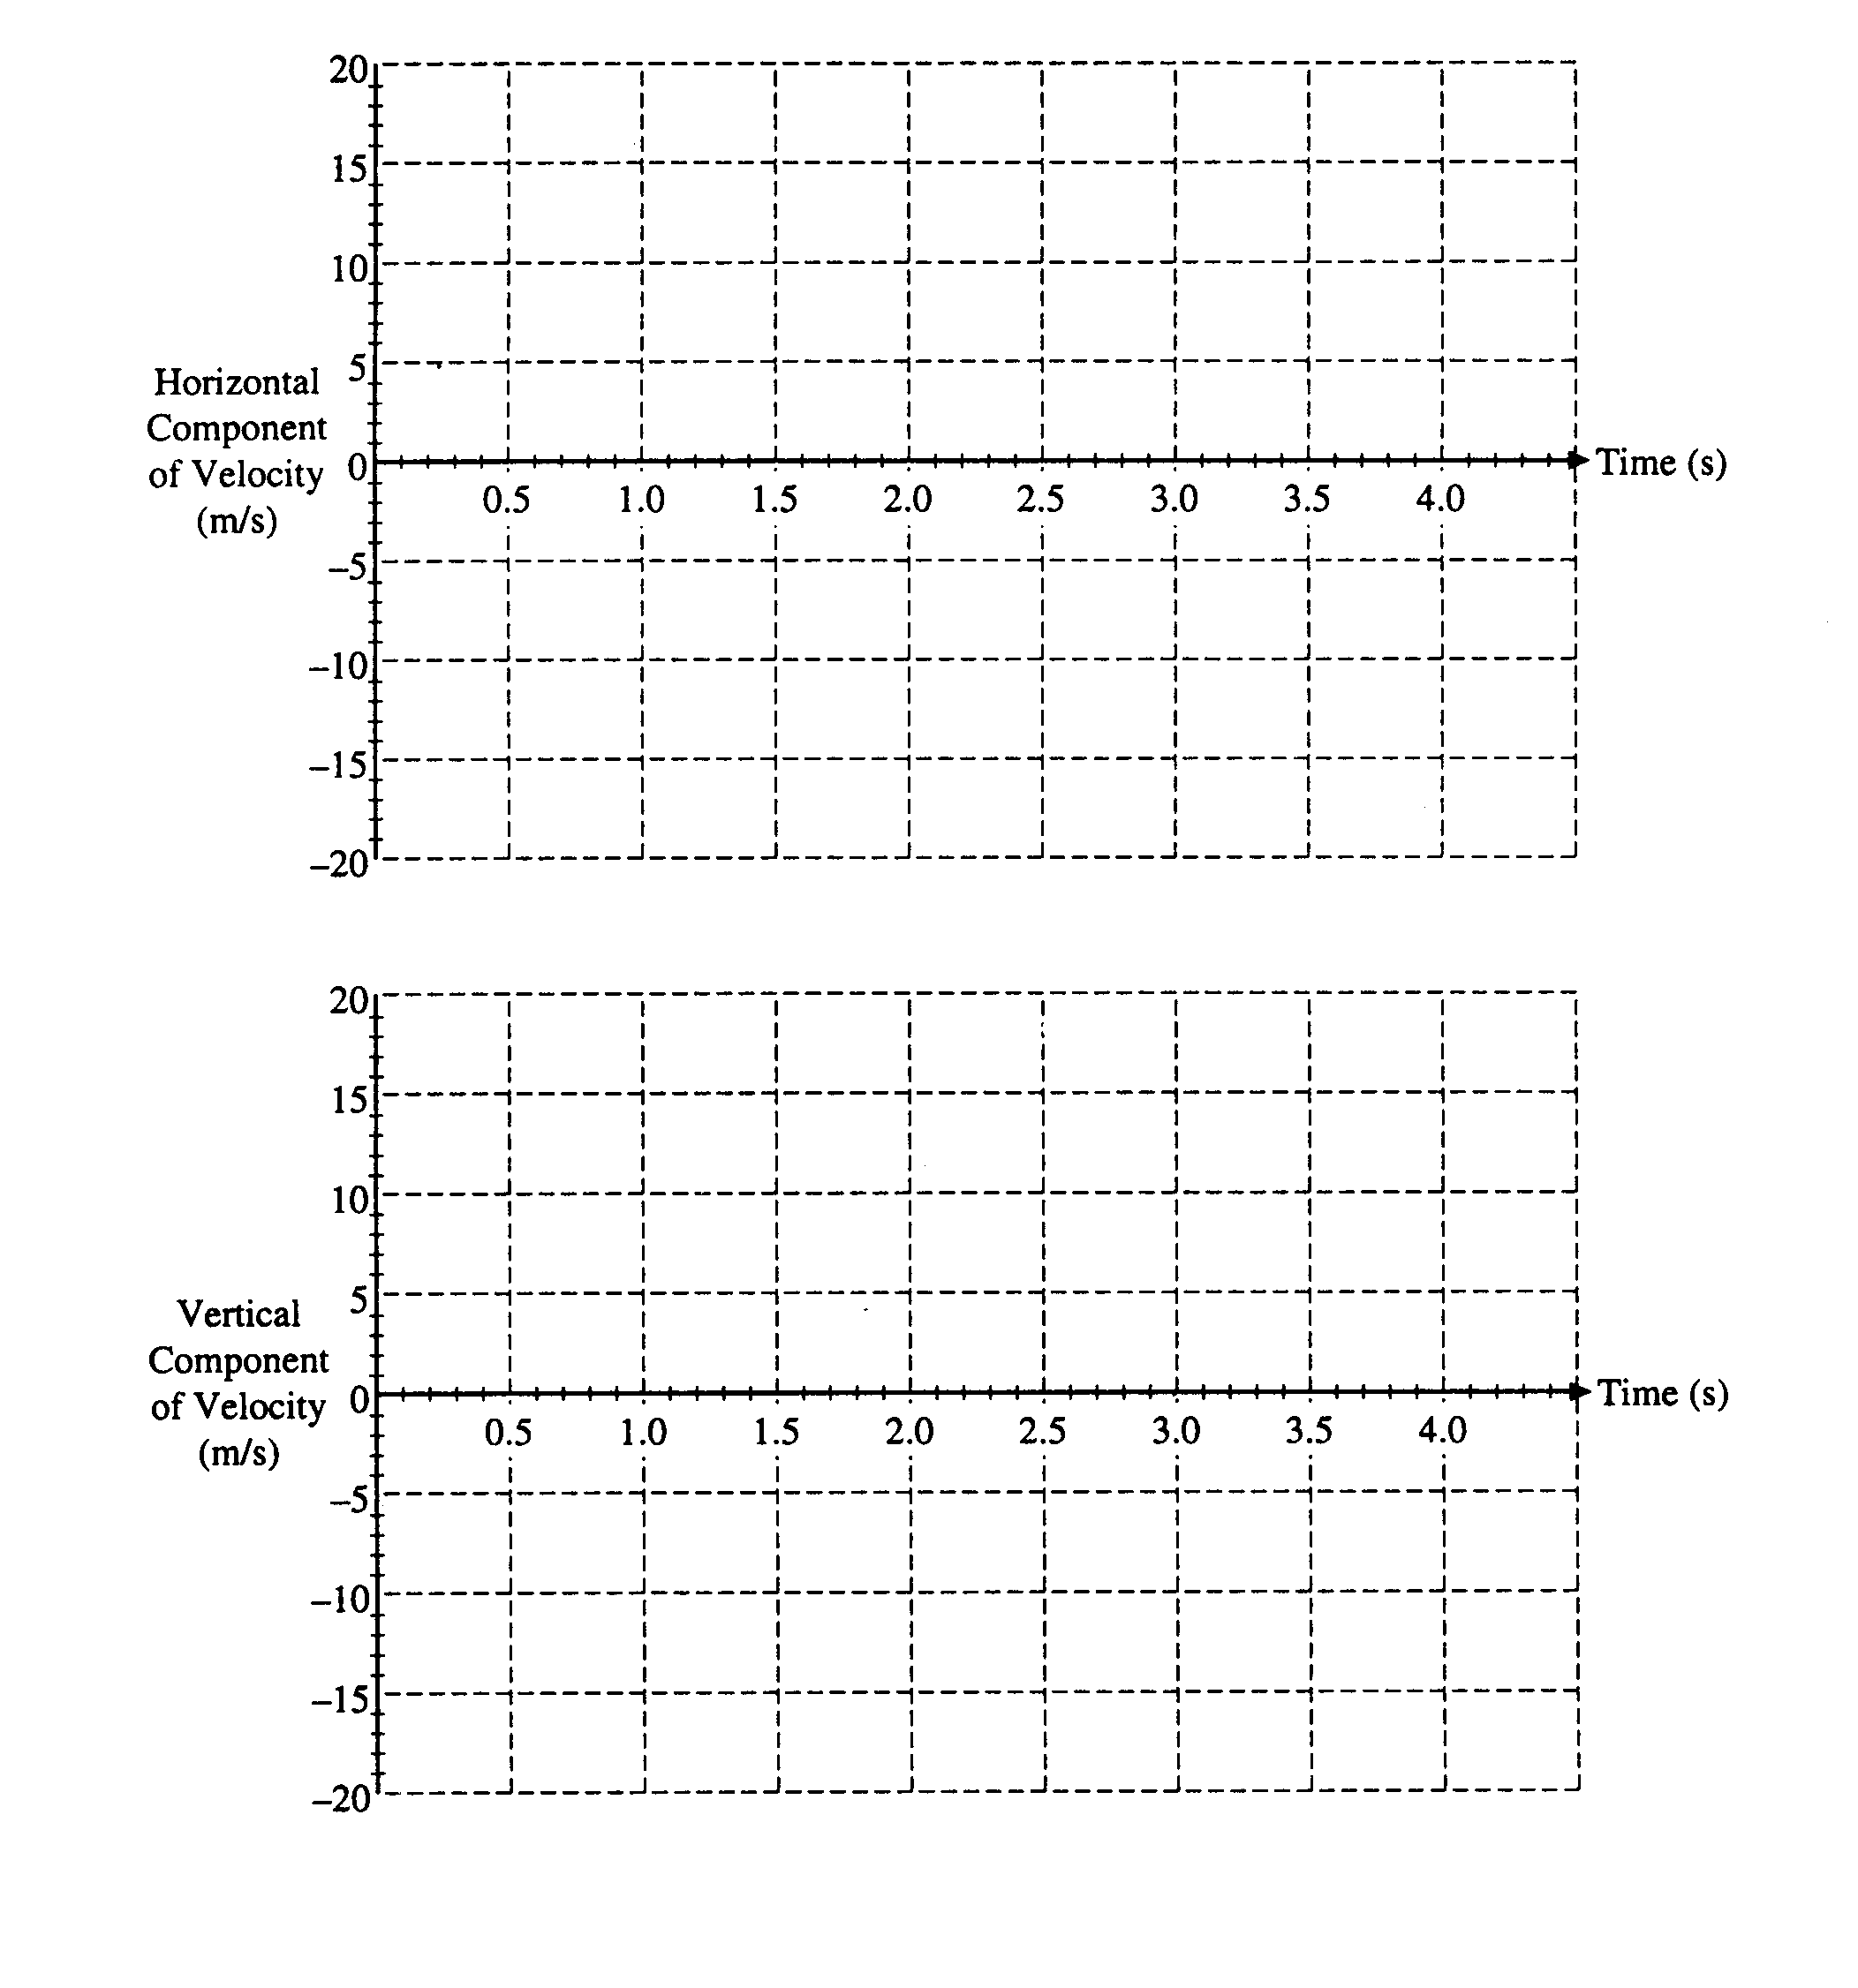
d. On the axes below, sketch the horizontal and vertical components of the velocity of the ball as functions of time until the ball reaches the plane of the fence.
The idea here is that the horizontal velocity is constant, but that the vertical velocity is changing. The lower graph shows this, the velocity is a straight line. The point where it crosses the x axis and becomes negative is, of course, the highest point on its path where its velocity is zero.

