Applying the Marketing Mix (The 4 P’s)
Situation:

You will team up in groups of four to create a sales pitch for a newly invented product/service. You are a team of entrepreneurs, and you have decided to join forces to open up a quick service restaurant in Parker. As savvy business people, you have recognized the opportunities for how you can meet your target market’s needs by carefully considering the Marketing Mix (4 P’s).

Your choices for your location will be on the corner _____ and _____, ______ and _____, or _____ and _____. (Or of you think of a different/better place, go for it). Each lot is 200 ft. by 200ft.

Assignment:
First, divide up responsibilities amongst your team members and write them down on your Marketing Mix Planning Sheet. Then, start developing your business plan and presentation. You will need to use the Four Ps of marketing in your presentation (sales pitch). The audience you make the sales presentation to will be a group of venture capitalists interested in choosing the best new restaurant to invest in. Convince them that your restaurant will bring in the business!

During your presentation your team will:
1) Describe the product/service, including any special features
2). Develop a unique theme for the restaurant; make it different from your competition.
3). Create a layout for your restaurant. Include inside and outside (don’t forget storefront/signage)
4). Describe the target market for the chosen product/service, and explain why your product/service would be beneficial to the target market
5) Create a logo and tagline for the product
6) Explain how your marketing strategies address each of the 4P’s: Product, Price, Promotion, and Place
7) Create a professional presentation, complete with visual aides, to present your information. You may choose to do a PowerPoint, display board, or another professional presentation method of your choice.

This is a TEAM effort and it will require each member to complete a specific part of the project. Each team member will get ‘team points” for the overall project and presentation, as well as ‘individual points’ for their specific assignments. If you are absent more than 1 work day, you will be responsible for completing the entire assignment on your own.

You will have approximately 3 days in class to work on this project, so use your time wisely to avoid homework. You will be expected to produce a professional presentation. Make sure that all aspects of your presentation are well coordinated and appeal to your target market. Your presentation will be no better than the weakest of the four areas. In other words, it is to your advantage to make sure that every part of the presentation is well thought out and professionally done.

Name: ____________________________________ Period: ___________

Marketing Mix Planning Sheet

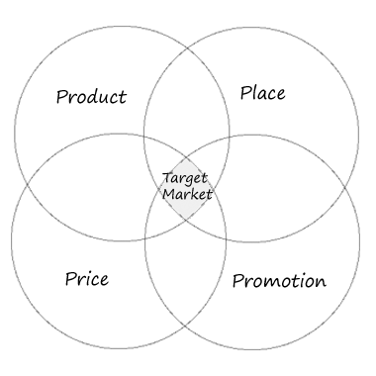
Each of the following should be the minimum included in your presentation, but most students will incorporate more. Remember that being creative and making a presentation that flows well will help sell your idea to your audience.

Product/Service
Explanation about product/service
Benefits of this product
Explanation of how the product differs from the competition

Place
Established best possible place to market the product/service
Location relative to competition

Price
Cost of product/service
Price determined allowing for profit

Promotion
Creative ways of promoting product/service
Variety of ways to reach target market
General campaign ideas and budget
Name: ____________________________________ Period: ___________

Pitching a Product - Planning/Evaluation Sheet

Product/Service: ____________________________________ Class Period: _____

List your team members and their main contribution. Score each member out of 10 possible participation points:

Name: _________________ Responsibility _________________________ ___ pts.

Name: _________________ Contribution _________________________ ___ pts.

Name: _________________ Contribution _________________________ ___ pts.

Name: _________________ Contribution _________________________ ___ pts.

Rate the strength of your proposal in the following areas based out of points each:

Presentation Element | Teacher’s Notes | Possible Points | Self-Given Points | Teacher-Given Points
Target Market |  | 5
Logo & Tagline |  | 5
Product |  | 5
Price |  | 5
Place |  | 5
Promotion |  | 5
Oral Presentation Quality |  | 10
Team Evaluation Score |  | 5
Total |  | 45

