DNA, RNA, and Snorks
Introduction: In this simulation, you will examine the DNA sequence of a fictitious organism - the Snork. Snorks were discovered on the planet Dee Enae in a distant solar system. Snorks only have one chromosome with eight genes on it. Your job is to analyze the genes of its DNA and determine what traits the organism has and then sketch the organism (You can be creative here).
For simplicity, the gene sequences are much smaller than -real- gene sequences found in living organisms. Each gene has two versions that result in a different trait being expressed in the snork.
Genes | Amino Acid Sequence | Description
Gene 1 - body covering | val - ser - leu | hairless
 | val - ser - lys | hairy
Gene 2 - body style | tyr - pro - glu - glu - lys | plump
 | val - pro - thr - glu - lys | skinny
Gene 3 - legs | leu - leu - leu - pro | 3 legged
 | leu - leu - ser - ala | 2 legged
Gene 4 - head shape | ala - val - val | round head
 | val - ala - ala | square head
Gene 5 - tails | his - ile | tail
 | his - his | no tail
Gene 6 - body pigment | ser - pro - val | blue pigment (hair/skin)
 | val - phe - tyr | red pigment (hair/skin)
Gene 7 - eyes | asp - ile - leu - leu - pro - thre | small slanted eyes
 | asp - ile - pro - pro - pro - thre | large round eyes
Gene 8 - mouth | val - asp - asp - ala | circular mouth
 | asp - asp - asp - ala | rectangular mouth
Gene 9 - ears | phe - ser - gly | pointed standing-up ears
 | phe - phe - gly | rounded floppy ears
Gene 10 - arms | arg - tyr - cys - lys | long spaghetti like arms
 | arg - arg - asp - thre | short stumpy arms
Each of the following DNA samples was taken from volunteer snorks. The DNA was then transcribed to its complimentary RNA strand. Your job is to analyze the RNA sample and determine the phenotype (how the organism looks) based on the sequence. Remember that AUG is a start codon, and it signifies the beginning of each gene. UAA is a stop codon and signifies the end of a gene. The genes are in order from gene 1 to gene 9. Your teacher may assign you one or all of the samples to analyze. Use the codon chart in your text or print one from the web: codon chart

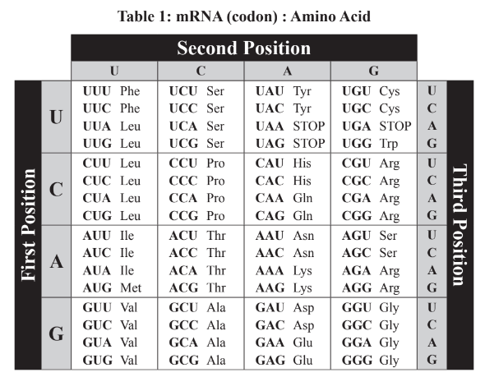

Snicker Snork
AUG | GUC AGC AAA | UAC CCC GAA GAG AAA | CUC UUA AGU GCG | GCU GUU GUG | CAU CAU | GUU UUU UAC |
| GAU AUC UUA CUG CCC ACC | GAC GAC GAU GCC | UUU UCU GGG | AGA UAU UGU | UAA

Snuffle Snork
AUG | GUA UCU AAA | GUU CCU ACU GAA AAG | CUU CUC CUC CCC | GUU GCG GCU | CAU CAC |
| GUA UUU UAU | GUA AUU CUU CUG CCC ACA | GUU GAC GAC GCA | UUC UCG GGU | AGA UAU UGU | UAA

Snapple Snork
AUG | GUC AGC CUU | GUU CCC ACA GAA AAA | CUC UUA AGU GCG | GUU GCG GCU | CAC AUU |
| UCU CCC GUA | GAU AUU CCC CCC CCC ACC | GAU GAC GAC GCA | UUC UUU GGG | CGC CGG GAC | UAA

Snoopy Snork
AUG | GUA UCC CUC | UAC CCC GAG GAA AAA | UUA UUA CUG CCC | GCU GUU GUA | CAU AUU |
| UCU CCC GUA | GAU AUU CUU CUG CCC ACA | GUU GAU GAU GCC | UUU UCU GGU | CGC CGU GAC | UAA
The Snorks!
Snork:
Gene | Amino acid sequence | Snork Characteristic
1
2
3
4
5
6
7
8
9
10

Snork Sketch:

