AP Physics – Waves Wrapup

There are four equations that you get to play with. You must recognize them, right? Here they are:

This baby relates wavelength and frequency to the velocity of the wave. Very important equation, not only now, but later on as well.

This one relates the period of a wave to the frequency – you can flip it (do a bit of cross multiplying) as well and get frequency equal to the inverse of the period.

This third one finds the period for an oscillating mass on a spring. The period is directly proportional to the mass and inversely proportional to the spring constant. Increase the mass, increase the period. Increase the spring constant value, decrease the period.

This fourth one is the period for a pendulum. The period is a function of the length of the thing. Increase the length and you increase the period. So the period is directly proportional to the length of the pendulum.

Here are the things that you are required to be able to do – turns out that there is a lot of stuff in this unit.

Oscillations

- You should understand the kinematics of simple harmonic motion so you can:

- Sketch or identify a graph of displacement as a function of time, and determine from such a graph the amplitude, period, and frequency of the motion.

This is not too difficult. We’ve done several of these type things in the previous units.

- Identify points in the motion where the velocity is zero or achieves its maximum positive or negative value.

This is also a fairly simple task. Just examine the graph or drawing and pick off the required values.

- State qualitatively the relation between acceleration and displacement.

The relationship is simple. The maximum acceleration occurs at the points of maximum displacement. The acceleration is least when the displacement is zero. The maximum acceleration coincides with the maximum restoring force.

- Identify points in the motion where the acceleration is zero or achieves its greatest positive or negative value.

This is pretty much the same stuff as the thing above. Again, the maximum acceleration occurs at the points of maximum displacement. The acceleration is least when the displacement is zero.

- State and apply the relation between frequency and period.

The relationship between frequency and period is given by: The nice thing is that the equation will be provided you. You can see that as the frequency gets larger, the period gets smaller and vice versa.

- State how the total energy of an oscillating system depends on the amplitude of the motion, sketch or identify a graph of kinetic or potential energy as a function of time, and identify points in the motion where this energy is all potential or all kinetic.

The total energy of the system is set by the amplitude. This determines the potential energy the system has. When the mass is released, the potential energy is converted to kinetic energy. At zero displacement all the energy is kinetic. When the mass is at the maximum displacement (the amplitude) all the energy is kinetic. Between the amplitude and zero displacement the energy will be a combination of kinetic and potential energy.

A graph of kinetic energy, potential energy, and displacement Vs time looks like this:

Picking off the points where the energies are zero should be pie for a superior student such as yourself.

- Calculate the kinetic and potential energies of an oscillating system as functions of time, sketch or identify graphs of these functions, and prove that the sum of kinetic energy and potential energy is constant.

You can use the equations for the potential energy of a spring and kinetic energy to work things out.

The potential energy of the spring is given by:

When the displacement is equal to the amplitude, we get the maximum potential energy, which will be the total energy of the system.

You can bring in the time element by using the equation for the period of the system.

The reason that the sum of the potential energy and kinetic energy are constants – come on, does the Physics Kahuna have to give you this one? No? Yes? Right, its because of the law of conservation of energy.

- You should be able to apply their knowledge of simple harmonic motion to the case of a mass on a spring, so you can:

- Apply the expression for the period of the oscillation of a mass on a spring.

Use the equation for the thing please.

- You should be able to apply their knowledge of simple harmonic motion to the case of a mass of a pendulum, so you can:

- Apply the expression for the period of a simple pendulum.

Use the equation.

- State what approximation must be made in deriving the period.

The approximation thing? Oh yeah, it’s that the equation is only good for small swings.

1. You should understand the description of waves so you can:

- Sketch or identify graphs that represent traveling waves and determine the amplitude, wavelength, and frequency of a wave from such a graph.

This is pie. You look at the graph and figure out what they want to know. Most graphs will have time plotted on the x axis and the displacement on the y axis. In the example above pressure is plotted on the y axis. The amplitude A is the maximum positive or negative displacement from the zero displacement centerline value. This is where the pressure is zero on the graph drawn above. You just read off the value. To fine the frequency you have to measure the period T of the wave off the graph. The period is the time for one cycle. To find the wavelength you need to know the velocity of the wave. You can then use the equation to find frequency.

Sometimes a graph is made that plots the displacement of the disturbance on the y axis and distance on the x axis. This might be useful for water waves, things like that. Anyway the graph would look like this.

You can read the amplitude and the wavelength directly off the graph. You still need to know the velocity of the wave to find the frequency.

- State and apply the relation among wavelength, frequency, and velocity for a wave.

You just be using the equation .

- Sketch or identify graphs that describe reflection of a wave from the fixed or free end of a string.

This is pie. Just remember, fixed end reflection – out of phase. Free end reflection – in phase. Lovely drawings are available in the handout on waves.

- Know quantitatively what factors determine the speed of waves on a string and the speed of sound.

Factors for speed of wave on string – tension. Increase tension, increase wave speed.

Factors for speed of wave in air – temperature (and, to a lessor extent, pressure and density). Increase temperature increase speed of sound.

2. You should understand the physics of standing waves so you can:

- Sketch possible standing wave modes for a stretched string that is fixed at both ends, and determine the amplitude, wavelength, and frequency of such standing waves.

This is where you draw half a wave, a wave and a half, and so forth. This is pie. Excellent, clear drawings for what they look like are available in the useful handout.

- Describe possible standing sound waves in a pipe that has either open or closed ends, and determine the wavelength and frequency of such standing waves.

Drawing the waves in a pipe is pie. You can easily do that. The equations for wavelength and frequency are not provided you, however, so you have to be able to develop them yourself. The Physics Kahuna was kind of enough to show you how to do this.

The main thing here is that the wavelength is four times the length of the pipe for a close-ended pipe and two times the length of an open-ended pipe.

Open-ended pipes can resonate at all harmonics. Close-ended pipes can only resonate at the odd harmonics.

3. You should understand the Doppler effect for sound so you can:

- Explain the mechanism that gives rise to a frequency shift in both the moving-source and moving-observer case, and derive an expression for the frequency heard by the observer.

It’s fairly simple to explain how the Doppler shift occurs (see the previous section on sound). The nasty part is that they expect you to derive the Doppler shift equations yourself. The Physics Kahuna has kindly shown you how to do it. Seriously now, the Physics Kahuna has never seen a question on the old AP tests that actually required you to derive the Doppler shift equations. The Physics Kahuna suggests that you have a good conceptual understanding of the Doppler shift and how it relates to frequency and wavelength.

- Write and apply the equations that describe the moving-source and moving-observer Doppler effect, and sketch or identify graphs that describe the effect.

This is where you use the equations that you painfully derived. Using them is actually pretty simple. The Physics Kahuna, out of the goodness of his heart, provided you numerous example problems to do so you could have lots of practice. “Thanks” – not necessary. Part of the service.

- You should understand the principle of superposition so they can apply it to traveling waves moving in opposite directions, and describe how a standing wave may be formed by superposition.

This is pretty simple, the idea is that the waves at a particular point add algebraically to produce a resultant wave. We went over several examples of this in a previous unit.

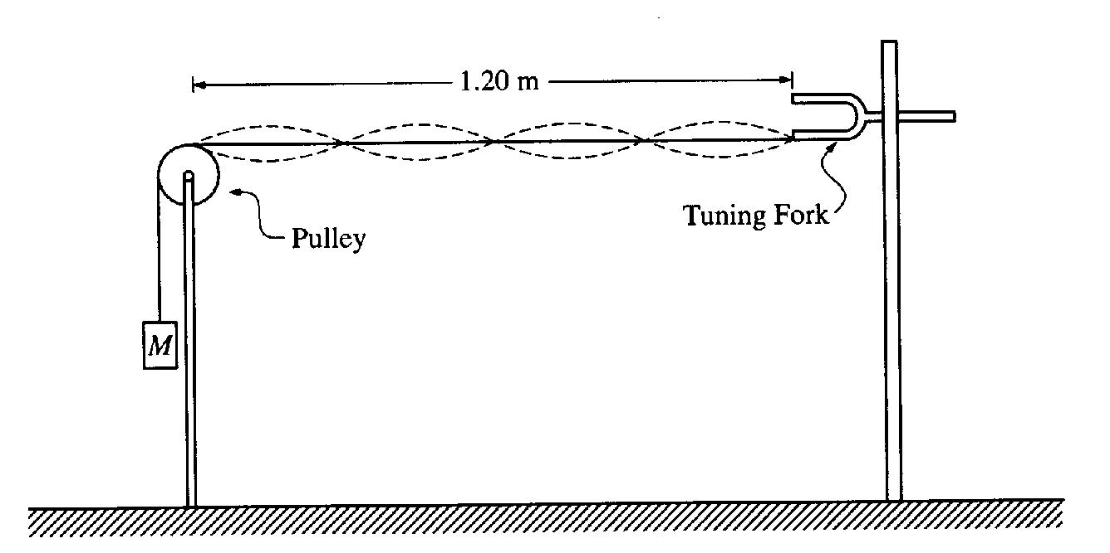
AP Question Time:

From 1998:
- To demonstrate standing waves, one end of a string is attached to a tuning fork with frequency 120 Hz. The other end of the string passes over a pulley and is connected to a suspended mass M as shown in the figure below. The value of M is such that the standing wave pattern has four loops. The length of the string from the tuning fork to the point where the string touches the top of the pulley is 1.20 m. The linear density of the string is 1.0x10⁻⁴ kg/m, and remains constant throughout the experiment.
  - Determine the length of the standing wave.
There are 2 waves in the 1.20 m.
  - Determine the speed of transverse waves along the string.
  - The speed of waves along the string increases with increasing tension in the string. Indicate whether the value of M should be increased or decreased in order to double the number of loops in the standing wave pattern. Justify you answer.

To double the number of loops the wavelength must be decreased by a factor of 2.
If wavelength is halved then speed is halved. ()
So tension must be decreased to decrease speed.

Thus the mass must be decreased. Mass is proportional to velocity as stated in the question.

  - If a point on the string at an antinode moves a total vertical distance of 4 cm during one complete cycle, what is the amplitude of the standing wave?

Amplitude is the maximum displacement from equilibrium, one way. So it is one quarter the total vertical motion, during one up down cycle. The string goes up one centimeter from its centered position. It then goes down a centimeter to the center position, so it has traveled two centimeters. Then it goes down one centimeter to the lowest position (a trough thing), so it’s moved three centimeters. Then it moves back to the center position – that’s one more centimeter for a total displacement of 4 cm. So the amplitude is 1 cm.

From 1995:

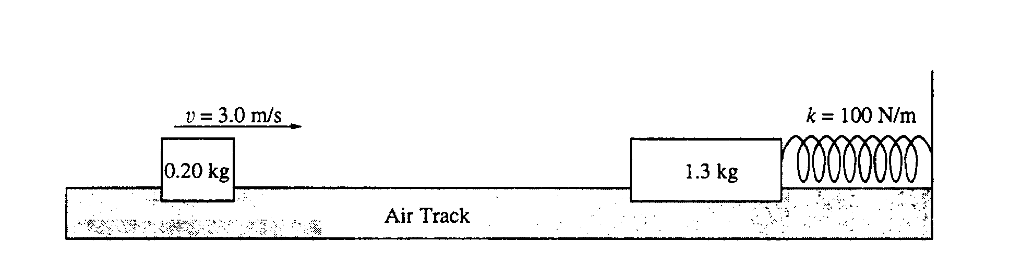
- As shown, a 0.20-kilogram mass is sliding on a horizontal, frictionless air track with a speed of 3.0 meters per second when it instantaneously hits and sticks to a 1.3-kilogram mass initially at rest on the track. The 1.3-kilogram mass is connected to one end of a massless spring, which has a spring constant of 100 Newtons per meter. The other end of the spring is fixed.
- Determine the following for the 0.20-kilogram mass immediately before the impact.
    - Its linear momentum.
    - Its kinetic energy.

  - Determine the following for the combined masses immediately after the impact.
    - The linear momentum
so
    - The kinetic energy

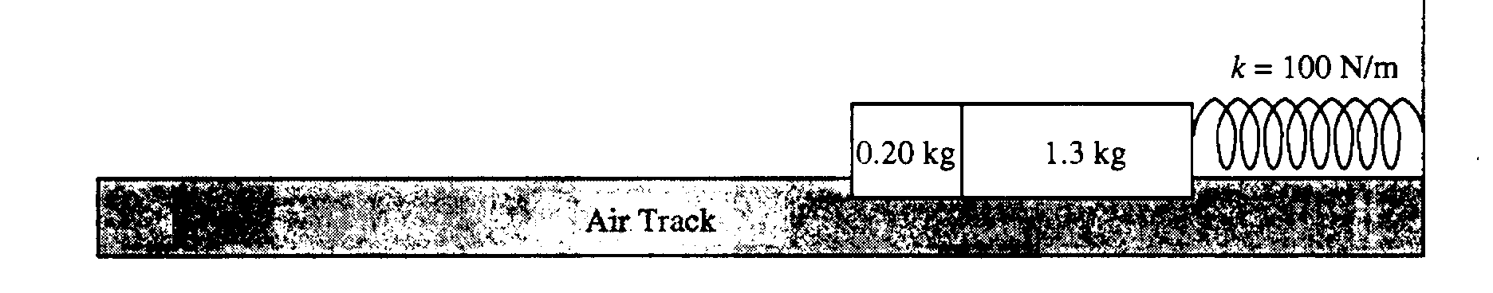
After the collision, the two masses undergo simple harmonic motion about their position at impact.

  - Determine the amplitude of the harmonic motion.

  - Determine the period of the harmonic motion.


From 1995:
- A hollow tube of length open at both ends as shown above, is held in midair. A tuning fork with a frequency f _{o} vibrates at one end of the tube and causes the air in the tube to vibrate at its fundamental frequency. Express your answers in terms of  (length) and f_{o.}

  - Determine the wavelength of the sound.
In an open tube multiples of half wavelengths cause resonance. Resonance occurs for the first time with a half wavelength in the tube, so
  - Determine the speed of sound in the air inside the tube.
  - Determine the next higher frequency at which this air column would resonate.

At the next higher frequency 2 half wavelengths fit so
The tube is submerged in a large, graduated cylinder filled with water. The tube is slowly raised out of the water and the same tuning fork, vibrating with frequency f_{O}, is held a fixed distance from the top of the tube.

  - Determine the height h of the tube above the water when the air column resonates for the first time. Express your answer in terms of (length).

In closed tubes multiples of 1/4 wavelengths cause resonance. So if the tube vibrated at f_{o} with a wavelength of 2 l when opened ended, then it will vibrate at the same frequency with a wavelength of 4 l when close ended.
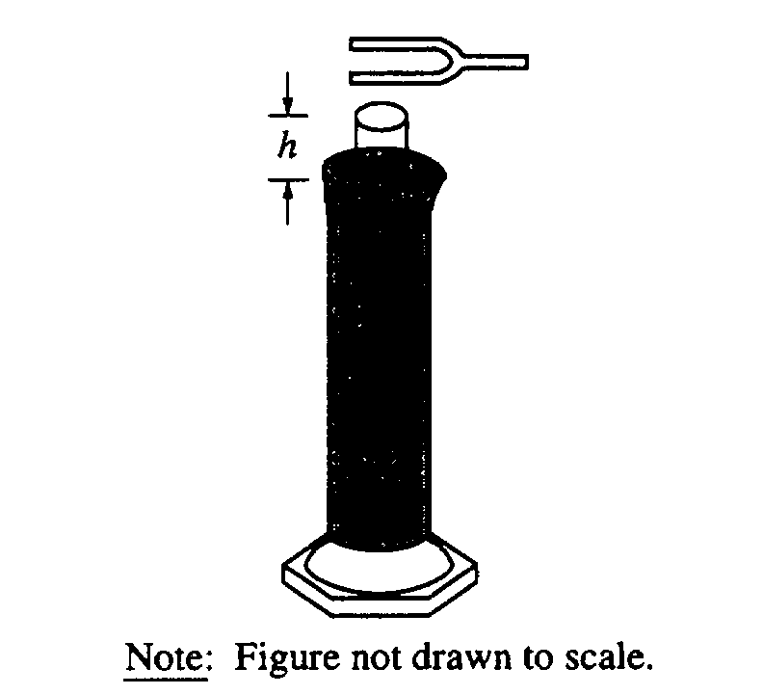
for the tube, and
The speed of sound is the same for the open ended tube, so:

Now we can set the two velocities equal to each other.

Waltzing Matilda (Carrying a Swag)

OH! there once was a swagman camped in a Billabong,
Under the shade of a Coolabah tree;
And he sang as he looked at his old billy boiling,
'Who'll come a-waltzing Matilda with me?'

Chorus:

Who'll come a-waltzing Matilda, my darling,
Who'll come a-waltzing Matilda with me?
Waltzing Matilda and leading a water-bag --
Who'll come a-waltzing Matilda with me?

Down came a jumbuck to drink at the water-hole,
Up jumped the swagman and grabbed him with glee;
And he sang as he stowed him away in his tucker-bag,
You'll come a-waltzing Matilda with me.'

Chorus

Down came the Squatter a-riding his thoroughbred;
Down came Policemen -- one, two and three;
'Whose is the jumbuck you've got in the tucker-bag?
You'll come a-waltzing Matilda with me.'

Chorus

But the swagman, he up and he jumped in the water-hole,
Drowning himself by the Coolabah tree;
And his ghost may be heard as it sings in the Billabong
'Who'll come a-waltzing Matilda with me?'

Andew Barton 'Banjo' Paterson

