AP Physics – Yer’mo Thermo – 4 Ans
- In each cycle of a Carnot engine, 125 J of heat is absorbed from the high temperature reservoir and 77.2 J of work is done. What is the efficiency of the engine?
- An ideal gas is confined in a box that initially has pressure P. If the absolute temperature of the gas is doubled and the volume of the box is quadrupled, the pressure is:
- Heat is added at a constant rate to a sample of pure substance that is initially a solid at temperature T₀ . The temperature of the sample as a function of time is shown in the graph. From the graph one can conclude that the
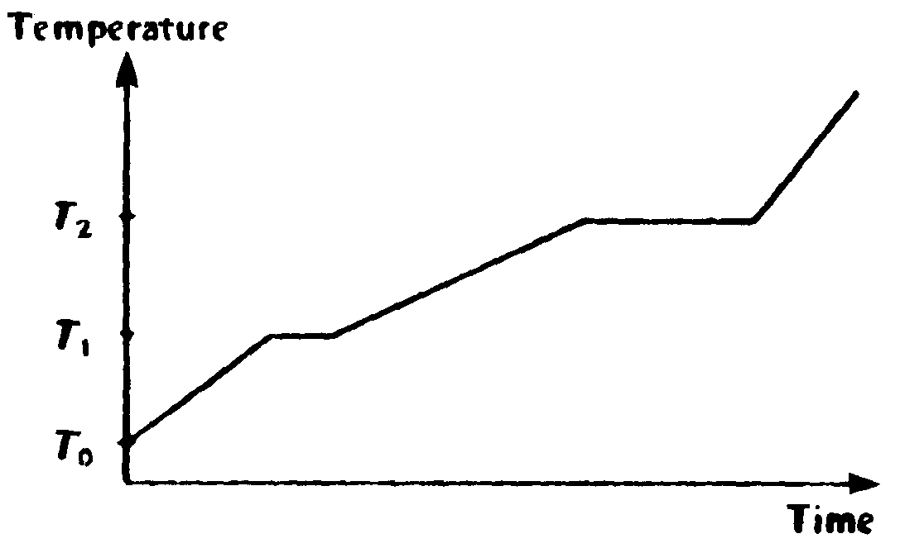
- substance sublimes directly from the solid phase to the vapor phase
- melting point is T₂
- specific heat is greater for the liquid phase than for the solid phase
- heat of fusion and heat of vaporization are equal
- specific heat of the solid increases linearly with temperature
- An ideal gas is made up of N diatomic molecules, each of mass M . All of the following statements about this gas are true EXCEPT
(A) The temperature of the gas is proportional to the average translational kinetic energy of the molecules
(B) All of the molecules have the same speed
(C) The molecules make elastic collisions with the walls of the container
- The molecules make elastic collisions with each other
- The average number of collisions per unit time that the molecules make with the walls of the container depends on the temperature of the gas
- A 2.00 kg block of metal has a specific heat of 115 J/kg⋅K. It falls from rest through a distance of 100.0 meters to the earth’s surface. If half of the potential energy lost by the fallen block when it hits is converted to internal energy of the block, what is the temperature change of the block?
- The maximum efficiency of a heat engine that operates between two temperatures is 21.5 %. If its low temperature heat reservoir is the atmosphere (at 25 °C), then what is its high temperature heat reservoir temperature?
- If the gas in a container absorbs 275 joules of heat, has 125 joules of work done on it, and then does 50 joules of work, what is the increase in the internal energy of the gas?
(A) 100 J (B) 200 J
(C) 350 J (D) 400 J (E) 450 J
- A piece of metal with a mass of 1.50 kilograms, specific heat of 200 J/kg · C°, and initial temperature of 125 °C is dropped into an insulated jar that contains liquid with a mass of 3.0 kg, specific heat of 1.0 x 10³ J/kg · C°, and initial temperature of 0 °C. The piece of metal is removed after 5.0 seconds, at which time its temperature is 20.0 °C. Neglect any effects of heat transfer to the air or to the insulated jar. What is the temperature of the liquid after the metal is removed?
- A particle with an unknown mass and charge moves with a constant speed of v = 7.50 x 10⁶ m/s as it passes undeflected through a pair of parallel plates as shown. The plates are separated by a distance of d = 7.00 x 10⁻³ m, and a constant potential difference V is maintained between them. A uniform magnetic field of B = 0.250 T directed into the page exists between the plates and to the right of them as shown. After the particle passes into the region to the right of the plates where only the magnetic field exists, it trajectory is circular with radius r = 0.250 m.
(a) What is the sign of the particle’s charge? Explain your answer.
(b) On the drawing, indicate the direction of the electric field provided by the plates.
(c) Determine the magnitude of the potential difference between the plates.
(d) Determine the ratio of charge to mass (q/m) of the particle.
(a) If particle positive, magnetic force would be up and particle would curve above plates. If it was negative, force would be down. So positive.
(b) Electric field is down -- arrows point downwards.
(c) Magnetic force:
Electric Force:
Set Equal:
(d) Centripetal force: Solving for q/m

