Lesson 4: Thursday, March 26, 2020. Biology MHS
AIM: How do the nucleus and the ribosome work together for protein synthesis?
Ok! I get it! Genes code for proteins! And proteins control traits! But HOW does DNA code for proteins? Doesn’t the ribosome make proteins? …

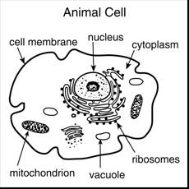
Look at the two cell diagrams. Recall that the nucleus stores the genetic material in a cell. The nucleus stores the DNA and all of your genes. Just outside of the nucleus, you will find ribosomes. Ribosomes are where proteins are built.
- Nucleus = stores the instructions for building proteins
- Ribosome= site of protein synthesis

But, we have 2 problems:
- Each cell contains ONE copy of your DNA, and the DNA never leaves the nucleus.
- The ribosome can’t even read DNA!! It reads a molecule called RNA.

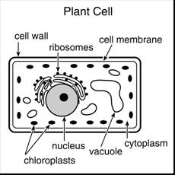
Solution:
- In the nucleus, DNA is used to make a strand of RNA. RNA leaves the nucleus and goes to the ribosome. The RNA carries the information from the gene so that the ribosome knows how to make the protein. RNA is another information molecule similar to DNA

How is DNA used to code for RNA?
- RNA is a very similar molecule. The one difference is that RNA does NOT have the base “T” (thymine). Instead, it has the base “U” (uracil). U is so similar to T, that it can still pair with A.
- SO, the DNA bases are G, C, A, and T
- The RNA bases are G, C, A, and U

When a strand of DNA is being used to code for RNA, we will use the following rules for base pairs:
DNA | mRNA
G | C
C | G
A | U
T | A
- If the DNA template says G, the matching RNA will be a C
- If the DNA template says C, the matching RNA will be a G
- If the DNA template say T, the matching RNA base will be A
- If the DNA template the A, the matching RNA base will be U
- Look at the example below.

DNA template: G T T A C G A T G A T C
mRNA strand: C A A U G C U A C U A G

When DNA is used to make RNA, we call the RNA that is being produced “mRNA.” The m stands for messenger. Once complete, the single strand of mRNA leaves the nucleus and goes to the ribosome. The mRNA message contains the information needed to build a specific protein.
- SO, DNA can act as a template to make more DNA for DNA replication.
  - Use the DNA base-pair rules FOR DNA REPLICATION QUESTIONS.
- OR, DNA can act as a template to make a strand of mRNA for protein synthesis.
  - Use the DNA to RNA base-pair rules for PROTEIN SYNTHESIS QUESTIONS.

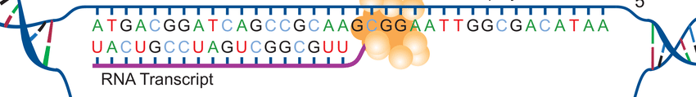
^ This pic shows a sequence of DNA being used to code for a strand of mRNA

Look at the 2 Regents questions below. One is asking about DNA replication; the other is asking about protein synthesis. Always be sure to read questions carefully and to use the correct rules for base-pairing!

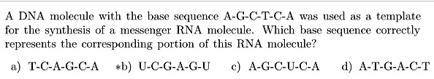

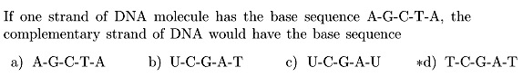

Here are some important pictures to analyze! Please look at every picture and read each caption!!!
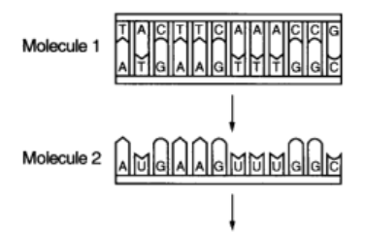  PROTEIN | 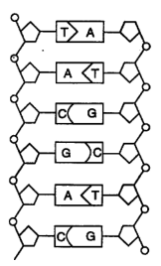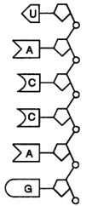
- Molecule 1 represents DNA. I can tell because its double-stranded, and I see the 4 DNA bases (G, C, A, and T).  - Molecule 2 represents mRNA. I can tell because it is single-stranded, and I see the 4 RNA bases (G, C, A, and U) | - The first molecule represents DNA.  - The second molecule represents a strand of RNA.  - DNA can be used to code for RNA.
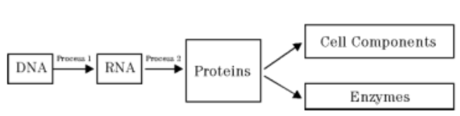 | 
- This shows me that DNA can be used to make RNA. This process happens in the nucleus.  - mRNA then goes to the ribosome. The mRNA is read by the ribosome to build proteins.  - Proteins in the body can become various parts of cells, enzymes, or other things. | - DNA can be used to code for mRNA. This takes place in the nucleus.  - RNA is used by the ribosome to build proteins.  - Proteins give rise to various traits.
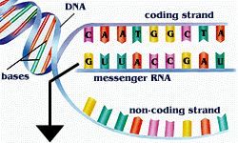 | 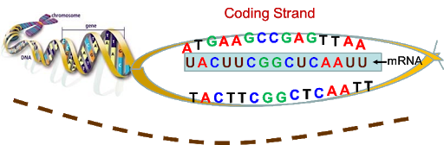
This picture shows how one strand of my DNA is used to make the strand of messenger mRNA. | Here is another picture that shows how a sequence of DNA can be used to make a strand of mRNA to send to the ribosome.

