AP Physics – Momentum - 4
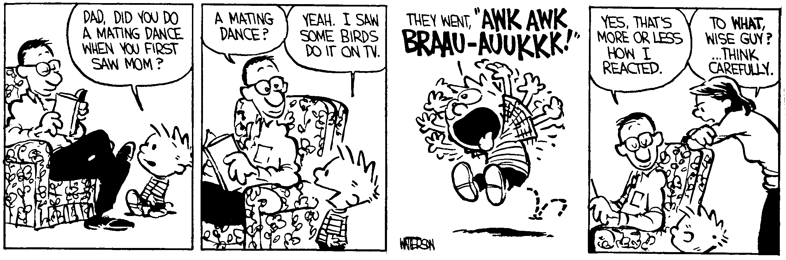
Gasp_________________________________________________________________________Per___
If at first you don't succeed, don't tell anybody you tried. -- Walt Harper
- One of those Civil War cannons is fired. The cannon has a mass of 875 kg. It fires a 35.0 kg cannon ball at a velocity of 145 m/s at an elevation angle of 35.0°. The length of the barrel is 2.10 m. (a) What is the recoil velocity of the cannon? (b) What is the KE of the cannon ball as it leaves the cannon? (c) How far does the cannon ball travel in the horizontal direction? (d) What is the KE of the cannon ball at the top of its trajectory? (e) What is its momentum at this point? (f) What is the force exerted on the cannonball?

- A 0.15 kg ball is thrown with a speed of 20.0 m/s. It is hit straight back at the pitcher with a final speed of 22.0 m/s. (a) What is the impulse delivered by the bat to the ball? (b) Find the average force exerted by the bat on the ball if the two are in contact for 2.0 x 10⁻³ s

- A railroad car of mass 2.00 x 10⁴ kg moving at 3.00 m/s collides and couples with two coupled railroad cars, each of the same mass as the single car and moving in the same direction at 1.20 m/s. (a) What is the speed of the three coupled cars after the collision? (b) How much kinetic energy is lost in the collision?

- A 2.35 kg ball moving at 4.20 m/s to the right hits a 3.45 kg ball head-on that is traveling at 3.50 m/s to the left. The second ball ends up going to the left with a velocity of 2.50 m/s. What is the velocity of the first ball after the collision?

- A 10.5 g bullet is fired into a 8.50 kg wooden block that is hanging straight down, suspended by a 1.50 m length of light line. The bullet stays in the block. The block swings outward, so that the line it hangs from makes an angle of 7.00° to the vertical. (a) What is the velocity of the bullet before it strikes the block? (b) What is the loss of energy in the collision?

