AP Physics – Homework Oh the Homework – 4

emaN ___________________________________________________________________Per___
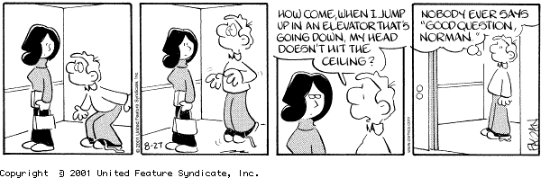
So many centuries after the Creation, it is unlikely that anyone could find hitherto unknown lands of any value. -- Spanish Royal Commission, rejecting Christopher Columbus' exploration proposal
- A can of tuna is dropped from a building. If the can takes 3.2 seconds to strike the ground, what distance did it fall?

- An engine falls off of a 737 from a height of 2500 m. Ignoring wind resistance, how fast is the thing traveling when it smacks into the turf?

- A ball is thrown straight down from a bridge with an initial velocity of 18.5 m/s. If it travels for 2.3 sec, how high is the bridge?

- A ball, initially at rest, rolls down a ramp. It experiences an acceleration of 1.2 m/s2 If it is rolls a distance of 1.8 m, how fast is it traveling?

- A ball rolls down a ramp with very little friction. Which of the following is not true?
- The ball covers a greater distance with each time increment.
- The ball’s acceleration increases with each time increment.
- The ball’s velocity increases with each time increment.
- The ball cover’s an equal distance in an equal amount of time.
- The distance that the ball covers in one second depends on the time and the ball’s initial velocity.

- A ball is thrown straight up, it rises 12.5 m before it falls back down. (a) What was its initial speed? (b) how much time is it in the air?

- A ball is thrown straight down from a bridge with an initial velocity of 18.5 m/s. The bridge is 22.0 m above the river. How much time to hit the water?

