AP Physics – Electric Fields – 4

Can it be thee?________________________________________________________________Per__
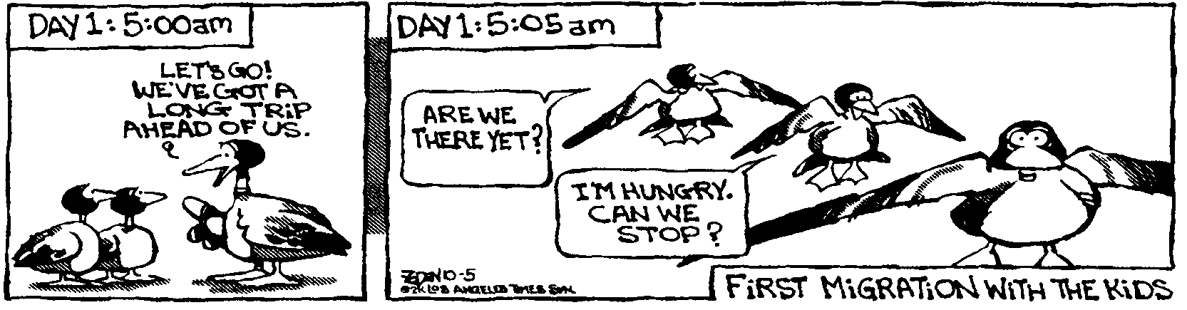
Wisdom is not a product of schooling but of the lifelong attempt to acquire it. -- Albert Einstein
- A uniform 10.0 m long ladder weighing 135 N rests against a smooth vertical wall. The bottom of the ladder makes an angle of 65.0° with the deck. A 56.6 kg humanoid stands on a rung, 3.00 m from the bottom end of the ladder. What is the frictional force exerted on the bottom of the ladder?

- A proton is placed in an electric field of 2.50 x 10⁴ N/C directed along the y axis. Find the force acting on the proton.

- A charge of 15.5 μC is placed 4.85 cm from a second charge. If the force between the charges is 32.8 N, what is the magnitude of the second charge?

- Three charges are arranged as shown. What is the magnitude and direction of the force acting on q₂, the –2.95 μC charge, by the other two charges?

- The potential difference between two points is 12.0 V. What amount of work is needed to move a 2.00 μC charge within the field?

- Two charged plates are 3.00 cm apart. The electric field between them is 565 N/C. (a) What is potential difference between plates and (b) what work is done moving an electron from one plate to another?

- An electron is released from rest in a uniform electric field, E = 7.30 x 10⁴ V/m. It is directed along the y axis. It’s displacement is 0.350 m in the direction of the field. (a) What is the change in electrical potential? (b) What is the change in electrical potential energy? (c) What is its velocity after it traveled the 0.350 m?

