AP Physics – Gravity Wrapup

You get three equations to work with, and only three. Everything else you have to develop from these three equations (also have to use some other ones). Here they are:

Newton’s law of gravity.
Centripetal acceleration equation.

Second law.

Here’s what you have to be able to do:

- You should understand the uniform circular motion of a particle so you can:

- Relate the radius of the circle and the speed or rate of revolution of the particle to the magnitude of the centripetal acceleration.
You have this equation to work with:

In this equation, v is the linear speed, so its fairly easy to relate it to the radius (r) or to the centripetal acceleration (a_{c}). You just use the old equation as it is given. If r gets bigger, then the centripetal acceleration gets smaller, &tc.

The rate of revolution is the rate that the thing rotates. This would be the number of rotations divided by the time it took to do them. This is called the angular velocity, . Unfortunately, you don’t got no equation for this. Just remember that any rate is simply a quantity divided by time, so the angular velocity is simply:

Where θ is the angular displacement, which will most likely be the number of revolutions that have been made?

What happens to the centripetal acceleration if the velocity is increased and you want to keep the same radius? If the radius increases, but the velocity stays the same, what happens to the centripetal acceleration?

That kind of thing.

You should be able to derive an equation that relates linear speed to angular velocity. We did that in your gravity handout. The Physics Kahuna showed you how to develop the equation:

Basically, the velocity is proportional to the angular velocity. So whatever happens when the linear speed increases also happens if the angular velocity increases.

You might be able to get away without developing the equation at all. Using this concept, it is a simple matter to relate the rate of revolution of the particle to the magnitude of the centripetal acceleration.

- Describe the direction of the particle’s velocity and acceleration at any instant during the motion.

The acceleration is always towards the center.

The velocity is always tangent to the object’s path.

For any type of circular motion, such as the moon orbiting a planet, the direction of the centripetal acceleration is towards the center and the velocity direction is a tangent to the path.

- Determine the components of the velocity and acceleration vectors at any instant and sketch or identify graphs of these quantities.

This is a simple matter – use trigonometry to resolve the acceleration and or velocity vector into its components. Again, graphing these quantities is quite simple.

Above is a drawing of an object that is following a circular path. The velocity and centripetal acceleration vectors are shown at five different positions. To the right of that is a graph of velocity Vs time for the same motion. Please now figure out how the graph works.

The velocity is either only up and down or only right or left at the four cardinal positions, 1, 3, 4, and 5. So the speed is either all v_{x} or all v_{y}. For all other positions on the path, there will be both a horizontal and vertical component for the velocity. Can you see how the speed v is the sum of the squares of the components? Think about till you can.

Here is a graph of the centripetal acceleration Vs time for the same set of points.

- Students should be able to analyze situations in which a body moves with specified acceleration under the influence of one or more forces so they can determine the magnitude and direction of the net force, or of one of the forces that makes up the net force, in situations such as the following:

- Motion in a horizontal circle (e.g., mass on a rotating merry-go-round, or car rounding a banked curve).

The main thing here is using the second law and the centripetal acceleration to find the centripetal force.

The centripetal force can then be used to calculate the frictional force acting on a car traveling in a circle or some such thing.

In a previous unit we looked at several problems along this line.

The centripetal force will be used in several other sections. One that really requires it is when we study a charged particle moving through a uniform magnetic field. You’ll see how this works later on.

- Motion in a vertical circle (e.g., mass swinging on the end of a string, cart rolling down a curved track, rider on a Ferris wheel).

Draw a free body diagram. Analyze the forces. The centripetal force will always end up being the net force acting on the body and will always be directed to the center of the circular path. There are two forces working on the vertical circle – the weight of the object and the centripetal force. At the very top for the instant of time that the body is up there, the sum of the vertical forces must be zero since the body is moving sideways and not up and down. So you can solve for the tension which will turn out to be The idea here is that the centripetal force must equal the weight of the object. From this you can calculate an equation for the minimum velocity a body needs to travel along a vertical circular path. The equation is:

- You should know Newton’s Law of Universal Gravitation so you can:

- Determine the force that one spherically symmetrical mass exerts on another.

This is pie. You just use Newton’s law of gravity.

- Determine the strength of the gravitational field at a specified point outside a spherically symmetrical mass.

This is another slice of really good pumpkin pie with whipped cream on top (yummy). Again, merely apply good old Newton’s law of gravity.

- You should understand the motion of a body in orbit under the influence of gravitational forces so you can, for a circular orbit:

- Recognize that the motion does not depend on the body’s mass, describe qualitatively how the velocity, period of revolution, and centripetal acceleration depend upon the radius of the orbit, and derive expressions for the velocity and period of revolution in such an orbit.

This is a derivation special. The Physics Kahuna demonstrated how to do all of this in a previous unit.

You have to derive the equation for centripetal force and set it equal to the force of gravity from Newton’s law of gravity. Then you solve for the velocity. This gives you the orbital velocity.

To find the period, you use the equation for velocity, and the
equation for the orbital velocity we just found. The distance x is the circumference of the circle. Which is . Put them together and you end up with:

We did a number of problems that required developing and using these equations.

AP Test Examples: From 1997:
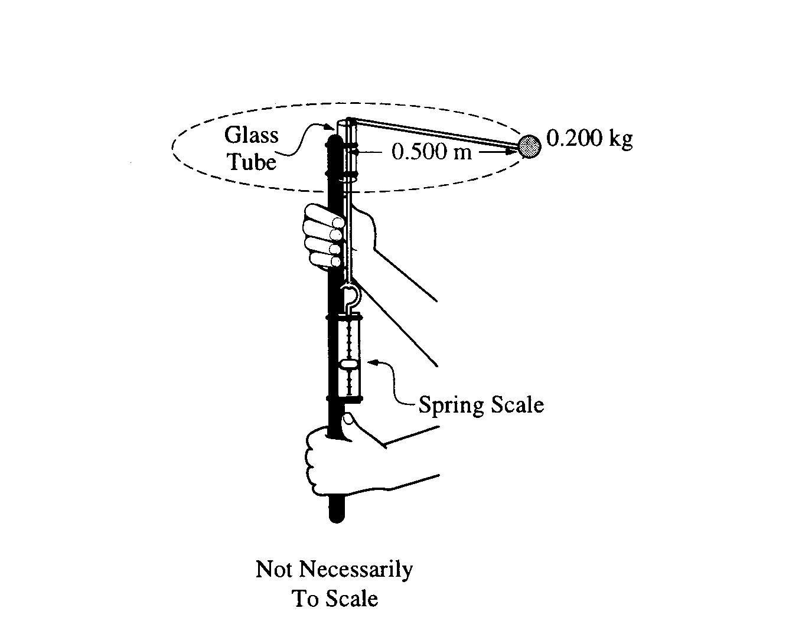
- To study circular motion, two students use the hand-held device shown, which consists of a rod on which a spring scale is attached. A polished glass tube attached at the top serves as a guide for a light cord attached the spring scale. A ball of mass 0.200 kg is attached to the other end of the cord. One student swings the ball around at constant speed in a horizontal circle with a radius of 0.500 m. Assume friction and air resistance are negligible.
  - Explain how the students, by using a timer and the information given above, can determine the speed of the ball as it is revolving.
Measure radius and calculate circumference. Use stop watch to measure the period (time of one revolution). Use to find the speed of the ball.
b. How much work is done by the cord in one revolution? Explain how you arrived at your answer.
No work. The motion is perpendicular to the force.

c. The speed of the ball is determined to be 3.7 m/s. Assuming that the cord is horizontal as it swings, calculate the expected tension in the cord.

d. The actual tension in the cord as measured by the spring scale is 5.8 N. What is the percent difference between this measured value of the tension and the value calculated in part (c)?
e. The students find that, despite their best efforts, they cannot swing the ball so that the cord remains exactly horizontal. On the picture of the ball below, draw vectors to represent the forces acting on the ball and identify the force that each vector represents.
Explain why it is not possible for the ball to swing so that the cord remains exactly horizontal.
The tension in the string, t, provides the centripetal force. mg is the weight of the ball.
There is always a downward force acting on the ball, its weight, mg. So there must be a component of the tension in the opposite direction since the ball is not moving in a vertical direction. The sum of the vertical forces must be zero.

- Calculate the angle that the cord makes with the horizontal.
From 2001:
- A ball of mass M is attached to a string of length R and negligible mass. The ball moves clockwise in a vertical circle, as shown to the right. When the ball is at point P, the string is horizontal. Point Q is at the bottom of the circle and point Z is at the top of the circle. Air resistance is negligible. Express all algebraic answers in terms of the given quantities and fundamental constants.

- On the figures below, draw and label all the forces exerted on the ball when it is at points P and Q, respectively.
(b) Derive an expression for v_{min}, the minimum speed the ball can have at point Z without leaving the circular path.

but the tension is zero
Derive the equation for centripetal force.

(c) The maximum tension the string can have without breaking is T_{max}. Derive an expression for v_{max}, the maximum speed the ball can have at point Q without breaking the string.

The Tension in the string is the upward force and the weight is the downward force, the sum of these two forces is ma so:

But the acceleration acting on the system is the centripetal acceleration.

(d) Suppose that the string breaks at the instant the ball is at point P. Describe the motion of the ball immediately after the string breaks.

The ball would go straight up, slowing down as it is accelerated downward by gravity, it will stop, then fall down, accelerating as it goes. Its motion is tangential to the path, which is straight up.

From 1999:
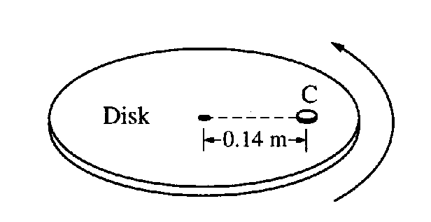
- A coin C of mass 0.0050 kg is placed on a horizontal disk at a distance of 0.14 m from the center, as shown below. The disk rotates at a constant rate in a counterclockwise direction as seen from above. The coin does not slip, and the time it takes for the coin to make a complete revolution is 1.5 s.
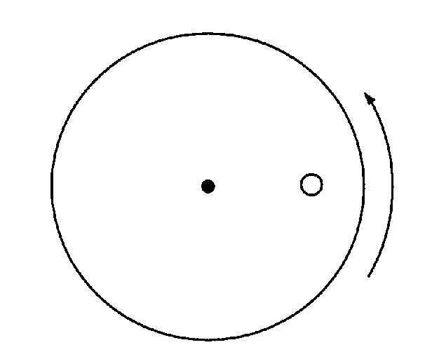
v
a
  - The figure to the right shows the disk and coin as viewed from above. Draw and label vectors on the figure below to show the instantaneous acceleration and linear velocity vectors for the coin when it is at the position shown.

  - Determine the linear speed of the coin.

The coin makes one revolution is a time of 1.5 s. So the distance it travels in that time is the circumfrence of the circle it makes, which is .

  - The rate of rotation of the disk is gradually increased. The coefficient of static friction between the coin and the disk is 0.50. Determine the linear speed of the coin when it just begins to slip.

  - If the experiment in part (c) were repeated with a second, identical coin glued to the top of the first coin, how would this affect the answer to part (c)? Explain your reasoning.
There would be no change. The mass cancels out.

From 1995:
- Part of the track of an amusement park roller coaster is shaped as shown below. A safety bar is oriented length-wise along the top of each car. In one roller coaster car, a small 0.10 kilogram ball is suspended from this bar by a short length of light, inextensible string.
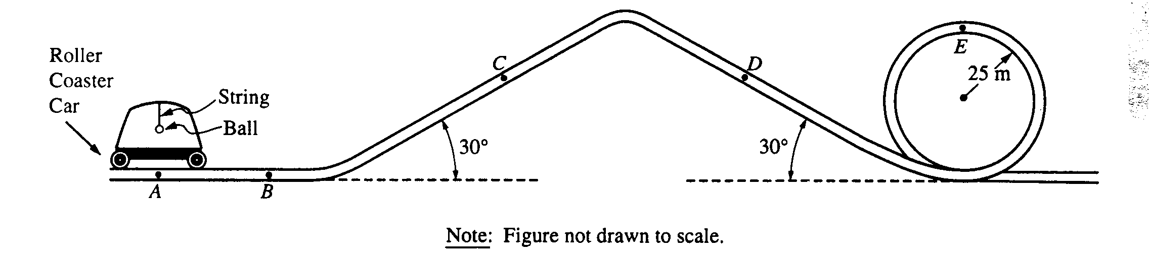
  - Initially, the car is at rest at point A.
    - On the diagram to the right, draw and label all the forces acting on the 0.10-kilogram ball.
    - Calculate the tension in the string.
The car is then accelerated horizontally, goes up a 30° incline, goes down a 30° incline, and then goes around a vertical circular loop of radius 25 meters. For each of the four situations described in parts (B) to (E), do all three of the following. In each situation, assume that the ball has stopped swinging back and forth. 1) Determine the horizontal component T_{h} of the tension in the string in newtons and record your answer in the space provided. 2) Determine the vertical component T_{v} of the tension in the string in newtons and record your answer in the space provided. 3) Show on the adjacent diagram the approximate direction of the string with respect to the vertical. The dashed line shows the vertical in each situation.
  - The car is at point B moving horizontally to the right with an acceleration of 5.0 m/s .

  - The car is at point C and is being pulled up the 30° incline with a constant speed of 30 m/s.
  - The car is at point D moving down the incline with an acceleration of 5.0 m/s².

The sum of the forces in the y direction must equal . Therefore:

The acceleration in the vertical direction is .

  - The car is at point E moving upside down with an instantaneous speed of 25 m/s and no tangential acceleration at the top of the vertical loop of radius 25 m.

In the vertical direction, we have a centripetal F_{C} , the tension, and the weight of the ball. The centripetal force must equal the sum of the other two forces.

More Foolish Trivia:
- A jogger's heel strikes the ground 1,500 times per mile.
- A lifetime supply of all the vitamins you need has a mass of only about 225 g (eight ounces).
- 3 out of 4 optometrists wear eyeglasses.
- Computer users, on average, blink seven times per minute.
- Dark circles under the eye are an inherited trait.
- The iris membrane controls the amount of light that enters your eye.
- In 1992, when EuroDisney first opened in France, park visitors beat up some of the costumed characters (oh please not Snow White!) because at the time most people had been against the park being built.
- Until the 1960's men with long hair were not allowed to enter Disneyland.
- Eiffel Tower was the tallest structure in the world before the construction of the Empire State Building in 1930.
- A B-25 bomber airplane crashed into the 79th floor of the Empire State Building on July 28, 1945.
- Sunbeams that shine down through clouds are called crepuscular rays.
- The Apollo 11 Lunar Module had only 20 seconds of fuel left when it landed on the moon in 1969.
- Kite flying is a professional sport in Thailand.
- A normal raindrop falls at about 7 miles per hour.
- A penny whistle has six finger holes.
- The human eye sees everything upside-down, but the brain turns it right side up.
- A shell constitutes 12 percent of an egg's weight.
- A silicon chip a quarter-inch square has the data processing capacity of the original 1949 ENIAC computer, which occupied a city block.
- All the dirt from the foundation to build the former World Trade Center in NYC was dumped into the Hudson River to form the community now known as Battery City Park.
- Rice paper does not contain rice or any rice products.
- The height of the Eiffel Tower varies as much as six inches depending on the temperature.
- At April 2000, Hong Kong had 392,000 faxlines - one of the highest rates of business fax use in the world.
- The only part of the human body that has no blood supply is the cornea. It takes its oxygen directly from the air.

