AP Physics – Fluids Fluids Everywhere – 4
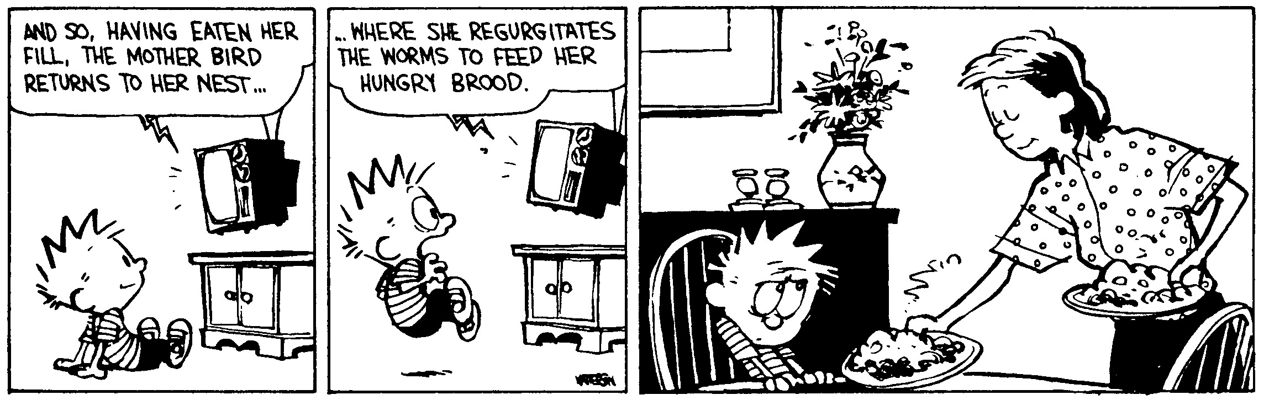
Velociraptor ____________________________________________________________________Per___
Where’s Waldon? – Alas, the challenge of locating Henry David Thoreau in each richly detailed drawing loses its appeal when it quickly becomes clear that he is always in the woods. -- Washington Post’s “Style Invitational”
- Two of these here masses are connected by a very light weight string that passes over your basic very low friction pulley. The mass on the left is 3.25 kg. The 3.25 kg mass accelerates upward at 0.215 m/s². What is the mass on the other side of the pulley?

- A roller coaster starts at some height that you do not know. It goes down this hill and then goes up a second hill that is 29.5 m above the first drop. So how high was the initial hill?

- A satellite is in orbit - like 595 km above the earth's surface. What is its orbital velocity? Earth's radius is 6.37 x 10⁶ m, earth's mass is 5.98 x 10²⁴ kg.

- A 2.35 kg ball is traveling at 5.30 m/s to the north. It glances off of a 2.75 kg ball that is at rest. The first ball ends up traveling to the west at 3.16 m/s. What is the velocity of the 2.75 kg ball?

- An electron is released from rest in a uniform electric field, E = 8.30 x 10⁵ V/m. It is directed along the y axis. It’s displacement is 0.155 m in the direction of the field. (a) What is the change in electrical potential? (b) What is the change in electrical potential energy? (c) What is its velocity after it traveled the 0.155 m?

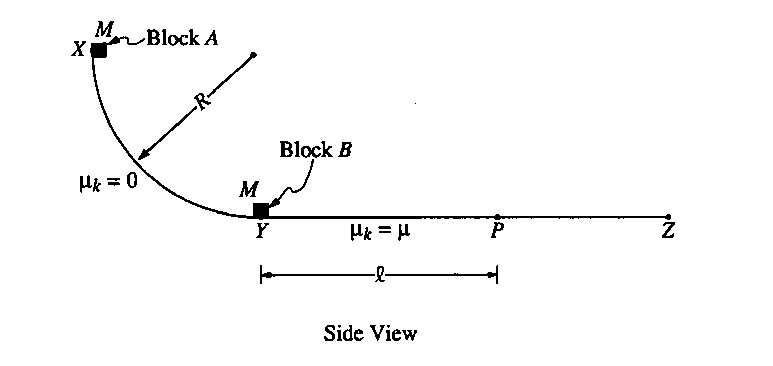
- A track consists of a frictionless arc XY, which is a quarter-circle of radius R, and a rough horizontal section YZ. Block A of mass M is released from rest at point X, slides down the curved section of the track, and collides instantaneously and inelastically with identical block B at point Y. The two blocks move together to the right, sliding past point P, which is a distance l from point Y. The coefficient of kinetic friction between the blocks and the horizontal part of the track is μ. Express your answers in terms of M, l, μ, R, and g.
- Determine the speed of block A just before it hits block B. (b) Determine the speed of the combined blocks immediately after the collision. (c) Determine the amount of kinetic energy lost due to the collision. (d) The specific heat of the material used to make the blocks is c. Determine the temperature rise that results from the collision in terms of c and the other given quantities. (Assume that no energy is transferred to the track or to the air surrounding the blocks). (e) Determine the additional thermal energy that is generated as the blocks move from Y to P

