AP Physics – Electro/Magnetic Stuff - 4

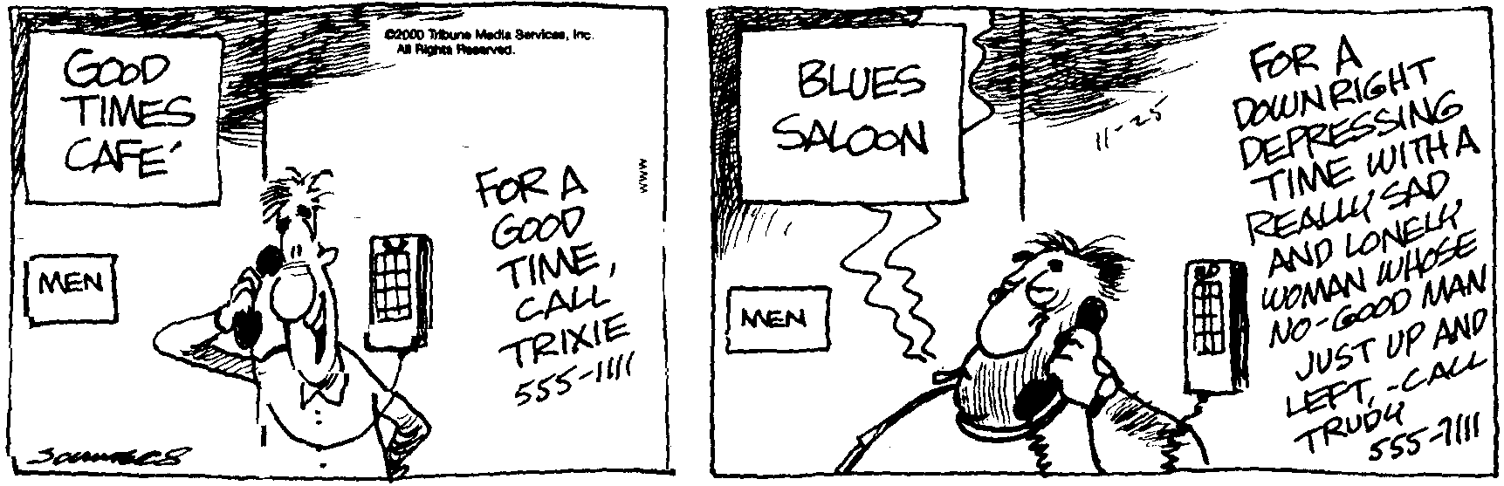
And you beith?________________________________________________________________Per___
No person is your friend who demands your silence, or denies your right to grow. -- Alice Walker
- Three resistors are arranged in a circuit as shown. There is also a switch and a capacitor. R₁ is 25.0 Ω, R₂ is 25.0 Ω, R₃ is 45.0 Ω, and C₁ has the value of 1.25 μF. (a) When S₁ is open, what is the total current? (b) What is the Voltage drop for R₁? (c) Switch S₁ is now closed for a long time. What is the charge Q on the capacitor? (d) What is the potential energy stored in the capacitor?

- You are given a 12.0 V battery, and four resistors with the following values: 100.0 Ω, 30.0 Ω, 20.0 Ω, and 10.0 Ω. You also have plenty of wire that has essentially zero resistance. (a) Draw a circuit in which each resistor has current flowing through it, but in which the current from the battery is as small as possible. (b) Now draw a circuit in which the current from the battery is as large as possible. (no short circuiting of the battery, however.)

- Find the: (a) total current, (b) total resistance, (c) power dissipated by R₄.

- A proton has a velocity of 1.25 x 10⁶ m/s. It travels into a magnetic field that has a strength of 1.50 T. What is the maximum force that the proton can experience?

- A circuit is as shown. Find: (a). the total resistance, (b). the total current, (c). the voltage provided by the battery, and (d). the amount of energy that the battery puts out in 1.00 hours in kWh.

- A circuit is arranged as shown. The battery has an internal resistance of 2.5 Ω, the source of emf is 15 V. Find: (a) the total current in the circuit, and (b) The voltage provided by the battery.

