AP Physics – Electric Current Wrapup

“What equations will I have to play with that deal with electricity?” Asks the concerned AP Physics student.

“Why, you will have these.” Responds the kindly Physics Kahuna.

This is the definition of capacitance as a function of charge and potential difference.

This is capacitance as a function of plate area and plate separation.

The potential energy stored in a capacitor.

The equation for current showing that it is the rate at which charge is flowing.

The equation to determine the resistance of a long conductor. Short lengths of conductors are considered to have zero resistance, but long power lines and things like that have a significant amount of resistance. This equation will figure it all out.

This is Ohm’s law. A very important equation in the world of electricity.

Electric power.

Capacitors add algebraically when they are in parallel – you just add them up.

Capacitors in series add up like resistors in parallel.

Resistors in series add up algebraically. Sum them up.

This is the equation for finding the equivalent resistance for a set of parallel resistors.

Next the Physics Kahuna will run the standards – stuff that a student has to be able to do. There’s a bunch of things here.

Capacitors and Dielectrics:

- You should know the definition of capacitance so you can relate stored charge and voltage for a capacitor.

Use the capacitor equation. Pie.

- You should understand energy storage in capacitors so you can:

- Relate voltage, charge, and stored energy for a capacitor.

You use the capacitor equation and the potential energy of a capacitor equation. Pretty simple stuff. Definitely pie.

- Recognize situations in which energy stored in a capacitor is converted to other forms.

The energy in the capacitor is released when it is hooked up so that there is a path for the electrons on the negative plate to flow to the positive plate. This generates a current.

- You should understand the physics of the parallel-plate capacitor so you can:

- Describe the electric field inside the capacitor, and relate the strength of this field to the potential difference between the plates and the plate separation.

The electric field inside the capacitor looks like this:
The lines of force between the charged plates are parallel to each other and equally spaced, indicating a uniform electric field.

The field strength depends on the voltage and the separation between the charges:

So as the voltage increases, the field increases. As the distance between the plates increases, the field decreases.

- Determine how changes in dimension will affect the value of the capacitance.

To do this, you use the equation: This equation tells us that as the area of the plates increases, the capacitance also increases. Capacitance and plate area are directly proportional. Also it tells us that as the distance between the plates increases the capacitance decreases. If the separation decreases the capacitance increases. Capacitance and plate separation are inversely proportional.

Current, Resistance, Power:

- You should understand the definition of electric current so you can relate the magnitude and direction of the current in a wire or ionized medium to the rate of flow of positive and negative charge.

Just use the equation for current, you know, charge divided by time.

- You should understand the conductivity, resistivity, and resistance so you can:

- Relate current and voltage for a resistor.

This is just your basic old Ohm’s law.

- Describe how the resistance of a resistor depends upon its length and cross-sectional area.

Use the resistivity equation.

- Apply the relationships for the rate of heat production in a resistor.

This sounds weird – did we study any stuff about this? Well, we did. Remember that the resistor basically turns electricity into heat. So figure the amount of work done by the resistor and that is equal to the heat produced by the resistor. Power is equal to work divided by time so the heat developed is simply:

Steady-State Direct Current Circuits with Batteries and Resistors Only:

- You should understand the behavior series and parallel combinations of resistors so you can:

- Identify on a circuit diagram resistors that are in series or in parallel.

Please don’t try to tell the Physics Kahuna that you can’t do this!

- Determine the ratio of the voltages across resistors connected in series or the ratio of the currents through resistors connected in parallel.

This is using Ohm’s law for different sorts of circuits. Recall how much phun we had doing this sort of problem.

- Calculate the equivalent resistance of two or more resistors connected in series or parallel, or of a network of resistors that can be broken down into series and parallel components.

This is pretty simple, just use the equations for equivalent resistance.

- Calculate the voltage, current, and power dissipation for any resistor in such a network of resistors connected to a single battery.

You use the power equation, Ohm’s law, the rules for parallel and series circuits, etc. We did us several of these.

- Design a simple series-parallel circuit that produces a given current and terminal voltage for one specified component, and draw a diagram for the circuit using conventional symbols.

Use Ohm’s law, the rules for parallel and series circuits, &tc. to figure out the needed circuit.

- You should understand the properties of ideal and real batteries so you can:

- Calculate the terminal voltage of a battery of specified emf and internal resistance form which a known current is flowing.

The Physics Kahuna was proud to show you how to do this. Treat the battery like a small circuit. The emf is the voltage and the internal resistance is the resistor. You can find the voltage drop of the resistor. Subtract this voltage drop from the emf and you get the voltage the battery actually produces. Simple.

- You should be able to apply Ohm’s law and Kirchoff’s rules to direct-current circuits in order to:
- Determine a single unknown current, voltage or resistance

Okay, what the heck is Kirchoff’s rules? Well, we didn’t study them. Mainly because the rules are a very confusing way to solve circuit problems. The Physics Kahuna showed you a better way. What you do is analyze the circuit using the rules for parallel and series circuits and apply Ohm’s law to the thing to find the unknown value.

- You should understand the properties of voltmeters and ammeters so you can:

- State whether the resistance of each is high or low.

Ammeter – low resistance. Voltmeter – high resistance.

- Identify or show correct methods of connecting meters into circuits in order to measure voltage or current.

Ammeters are placed in series with the circuit to measure current. Voltmeters are placed in parallel to measure the voltage of a circuit or component of a circuit.

The voltmeter has very high resistance. When placed in parallel with a component, the voltage drop is the same across both the meter and the component, but because the resistance is very large in the meter, the current through it is extremely small.

The ammeter has a very low resistance. It is placed in series with the component. It measures the current, but because its resistance is so small, it doesn’t add anything significant to the total resistance so that the current it measures is essentially the current in the circuit without the meter.

Capacitors in Circuits:

- You should understand the behavior of capacitors connected in series or in parallel so you can:

- Calculate the equivalent capacitance of a series or parallel combination.

Use the equations. We did several of these.

- Describe how stored charge is divided between two capacitors connected in parallel.

Let’s look at a parallel capacitor circuit:

The top plate of each capacitor has the same potential difference as the other. The equivalent capacitance of the circuit is simply the sum of the capacitance of the two capacitors. This is also true for the charge. The total charge stored in such a parallel circuit is equal to the sum of the two charges:

- You should be able to calculate the voltage or stored charge, under steady-state conditions, for a capacitor connected to a circuit consisting of a battery and resistors.

- You should develop skill in analyzing the behavior of circuits containing several capacitors and resistors so you can:

- Determine voltages and currents immediately after a switch has been closed and also after steady-state conditions have been established.

Immediately after the switch is thrown, current flows as if the capacitors did not exist. As the capacitors gain charge, the current decreases until, when the capacitors are fully charged, no current flows at all. So when the switch is initially thrown, solve for voltage, current, or resistance as if the capacitors did not exist.

Once steady state conditions are established, no current flows in the circuit and the capacitor(s) is/are fully charged.

Sample AP Physics Test Problems Involving DC Electricity:

The year 2000:
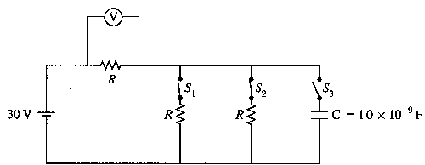
- Three identical resistors, each with resistance R, and a capacitor of 1.0 x 10⁻⁹ F are connected to a 30 V battery with negligible internal resistance, as shown in the circuit diagram above. Switches S₁ and S₂ are initially closed, and switch S₃ is initially open. A voltmeter is connected as shown.
- Determine the reading on the voltmeter.
V through R₁:
- Switches S₁ and S₂ are now opened, and then switch S₃ is closed. Determine the charge Q on the capacitor after S₃ has been closed for a very long time.

After the capacitor is fully charged, switches S₁ and S₂ remain open, switch S3 remains closed, the plates are held fixed, and a conducting copper block is inserted midway between the plates, as shown below. The plates of the capacitor are separated by a distance of 1.0 mm, and the copper block has a thickness of 0.5 mm.
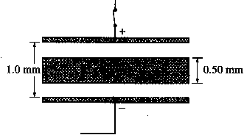
(c) What is the potential difference between the plates? 30 V

(d) What is the electric field inside the copper block? Zero. The copper plate is a conductor, there is not potential difference across it as every point within the copper plate is at the same potential.

(e) On the diagram above, draw arrows to clearly indicate the direction of the electric field between the plates. The copper plate has no effect. The lines of force point towards the negative plate, the direction of a force that would be exerted on a positive charge.

- Determine the magnitude of the electric field in each of the spaces between the plates and the copper block.

The next question is from the 1998 test:

This question doesn’t have any problems to solve, just asks questions about the circuit.
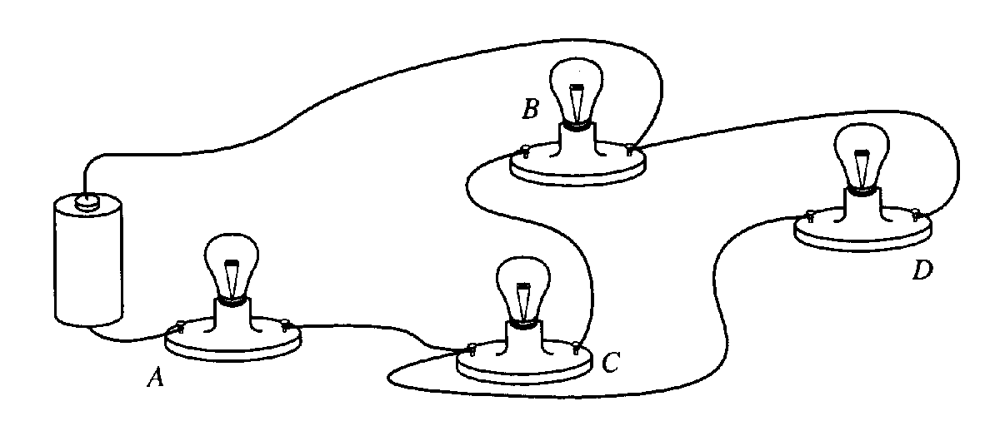
- In the circuit shown below, A, B, C, and D are identical light bulbs. Assume that the battery maintains a constant potential difference between its terminals (i.e., the internal resistance of the battery is assumed to be negligible) and the resistance of each light bulb remains constant.
- Draw a diagram of the circuit in the box below, using the following symbols to represent the components in your diagram. Label the resistors A, B, C, and D to refer to the corresponding light bulbs.
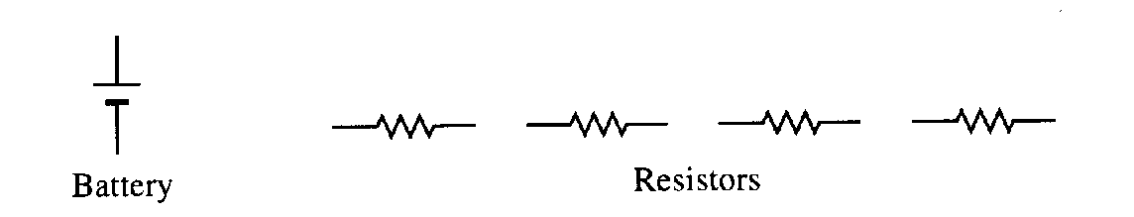
B. List the bulbs in order of their brightness, from brightest to least bright. If any two or more bulbs have the same brightness, state which ones. Justify your answer.
A, D, and then B & C equally.
All the current from the battery goes thru A, so it has the most current, greatest power, and is brightest.
The current splits between D and B & C which are parallel – they receive less current and aren’t as bright.
D is by itself and receives the next most current.
B & C in series have higher resistance than D, so they get the least. They receive the same amount since they are in series.
Bulb D is then removed from its socket.
- Describe the change in the brightness, if any, of bulb A when bulb D is removed form its socket. Justify your answer.
Bulb A becomes dimmer.
The circuit becomes a series circuit. The resistance is greater so the current decreases. Light A receives less current and is less bright. All bulbs have the same brightness – the current is same through all bulbs, so the power and therefore the brightness is the same.

- Describe the change in the brightness, if any, of bulb B when bulb D is removed from its socket. Justify you answer.

Bulb B becomes brighter.
It was receiving the least amount of current since D was an alternate pathway for the current. With D gone all the current must go through B, which is in series now. More current means B will be brighter.
From 1996:
- A student is provided with a 12.0-V battery of negligible internal resistance and four resistors with the following resistances: 100 Ω, 30 Ω, 20 Ω, and 10 Ω. The student also has plenty of wire of negligible resistance available to make connections as desired.

  - Using all of these components, draw a circuit diagram in which each resistor has nonzero current flowing through it, but in which the current from the battery is as small as possible.

Draw a circuit where all the resistors are in series. This maximizes the resistance, which will make sure that the current is the smallest amount possible.

  - Using all of these components, draw a circuit diagram in which each resistor has nonzero current flowing through it, but in which the current from the battery is as large as possible (without short circuiting the battery).

Draw a circuit where all the resistors are in parallel. This will minimize the resistance which will max out the current.

The battery and resistors are now connected in the circuit shown.

  - Determine the following for this circuit.
    - The current in the 10 Ω resistor.
This is the current in the 10 Ω resistor since it is in series with everything else.

    - The total power consumption of the circuit.

  - Assuming that the current remains constant, how long will it take to provide a total of 10 kJ of electrical energy to the circuit?
From 1995:
- A certain light bulb is designed to dissipate 6.0 watts when it is connected to a 12 volt source.
  - Calculate the resistance of the light bulb.
  - If the light bulb functions as designed and is lit continuously for 30. days, how much energy is used? Be sure to indicate the units in your answer.
The 6.0 watt, 12 volt bulb is connected in a circuit with a 1,500 watt, 120 volt toaster; an adjustable resistor; and a 120 volt power supply. The circuit is designed such that the bulb and the toaster operate at the given values and, if the light bulb fails, the toaster will still function at these values.

  - On the diagram below, draw in wires connecting the components shown to make a complete circuit that will function as described above.
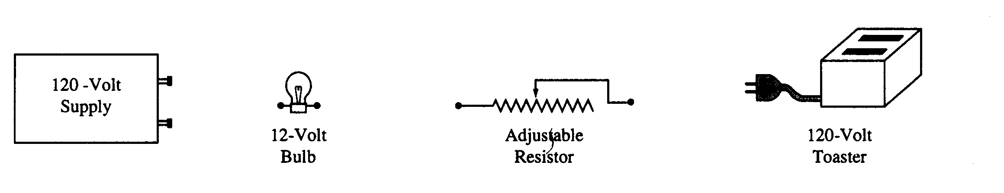
Okay let’s draw in some wires. The basic idea is that the bulb must have 12 V to produce the 6.0 watts. The toaster requires 120 volts to operate properly. So the bulb must be in series with the adjustable resistor – the resistor needs to have a voltage drop of 120 V – 12 V. Then the bulb will have a voltage drop of 12 V. The toaster needs to be in parallel with the bulb/resistor deal. Let’s draw the circuit (add the lines).
  - Determine the value of the adjustable resistor that must be used in order for the circuit to work as designed.
The bulb has a resistance of 24 Ω (which we figured out in the first part of this question). We can calculate the current that flows through the bulb. This will be same current as the resistor gets.

Now we know the current and the voltage through the parallel leg of the bulb/resistor leg. The total voltage is the sum of the two voltages dropped by each component, the bulb and the resistor. The resistor drops 12 V, the total voltage is 120 V, so we can find the voltage drop for the resistor.

Now we can use Ohm’s law to find the resistance for the adjustable resistor.

  - If the resistance of the adjustable resistor is increased, what will happen to the following?
    - The brightness of the bulb. Briefly explain your reasoning.
If resistance goes up then current drops in the resistor. Current stays the same in series, so it also drops in the light. If the light receives less current, then it will be less bright. Recall that since the current flowing into the bulb is less, the power is less, and the bulb is not as bright.

    - The power dissipated by the toaster. Briefly explain your reasoning.
Voltage is the same in parallel. The toaster still receives 120 V. It will draw the current it needs from the power supply. The resistance change in the other leg of the circuit has not effect on the toaster.

