AP Physics – Energy Wrapup

Here are the equations that you will have available for you on AP test.
This is the equation for kinetic energy

This is your basic equation for gravitational potential energy.

The equation for work. Remember that if the angle θ is zero, the equation simplifies and becomes the first one. The Δr is the displacement.

Power equation. Here it’s called average power.

Another power equation. This here one uses an applied force and the velocity of the object. The part is for when the velocity is at an angle to the direction of the force.

Hooke’s law, the force on a spring deal. It gives the force required to compress a spring. This is also the force that the compressed spring can exert when it is released. The minus signs just means that the force the spring exerts is in the opposite direction of the force that compressed the spring.

Kinetic energy stored in a spring.

These are the equations for mechanical work, power, and energy. Later on in the course there will be other equations for energy as well, especially electrical potential energy and the maximum kinetic energy an electron can have after its been knocked out of the surface of a metal (the old photoelectric effect). But rest easy, we’ll get there.

Here is a list of the different sorts of things that you should be able to do in order to demonstrate your mastery of the material.

- Work and Energy Theorem

- You should understand the definition of work so you can:

- Calculate the work done by a specified constant force on a body that undergoes a specified displacement.

Use the equation for work.

- Relate the work done by a force to the area under a graph of force as a function of position and calculate this work in the case where the force is a linear function of position.

This is where you have a graph with force on the y axis and displacement on the x axis. The area under the curve represents the work done in changing an objects displacement from one point to another. We did a couple three of these problems. Kind of a geometry thing to find the area under the curve if the force isn’t constant. Of course if the force is constant then the area is simply the width times the height and the work is F times d.

- Use the scalar product operation to calculate the work performed by a specified constant force F on a body that undergoes a displacement in a plane.

The “scalar product operation” sounds pretty hairy, but actually means that you “multiply”. Anyway, you just use you the good old work equation.

- You should understand the work-energy theorem so you can:

- Calculate the change in kinetic energy or speed that results from performing a specified amount of work on a body.

The Physics Kahuna worked hard to drill this into your brains. The basic idea is that the change in kinetic energy of a system is equal to the work done on the thing. This is also true for the change in potential energy for a system. It takes work to change something’s potential energy. It also takes work to change its kinetic energy. If you do 45 J of work changing an object’s potential energy, it then has 45 J of potential energy. This means it can then do 45 J of work. This work can be transformed into other forms of energy – kinetic, thermal, &tc.

- Calculate the work performed by the net force, or by each of the forces that makes up the net force, on a body that undergoes a specified change in speed or kinetic energy.

The idea here is that the work done on the body is equal to its change in kinetic energy. So if you know the change in speed of the thing you can find its change in kinetic energy which is equal to the work done, &tc. The force is involved usually to find the acceleration of the system. Once you know the acceleration you can find the speeds, and once you know the speeds, you can find the change in kinetic energy.

- Apply the theorem to determine the change in a body’s kinetic energy and speed that results from the application of specified forces, or to determine the force that is required in order to bring a body to rest in a specified distance.

This is a lot like the item above. Once again you use the force to find the acceleration and then that gets you into the whole speed/kinetic energy thing. You can also work backwards – kinetic energy to change in speed to acceleration to force.

- Conservative Forces and Potential Energy

- You should understand the concept of conservative forces so you can:

- Write an expression for the force exerted by an ideal spring and for the potential energy stored in a stretched or compressed spring.

You just write out the equations, which are given. Easy as pie.

- Calculate the potential energy of a single body in a uniform gravitational field.

Use the equation.

- You should understand conservation of energy so you can:

- Identify situations in which mechanical energy is or is not conserved.

Energy is always conserved. Mechanical energy though means potential energy and kinetic energy. The main types of potential energy would be gravitational, energy in a spring. Later there will also be potential energy from an electric field, potential energy stored in a capacitor, and potential energy of photoelectric electrons. It’s all treated the same.

In elastic collisions we assume that kinetic energy is conserved.

Examples where mechanical energy is not conserved is when you have friction involved. The frictional force does work, which is an energy loss. Basically you have this:

We did several problems involving this sort of thing. Mainly with objects sliding down ramps where there was a coefficient of friction. You recall you had stuff like;

where is work done by friction – friction force multiplied by displacement. Here d is the distance the thing slid.

- Apply conservation of energy in analyzing the motion of bodies that are moving in a gravitational field and are subject to constraints imposed by strings or surfaces.

Think of things swinging off a platform type deal from a string to some lower height. We did several of these. These are your Tarzan on a grapevine type deal. Also you could get an object moving from a table top to the deck below.

In both of these examples, the body would undergo a change in potential energy. You’d usually have to find out what its new velocity would be or what the change in height was – that kind of stuff.

- Apply conservation of energy in analyzing the motion of bodies that move under the influence of springs.

Did you not totally love the spring energy problems we did? Go look at ‘em and relive the pleasure.

- Power

- You should understand the definition of power so you can:

- Calculate the power required to maintain the motion of a body with constant acceleration (e.g., to move a body along a level surface, to raise a body at a constant rate, or to overcome friction for a body that is moving at a constant speed).

Use the equation. Use the acceleration to find F, which will be the net force, i.e., the sum of the forces. If they throw friction at you or some other force, just remember that the force you find using acceleration is the net force. You’ll have to write an equation for the sum of the forces.

- Calculate the work performed by a force that supplies constant power, or the average power supplied by a force that performs a specified amount of work.

Use the equation as above. To get into work, use the general work equation. Just remember that you’re dealing with the net force as above.

The big thing on the test will be conservation of energy – the idea that the energy before has to equal the energy after. You should know when and how to use this concept. Expect spring problems or gravity problems, but there could be other ways to sore energy as well. The concepts will commonly be folded in with other stuff you haven’t had yet as well – electricity, magnetism, or nuclear physics for example.

Conservation of energy is one of the biggest deals in physics, so be really good at it because it will be all over the test.

Here are a couple of typical problems off previous tests:

This is question number 2 from the 1986 exam.

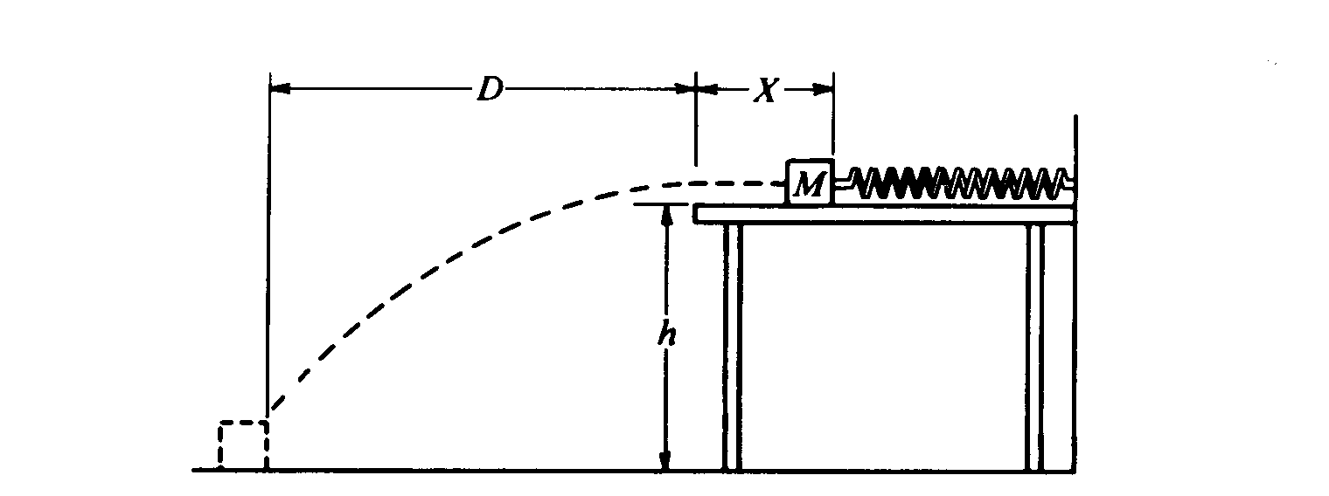
- One end of a spring is attached to a solid wall while the other end just reaches to the edge of a horizontal, frictionless tabletop, which is a distance h above the floor. A block of mass M is placed against the end of the spring and pushed toward the wall until the spring has been compressed a distance X, as shown below. The block is released, follows the trajectory shown, and strikes the floor a horizontal distance D from the edge of the table. Air resistance is negligible.
Determine expressions for the following quantities in terms of M, X, D, h, and g. Note that these symbols do not include the spring constant.
  - The time elapsed from the instant the block leaves the table to the instant it strikes the floor.

This time is controlled by the time it takes for the block to fall.

(This is a projectile motion problem, ain’t it?)
  - The horizontal component of the velocity of the block just before it hits the floor.

Velocity is constant in the x direction. We’ve figured out the time of flight.

  - The work done on the block by the spring.

Let’s use conservation of energy to solve this one. (Finally we get into work and energy.)

  - The spring constant.

The work is also equal to the potential energy of the spring.

Here’s another lovely problem:

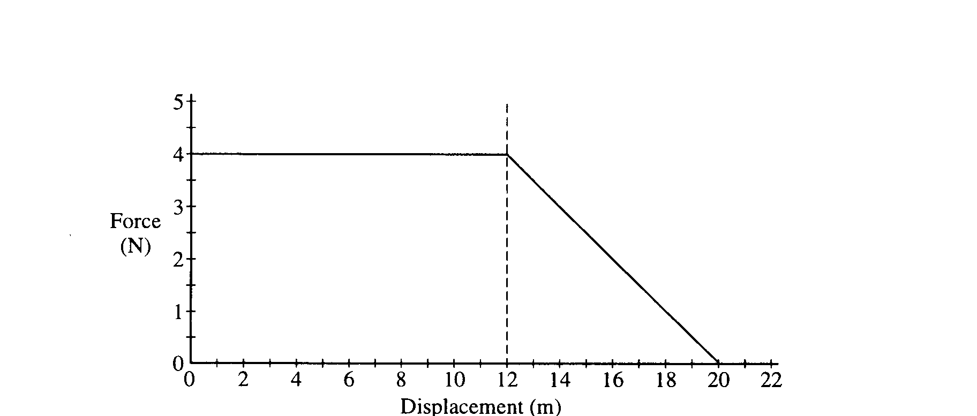
- A 0.20 kg object moves along a straight line. The net force acting on the object varies with the object's displacement as shown in the graph. The object starts from rest at displacement x = 0 and time t = 0 and is displaced a distance of 20 m. Determine each of the following.
- The acceleration of the particle when its displacement x = 6 m.
The force is constant from time zero till its displacement is 6 meters, so we can use the second law.

- The time taken for the object to be displaced the first 12 m.
Again, the force is constant from the start till the displacement is 12 m. This means that the acceleration is also constant, so we can use one of the kinematic equations to find the time.
- The amount of work done by the net force in displacing the object the first 12 m.
The work done is the area under the curve:

- The speed of the object at displacement x = 12 m.
We can use conservation of energy to solve this bit.
- The final speed of the object at displacement x = 20 m.
We can use conservation of energy again. The work is equal to the area under the curve, so we add the area of the rectangle to the area of the triangle.

f. The change in the momentum of the object as it is displaced from x = 12 m to x = 20 m.
You’ll learn all about momentum in the next unit.

