AP Physics – Review - 3

Kranken Hause___________________________________________________________________Per___
The rules of clockwork might apply to familiar objects such as snookerballs, but when it comes to atoms,
the rules are those of roulette. -- Paul Davies
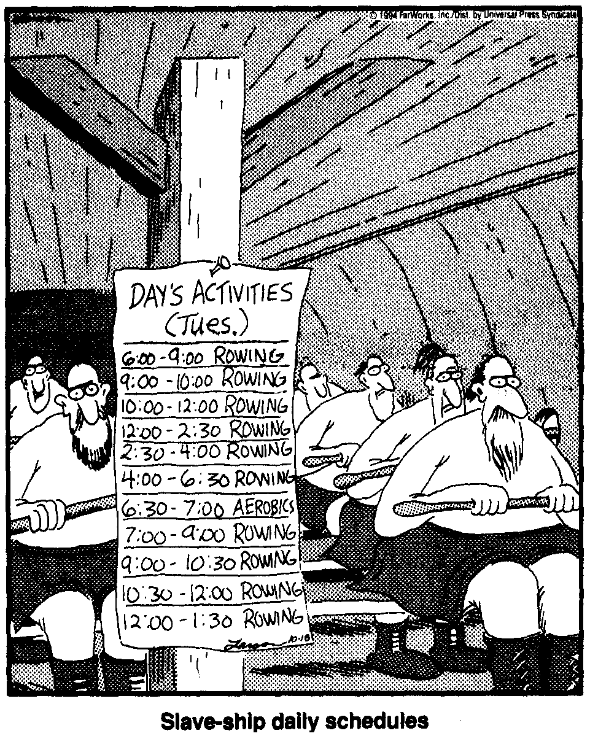
- A scuba tank has a volume of 1.50 L. It is at a pressure of 315 atm. The temperature is 25.0°C. How many moles of air does the tank hold?

- What is the average velocity of the particles of hydrogen gas at 25.5°C?

- In a thermodynamic process, a system absorbs 755 kJ of heat and does 117 kJ of work on its surroundings. By what amount did the system’s internal energy increase?

- A steam engine operates on a warm 28.0 °C day. The saturated steam operates at a temperature of 350.0 °C. What is the ideal efficiency for this engine?

- If you took all the heat energy that it takes to heat 10.0 liters of water from 20.0° C to 27.0°C for a baby’s bath and could somehow give it to the 5.0 kg baby in the form of kinetic energy directed vertically upward, how high would the baby go, ignoring friction (of course)?

- A 135.5 kg weight falls a distance of 12.5 m. It is attached to a set of paddles that rotate in an insulated tank of water. If the mass of the water is 3.50 kg and it begins at a temperature of 25.0°C, at what temperature does it end up?

- Three identical resistors, each of resistance 30.0 Ω are connected in a circuit to heat water in a glass beaker. 24.0 V battery with negligible internal resistance provides the power.
  - The three resistors may be connected in series or in parallel.
    - If they are connected in series, what power is developed in the circuit?
    - If they are connected in parallel, what power is developed in the circuit?
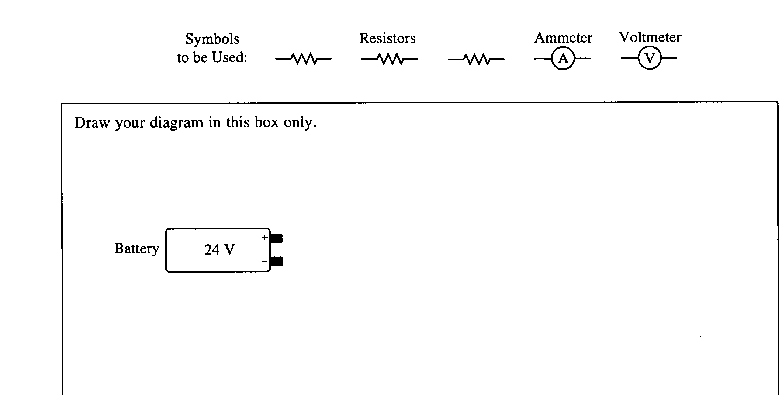
  - Using the battery and one or more of the resistors, design a circuit that will heat the water at the fastest rate when the resistor(s) are placed in the water. Include an ammeter to measure the current in the circuit and a voltmeter to measure the total potential difference of the circuit. Assume the wires are insulated and have no resistance. Draw a diagram of the circuit in the box below, using the following symbols to represent the components in your diagram.
  - The resistor(s) in the circuit in part (b) are now immersed in a 0.500 kg sample of water, which is initially at 298 K. Assume that the water absorbs all of the heat produced.
    - Calculate the amount of time it takes for the water to begin to boil.
    - Under actual experimental conditions, would the time taken for the water to boil be longer or shorter than the calculated time in part (c, i)? Justify your answer.
  - As the circuit continues to provide energy to the water, vapor is formed at the same temperature as the boiling water. Where has the energy used to boil the water gone?

