AP Physics – Thermo – 3 Ans
- A scuba tank has a volume of 1.50 L. It is at a pressure of 315 atm. The temperature is 25.0°C. How many moles of air does the tank hold?
- What is the average velocity of the particles of hydrogen gas at 25.5°C?
- In a thermodynamic process, a system absorbs 755 kJ of heat and does 117 kJ of work on its surroundings. By what amount did the system’s internal energy increase?
- A steam engine operates on a warm 28.0 °C day. The saturated steam operates at a temperature of 100.0 °C. What is the ideal efficiency for this engine?
- 35.7 kJ of energy are required to raise the temperature of a gold statue from 25.0°C to 435°C. What is the mass of the gold?
- A 135.5 kg weight falls a distance of 12.5 m. It is attached to a set of paddles that rotate in an insulated tank of water. If the mass of the water is 3.5 kg and it begins at a temperature of 25.0°C, at what temperature does it end up?

- Three identical resistors, each of resistance 30 Ω are connected in a circuit to heat water in a glass beaker. A 24 V battery with negligible internal resistance provides the power.
  - The three resistors may be connected in series or in parallel.
    - If they are connected in series, what power is developed in the circuit?
    - If they are connected in parallel, what power is developed in the circuit?
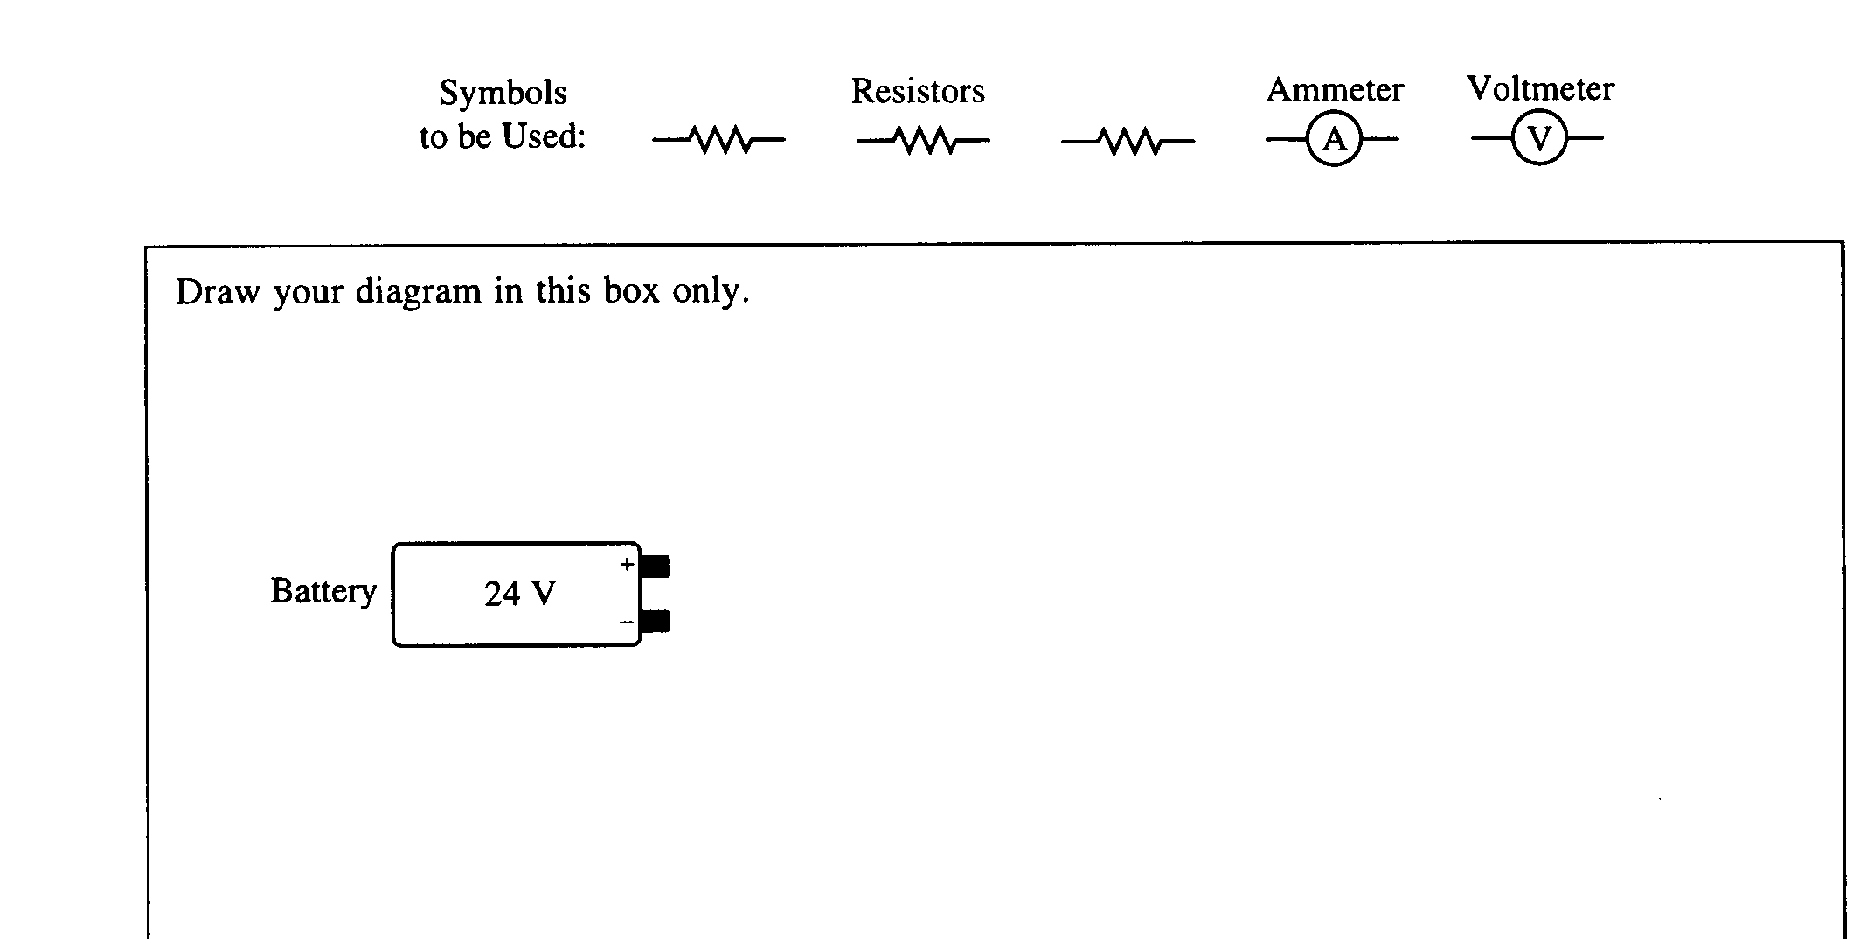
  - Using the battery and one or more of the resistors, design a circuit that will heat the water at the fastest rate when the resistor(s) are placed in the water. Include an ammeter to measure the current in the circuit and a voltmeter to measure the total potential difference of the circuit. Assume the wires are insulated and have no resistance. Draw a diagram of the circuit in the box below, using the following symbols to represent the components in your diagram.
V
A
  - The resistor(s) in the circuit in part (b) are now immersed in a 0.5 kg sample of water, which is initially at 298 K. The specific heat of water is 4,200 J/kg •K. Assume that all of the heat produced is absorbed by the water.
    - Calculate the amount of time it takes for the water to begin to boil.
    - Under actual experimental conditions, would the time taken for the water to boil be longer or shorter than the calculated time in part (c, i)? Justify your answer.
Longer. Some heat is lost to the environment.
  - As the circuit continues to provide energy to the water, vapor is formed at the same temperature as the boiling water. Where has the energy used to boil the water gone?
latent heat of vaporization is required to overcome the strength of the hydrogen bond intermolecular forces.

