AP Physics - Wave LP

Sound ≡ Longitudinal Wave

Audible Sound Waves ≡ 20 – 20 000 Hz

Infrasonic ≡ frequency less than 20 Hz

Ultrasonic ≡ frequency greater than 20 000 Hz
Speed of sound in air:

T is degrees Celsius

At 0 °C v of air is about 331 m/s

Use 345 m/s for problem solving

- What is speed of sound if temperature is 25.0°C?

Doppler

Relative motion between sound source and listener

Observer stationary, moving sound source:

Negative sign when source is closing

Observer moving, stationary source:

Plus sign if observer closing

Source and observer both moving:

+ v₀ and - v_{s} motion observer/source TOWARDS each other

- v₀ and + v_{s} motion observer/source AWAY from each other

- Train whistle - 550.0 Hz. Train traveling at 125 km/h. What is frequency heard by stationary listener in front of train?

- Car traveling at 35.0 m/s honks 775 Hz horn at jogger running away from car (in front of it) at 10.9 m/s. What frequency is heard?

Supersonic travel

Shock Wave

Mach number
Standing waves:

Incident wave and reflected wave in medium at same time
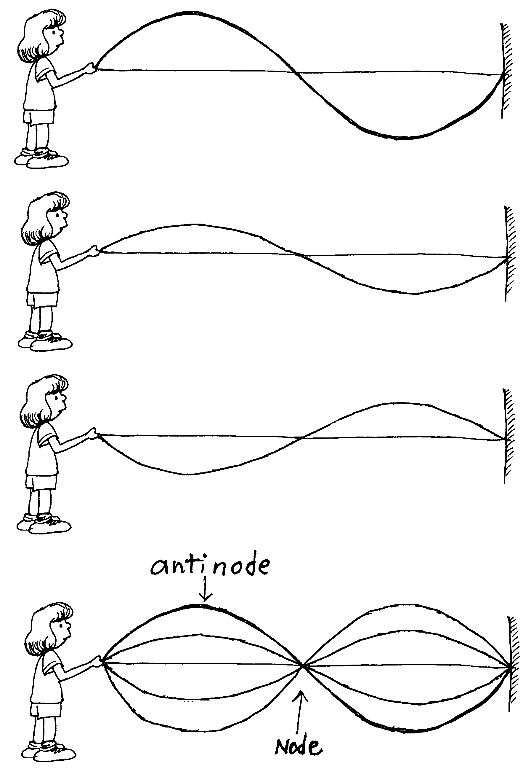

Fundamental Frequency ≡ Lowest frequency of vibration

First Harmonic

Second Harmonic

Third Harmonic

Change frequency of stretched string:

Change length

Change tension

Change density

Change Diameter

Standing waves in air columns (pipes)

Closed end pipes:

Only odd Harmonics

Open End Pipes:

All Harmonics present

Pipe open at one end:

Pipe Open at both ends:

- Pipe is closed at one end, 1.50 m in length. If sound speed is 345 m/s, what are the frequencies of the first three harmonics that would be produced?

Forced Vibration

Resonance ≡ driving force is same frequency as one of the harmonics

