AP Physics – Quantum Mechanics LP

Problems with behavior of electrons

Black Body Problem

Higher the temp, greater the freq, shorter the wavelength

Total radiation -- area under curve

Increases with T

Classical physics could not explain Curve

Classical mechanics works -- long wavelengths

Classical mechanics predicted E would approach infinity as wavelength approached zero

Max Planck

- What energy is carried by a quantum (photon) of electromagnetic radiation that has a frequency of 1.55 x 10¹⁷ Hz?

Energy as function of wavelength:

Photoelectric Effect

Light incident on metals – electrons get emitted

Energy that binds electron to metal

Depends on metal

Equation on AP test

Photon’s energy less work function

Pg 579 in handout

- What is the velocity of a photoelectron that has been liberated from a zinc metal surface by a photon that has a wavelength of 275 nm?

work function for zinc is 4.31 eV

Photoelectric Lab Setup:

Emitter ≡ Plate at neg potential
Light strikes emitter

Electrons emitted

Electrons travel to Collector

Vary wavelength:

intensity constant,

Get current curve

λ₀ ≡ photo-electric threshold wavelength

Current Depends on wavelength

Increase V -- max current

Even at zero potential get some current

Make Collector negative

-- Collector Repels electrons

-- Current drops to low value

ΔV less than or equal to ΔV_{s} no electrons reach C

All electrons get turned away

ΔV_{s} ≡ Stopping potential

current is zero

no electrons reach Collector

Stopping potential independent of light intensity

Max K is energy gained in field (PE:

SO
K_{Max} independent of intensity!

Einstein explained in 1905 (Noble Prize)

Electrons bound to metal

Photon gives all its energy to single electron

Electron gains energy and is liberated

Energy gained exceeds the energy that binds it to the metal

graph of frequency VS. kinetic energy

Has straight line.

f_{C} ≡ cutoff frequency

Slope of graph is h

Cutoff Frequency -- minimum frequency that will generate photoelectrons

minimum frequency is when kinetic energy = zero.

Set K_{Max} = 0

Cutoff Wavelength

Set K_{Max} = 0

–photon E can just overcome work function

be prepared to derive these equations on AP test

- What is the cutoff wavelength for a copper metal surface?

wavelength is smaller than visible light

Finding Work Function:

Set K_{Max} = 0 - solve for φ

Use cutoff wavelength

Also can find as function of cutoff frequency.

- 500.0 nm light is incident on a metal surface. The stopping potential is found to be 0.440 V. (a) Find the work function for this material and (b) the longest wavelength that will eject electrons from the metal.

(a) work function:

(b) longest wavelength

Classical Mechanics or wave theory cannot explain:

- No electrons emitted if light freq falls below cutoff freq, f_{C}

- Max K independent of light intensity

- Electrons emitted almost instantaneously

- KE_{Max} increases with increasing freq as it is function of hf

- Happens so fast because it is a one to one photon/electron deal

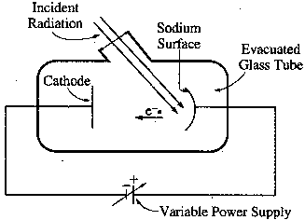AP Test: A sodium photoelectric surface with work function 2.3 eV is illuminated by electromagnetic radiation and emits electrons. The electrons travel toward a negatively charged cathode and complete the circuit shown below. The potential difference supplied by the power supply is increased, and when it reaches 4.5 V, no electrons reach the cathode.

(a) For the electrons emitted from the sodium surface, calculate the following.
i. The maximum kinetic energy.

ii. The speed at this maximum kinetic energy.

(b) Calculate the wavelength of the radiation that is incident on the sodium surface.

(c) Calculate the minimum frequency of light that will cause photoemission from this sodium surface.
for minimum Freq

Stopping Potential versus frequency

Stopping potential is function of frequency

Higher frequency → higher V_{S}

intercept on x axis is stopping potential for cutoff frequency.

At f_{C} - total E = φ

This energy = energy of photon, so:

solve for h/e

h/e is slope of the graph

AP Test Item:

- In a photoelectric experiment, light is incident on a metal surface. Electrons are ejected from the surface, producing a current in a circuit. A reverse potential is applied in the circuit and adjusted until the current drops to zero. That potential at which the current drops to zero is called the stopping potential. The data obtained for a range of frequencies are graphed below.
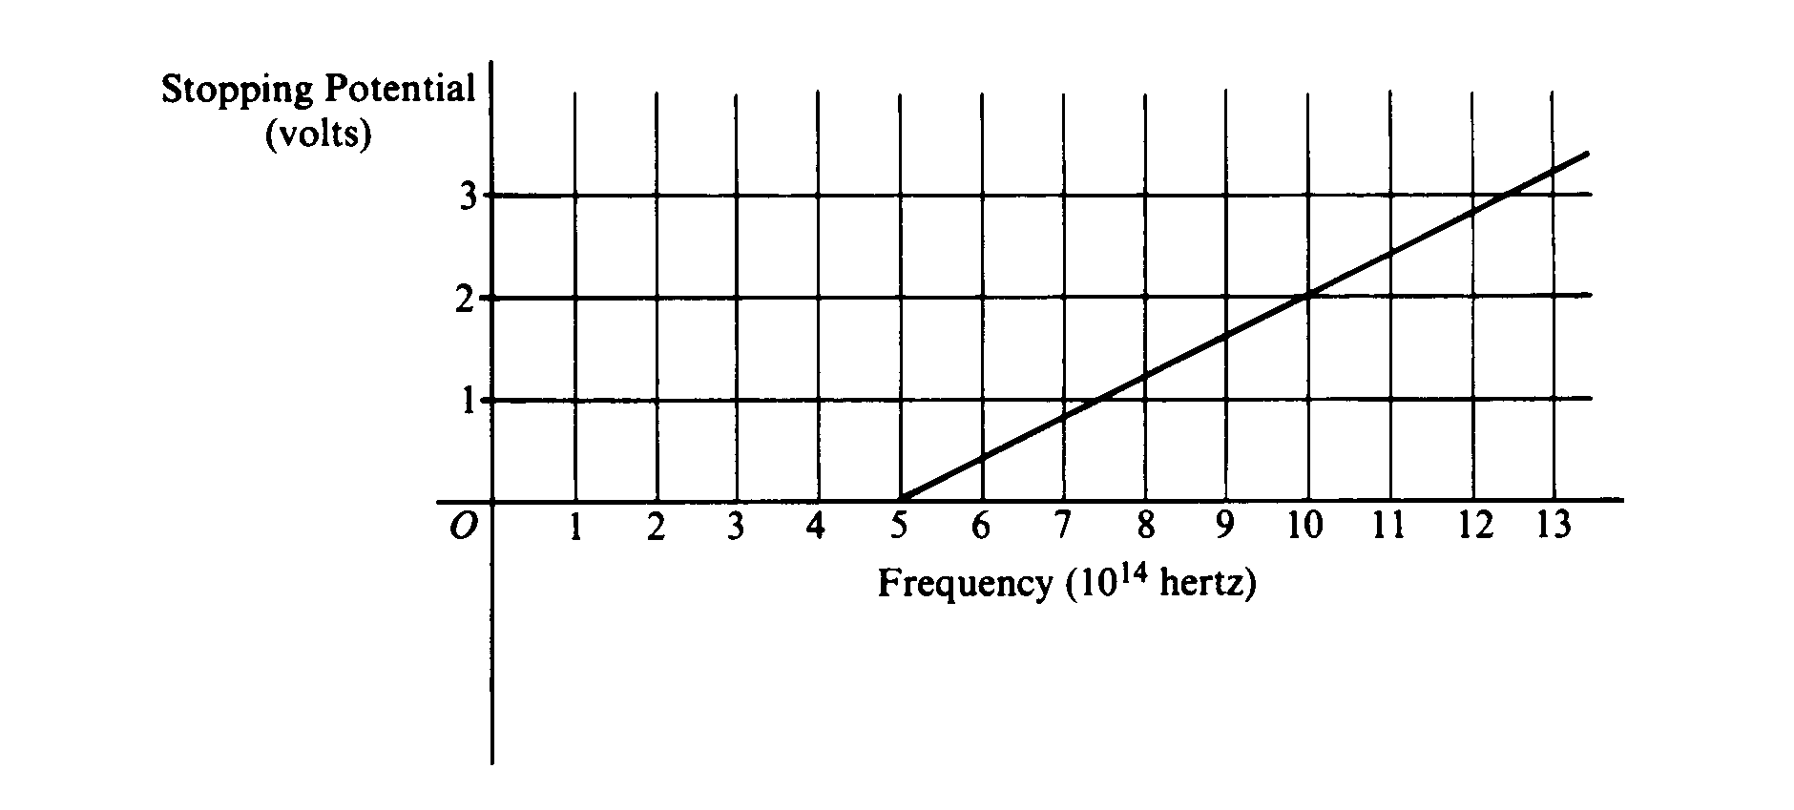

a. For a frequency of light that has a stopping potential of 3.0 volts, what is the maximum kinetic energy of the ejected photoelectrons?

b. From the graph and the value of the electron charge, determine an experimental value for Planck's constant.

Slope of graph is

or

c. From the graph, determine the work function for the metal.
graph of straight line
But eV_{s} is K_{Max}

so y intercept is work function φ times e

This is 2.0 eV

d. On the axes above, draw the expected graph for a different metal surface with a threshold frequency of 6.0 x 10¹⁴ hertz.

Photons and Power:

Given power of light source and wavelength

Can calculate number of photons per second.

- An LED produces 685 nm light at a power rating of 1.25 x 10⁻⁷ W. Find the number of photons emitted per second.
let t = 1 second solve for E

Energy of one photon:

