AP Physics – Quantum Mechanics

At the turn of the century, physics was in a terrible fix. What was the problem? Well, it was with the behavior of electrons. Classical physics had gotten quite good at dealing with motion, orbits, &tc. A physicist could sit down and figure out exactly what and where an electron should be doing. Unfortunately, the rotten electrons did not oblige the physicists with doing what it was supposed to be doing.
Ernest Rutherford pictured the atom as a sort of miniature solar system. The electrons circled the nucleus in orbits, just like the planets circle the sun. According to classical, Newtonian physics, a centripetal force acts on the electron, accelerating it towards the nucleus. This force is caused by the charge difference between the positive nucleus and the negative electron. The problem was this: accelerated electrons emitted light. Thus as the electrons were accelerated towards the nucleus, they should radiate photons of light. This would cause them to lose energy, which would drop them into a lower orbit, they would emit light, drop into a lower orbit, and so on. In about 10⁻⁹ seconds the electron would spiral into the nucleus. This meant that atoms as we know them could not exist in a stable state.

Unfortunately for classical physics, but fortunately for the universe, this does not happen. Clearly something was going on with the behavior of electrons that did not fit into classical kinematics.

Black Body Problem: All objects in the universe constantly emit electromagnetic waves. This is a fact of nature. You, as you read this, are quite happily emitting massive numbers of photons from all over your body into the universe. You, blighter that you are, have done this your entire life!

The frequency of the waves is a function of temperature – and only temperature. The higher the temperature of the body, the higher the frequency (and the shorter the wavelength) of the emitted electromagnetic wave. It doesn’t matter what the object is made from, for a given temperature it will emit a given frequency of light.

At the turn of the century physicists were looking at “black bodies”. A black body is one of those ideal things that physicists love to invent. It is defined as being an object that absorbs all the light that is incident on it. If you take a ball and make a small hole in it, the interior of the ball will appear to be black. The interior behaves as if were a black body - it absorbs just about all the electromagnetic waves that enter it. The radiation that does comes out of the hole from the inside of the thing depends only on its temperature and we refer to it as black body radiation

Stars are considered to be black bodies (even though they certainly aren’t black). Planets can be treated as black bodies as well.

Below is a graph made up of the emissions from a blackbody at three different temperatures. The area under the curve represents the total radiation. Each curve has a peak wavelength – this is the wavelength at which most of the energy is emitted. For 4 000 K you can see that the amount of radiation is much greater than for the lower temperature curves. The 3 000 K curve also has a peak wavelength, but it has a greater value than the one for the higher temperature – the wavelength of the emitted radiation is longer, which means that it has a lower frequency. The 2 000 K curve’s peak wavelength is much smaller in amplitude and longer in wavelength. Its frequency is lower as well.

The general rule is that the intensity and frequency of emitted radiation increases with temperature. This is seen in stars and planets. Planets, which are very cool, don’t even emit visible light, they can only manage infrared. Cool stars give off mostly red light, warmer stars give off yellow light, and the hottest stars give off blue light.

Classical mechanics cannot explain these curves. It works for the long wavelengths, but as the wavelength decreases (and the frequency increases), classical mechanics’ predictions become very bad, very bad indeed. In fact the old theory predicts that the intensity of the emitted radiation will approach infinity as the wavelength nears zero. You can see that this does not happen. The curve shows that as the wavelength gets close to zero, the intensity also approaches zero.
This is one of your basic contradictions. Classical mechanics cannot explain what actually happens, so physicists were forced to abandon the laws of Newton and develop a new theory that would explain the data. The theory that came out of this is known as quantum mechanics.
Max Planck (1858-1947) was a German physicist who spent a great many years trying to puzzle out this problem. Planck was trying to find a fundamental law that would describe the energy emitted by blackbodies. He got the job done, but to get this law to work, he had to assume that the radiation was made up of little packets of energy. He called these packets quanta (singular) and quantum (plural). There was no evidence for the quanta, except that the made his law work. Using this cobbled up thing, he was able to explain the blackbody radiation curve. Planck believed that the quanta were merely an artificial, mathematical device without reality that just happened to make his equation yield accurate results.

Planck’s equation is:

Here, E is energy, f is the frequency, and h is known as Planck's constant. It’s value is:

or .

- What energy is carried by a photon of electromagnetic radiation that has a frequency of 1.55 x 10¹⁷ Hz?

The energy of a photon can also be written as a function of wavelength. Wavelength is related to frequency by:

This is the equation for the speed of the wave.

Planck's theory came to be called the quantum theory and proved so important, that it is considered to be a watershed in science. All physics before Planck’s equation is called classical physics and all physics afterwards is known as modern physics.

But what did all this mean?

Photoelectric Effect: Towards the end of the 19th Century (in 1887 to be exact) Heinrich Hertz discovered that certain metals would emit electrons when light was incident on them. This was the first instance of light interacting with matter and was very mysterious. In 1905 Albert Einstein, a 3rd Class Technical Expert in the Swiss Patent Office, published a paper which provided the explanation for the effect. The light was actually made up of small particles - Planck’s little bundles of energy he called the quanta. These particles are now called photons.
The surface electrons were bound to the metal with a small amount of energy. Some of the incident photons would enter the surface of the metal and be totally absorbed. They would give their energy to the electron, which, if the absorbed energy was great enough, could then break free and be released. You can think of the photoelectric effect as being the result of collisions between photons and electrons which knock the electrons out of the metal.

The amount of energy binding the electrons to the metal is called the work function. The symbol for this is the Greek letter φ.

Recall that:

This is the energy of the photon.

The electron that has been knocked out of the metal has some amount of kinetic energy. This kinetic energy has to be less than the photon’s energy because some of the energy added to the system was used to break the electron free of the metal (this amount of energy is given by the work function). So the photon has to provide more energy than the work function if the electron is to be set free.

The maximum kinetic energy that an electron can have is just the difference between the energy of the work function (the energy that binds the electron to the metal) and the energy of the photon.

Work Function for some Different Metals
Metal | Work Function
Sodium (Na) | 2.28
Aluminum (Al) | 4.08
Copper (Cu) | 4.70
Cobalt (Co) | 3.90
Zinc (Zn) | 4.31
Silver (Ag) | 4.73
Platinum (Pt) | 6.35
Lead (Pb) | 4.14
Iron (Fe) | 4.50
Each metal has its own value for the work function. A handsome table of such values for selected metals has been helpfully provided to you.

Dear Doctor Science,
What is a laser beam made of?
-- Lauren Grace from Toledo, OH

Dr. Science responds:
Normal light is comprised of zillions of photons. Laser light is made of futons, which are fat, stuffed photons with a zipper down the side. Some have a foam core and these are often mistakenly referred to as mu mesons, which is just a fancy oriental term for futon. As in retail advertising, Science often gives the prosaic a new name to make it seem like things are really happening when, in fact, everyone is just playing Tetris on their office computers and waiting for lunch.
Wavelength and Energy: We have an equation that relates the electron’s energy to frequency, but what about the wavelength of the photon? For some reason physicists are very fond of wavelengths and prefer them frequencies.

The frequency and wavelength are related by the speed of light. So when we want to find the value for the frequency we get:

we can substitute this into the equation for kinetic energy and get:

This is the traditional equation used for the maximum kinetic energy of the photoelectron. It is the equation provided by the AP Physics Test.

The kinetic energy of the electrons is independent of the intensity of the light. More intense light will dislodge more electrons, so the current will increase, but the kinetic energy of the electrons will all be limited to the same value (the maximum kinetic energy).

Since the value of Planck’s constant multiplied by the speed of light is itself a constant, we can treat hc as a constant. (Save us some work!) Two such values, using different units, will be provided to you on the AP Test:

- What is the velocity of a photoelectron that has been liberated from a zinc metal surface by a photon that has a wavelength of 275 nm?

Consulting the table, we find that the work function for zinc is 4.31 eV. We can use this and the wavelength of the incident photons to find the kinetic energy of the ejected electrons. We can then solve for their velocity.

A typical laboratory setup for a photoelectric experiment would consist of a metal plate that the light will be incident upon. This plate is called the emitter (E). Across from the emitter is a plate called the collector (C). The emitter is connected to the negative terminal of a variable dc voltage source and the collector is connected to the positive terminal of the source. An ammeter is placed in series with the collector/battery and a voltmeter is placed in parallel with the photoelectric element. A typical circuit is shown below.

A typical laboratory setup for a photoelectric experiment would consist of a metal plate that the light will be incident upon called the emitter (E). Across from the emitter is a plate called the collector (C). The emitter is connected to the negative terminal of a variable dc voltage source and the collector is connected to the positive terminal of the source. An ammeter is placed in series with the collector/battery and a voltmeter is placed in parallel with the photoelectric element. A typical circuit is shown below.

Incident light strikes the emitter, which causes photo-electric electrons to be emitted. The electrons are attracted to the positively charged collector and a current is established. We can then measure the current and voltage.
If the wavelength of the incident light is varied, but the intensity of the light is kept constant, then we get a graph of current VS. wavelength that looks like this:

Notice that the current is emitted only for wavelengths less than ₀. For longer wavelengths, no current is emitted. These represent photons that don’t have enough energy to knock the electrons out of the metal.

This maximum wavelength, ₀ , is called the photoelectric threshold wavelength.
The amazing thing is that the current does not depend on the intensity of the light. This seems to make no sense. You would think that if you made the light brighter, you ought to get a bigger photo electric current. It’s another instance where classical physics fell apart.

According to classical physics, the incident waves would provide the energy to knock the electrons out of the metal. The greater the intensity of the light, the more electrons ought to be knocked loose. But this didn’t happen. For a great many wavelengths, no photoelectric current would flow no matter how large the intensity.

Current does depend on intensity, but only for wavelengths that cause the photoelectric effect.

Effect of Collector Voltage: If the positive voltage on the collector is increased we soon get a maximum amount of current. If the intensity is increased, we also see an increase in the current. But even for zero voltage on the collector, some current will flow. But what happens if you make the collector’s voltage negative instead of positive?

The electrons will be repelled from the collector. If the voltage is small, some will still make it, but as the voltage gets more negative it becomes harder and harder for the electrons to bridge the gap. More and more are turned away and the current falls off. At some voltage value, none of the electrons make it to the collector and current is zero. This is shown in a graph of Voltage VS. Current below.

At ΔV_{s} the current stops completely. If ΔV is less than or equal to ΔV_{s} no electrons reach the collector and all electrons are repelled.

ΔV_{s} is called the stopping potential.

The stopping potential is independent of the intensity of the light!

The electron is accelerated through the electric field between the collector and emitter. The energy it gains is equal to the potential energy the electron starts with. The equation for this energy is in the Electricity and Magnetism section of the equation sheet. It is given as . So at the stopping potential, the potential energy of the electrons is equal the maximum kinetic energy.
We can write:

Note here that K_{Max} is also independent of the intensity of the light!

If we look at a graph of frequency VS. kinetic energy, we see it has a straight line.

There is a minimum frequency before the electrons have any kinetic energy. The minimum frequency is called the cutoff frequency. The photons with a frequency less than f_{C} don’t have enough energy to dislodge the electrons from the metal.

The slope of the graph is h, Planck’s constant.

The value for the cutoff frequency is simply the intercept on the x axis.

The equation for kinetic energy as a function of frequency is:

This is a linear equation and the values for it can be found from the graph.

Finding the Cutoff Frequency: The cutoff frequency is the minimum frequency that will generate photoelectrons. So we use the max kinetic energy equation. The minimum frequency occurs when the kinetic energy is zero.
So the cutoff frequency is:

Cutoff Wavelength: At the cutoff wavelength, the kinetic energy of the electrons is zero – the photon has just enough energy to overcome the work function with nothing left over to give the electron any kinetic energy.

We can take the energy equation and set the kinetic energy to zero.

You should be prepared to derive these equation on the AP Test. Remember, just set the kinetic energy to zero and solve for wavelength.

- What is the cutoff wavelength for a copper metal surface?

Note that this wavelength is much smaller than visible light, so no photoelectric effect for copper with visible light – this would have to be like ultraviolet light.

Finding the Work Function: To find the work function, set the kinetic energy to zero as above and solve for φ. The wavelength is the cutoff wavelength, which is the minimum wavelength. The work function is the minimum energy needed to break an electron out of the metal’s surface.

Also, we can find it as a function of the cutoff frequency.

- 500.0 nm light is incident on a metal surface. The stopping potential is found to be 0.440 V. (a) Find the work function for this material and (b) the longest wavelength that will eject electrons from the metal.

(a) work function:

(b) longest wavelength

Classical Mechanics or wave theory cannot explain:

- No electrons emitted if light freq falls below cutoff freq, f_{C}

- Max K independent of light intensity

- Electrons emitted almost instantaneously

- KE_{Max} increases with increasing freq as it is function of hf

- Happens so fast because it is a one to one photon/electron deal

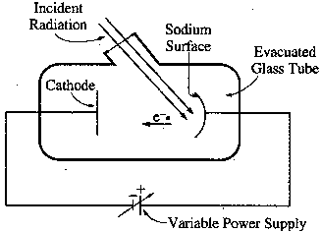AP Test Item: A sodium photoelectric surface with work function 2.3 eV is illuminated by electromagnetic radiation and emits electrons. The electrons travel toward a negatively charged cathode and complete the circuit shown below. The potential difference supplied by the power supply is increased, and when it reaches 4.5 V, no electrons reach the cathode.

(a) For the electrons emitted from the sodium surface, calculate the following.
i. The maximum kinetic energy.

ii. The speed at this maximum kinetic energy.

(b) Calculate the wavelength of the radiation that is incident on the sodium surface.

(c) Calculate the minimum frequency of light that will cause photoemission from this sodium surface.

for minimum Freq

Stopping Potential versus frequency: Stopping potential is a function of frequency. The higher the frequency, the higher the stopping potential. On the following graph stopping potential is plotted along the y axis while frequency is along the x axis. As you can see, the intercept on the x axis represents the stopping potential for the cutoff frequency.

At the cutoff frequency, the total energy is equal to the work function, so

So you can find the work function if the cutoff frequency is known.
At the stopping potential, the energy of the electron is equal to the electron charge times the voltage.

But this energy has to equal the energy of the photon, so:

solving for h/e

Thus, h/e is simply the slope of the graph.

AP Test Item 2: In a photoelectric experiment, light is incident on a metal surface. Electrons are ejected from the surface, producing a current in a circuit. A reverse potential is applied in the circuit and adjusted until the current drops to zero. That potential at which the current drops to zero is called the stopping potential. The data obtained for a range of frequencies are graphed below.
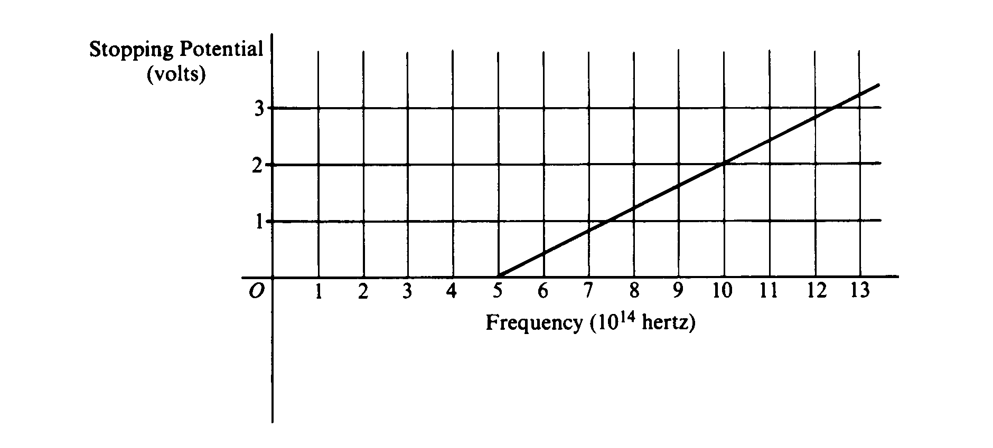

a. For a frequency of light that has a stopping potential of 3.0 volts, what is the maximum kinetic energy of the ejected photoelectrons?

b. From the graph and the value of the electron charge, determine an experimental value for Planck's constant.
Slope of graph is
or

c. From the graph, determine the work function for the metal.
graph of straight line
But eV_{s} is K_{Max} so y intercept is work function φ
This is 2.0 eV
d. On the axes above, draw the expected graph for a different metal surface with a threshold frequency of 6.0 x 10¹⁴ hertz.

