AP Physics – Quantum Mechanics Part 2

The photon theory received further support from the discovery of the Compton effect. This was in 1923. Arthur Compton aimed an x-ray beam at a chunk of graphite. An amazing thing took place; the scattered photons had a longer wavelength than the incident photons!

The energy of the scattered photons was less than the incident photons – because the wavelength was longer, right? The change in wavelength is called the Compton shift. So what happened to cause this energy to be lost? Compton figured that the photon, acting like a particle, has a collision with an electron in a carbon atom. Energy and momentum must be conserved, and the electron, initially at rest, gains energy. That energy has to come from something and it does, it comes from the incident photon. The energy gained by the electron is equal to the energy lost by the photon. Since the photon has lost energy, its wavelength must increase. This was stunning proof for the photon theory of light.

- In a collision, the photon acts like particle.
- Energy and momentum are conserved.
- The electron gets some of the photon’s energy and momentum.
- The photon loses energy, so its wavelength must increase (the frequency gets smaller, i.e., lower energy).
- Serves as valid proof of photon theory.

Wave Properties of Particles: In 1905 Albert Einstein showed that waves behaved like particles. This was very disconcerting – how could a wave be both a particle and a wave? But what about the opposite thing? Could matter (which is what particles are) exhibit wave-like properties? In 1923 (seems like a busy year, don’t it) Victor De Broglie (1892-1987) suggested just that. And he got Einstein to support him!. It seemed logical, if not symmetrical, to De Broglie that if waves had particle characteristics, then particles ought to demonstrate some wave characteristics. Fair is fair!
The wavelength of a massive particle, like a baseball, would have matter-waves of such ultra-short wavelength, that it would be impossible to detect. But the wavelength of a small, high-speed particle such as an electron ought to be long enough that it could be measured. In 1927 an American physicist, Clinton Davisson (1892-1975) did just that. He found that a beam of fast electrons could be diffracted and refracted. This was substantial evidence for the wave-like behavior of matter.

All matter behaves as both a particle and a wave.

It seems odd that a photon could have momentum since it has zero mass. But according to special relativity, photons do indeed have momentum.

The energy of a photon is of course:

The photon’s wavelength can be expressed as a function of its momentum:

This equation is provided on the AP Physics Test equation sheet.

So we now have an equation for the momentum of a photon.

Wavelength of Particle: We can now develop an equation for the wavelength of a particle.

The momentum of a particle is:

We now plug this value into the equation for the momentum of a photon and see what happens:

This gives us an expression for the wavelength of a particle.

You will be expected to be able to calculate the wavelength of a particle, but will not be given this equation. You will have to be able to develop it yourself, but it’s a pretty simple thing to do, don’t you think?

- Find the wavelength of a 1.2 kg rock thrown at a speed of 22 m/s.

This is a very small wavelength, one that would be impossible to measure.

- Calculate de Broglie wavelength for an electron moving at 1.50 x 10⁶ m/s.

This wavelength we can measure. Countless experiments have been done which have shown the wave nature of matter.

The reason that we do not notice matter behaving as a wave is because the wavelength’s of ordinary matter are incredibly small, way too small too measure. It is only when we get down to the scale of subatomic particles that this wave behavior becomes something that we can actually observe taking place. Here’s one of them.

Davisson-Germer Experiment: Another experiment that demonstrated the wave nature of electrons was the Davisson-Germer experiment. This took place in 1927. A beam of electrons was aimed at a chunk of nickel crystal in a vacuum. The regularly arranged nickel atoms in the crystal lattice scattered the electrons, producing a diffraction pattern with minima and maxima. The diffraction pattern was used to measure the wavelength of the electrons, which was found to be equal to the wavelength calculated using De Broglie’s equation.

We Forge Into Quantum Theory: Now that we’ve got into the wave nature of particles like electrons, we can explore the atom itself and try to understand how it works.

At the turn of the century, physicists were totally puzzled by the behavior of atoms and electrons. They did not seem to obey Newton’s law. Here’s what seemed to be happening.

When an electron was accelerated, it would give off light and slow down. Why?

Light from the sun and from stars was a continuous spectrum – the light ran all the way from red light of long wavelength to violet light with a short wavelength. Actually this was one of Newton’s discoveries, but he used a simple prism. Later sophisticated spectroscopes were developed which allowed a really good examination of the spectrum – they spread the colors out more. With this better view of the spectrum, it was discovered that there would be places where a certain color was missing. These appeared to be dark lines in the spectrum. These missing colors were called "Fraunhofer lines" (named after the dude what discovered them). The same thing was found when a continuous spectrum of light was sent through a sample of a gas. The light that emerged from the gas would also have some of these dark lines. These came to be called absorption spectrums. Each element had its very own emission spectrum. These absorption spectrums are really useful. We can identify elements in stars and elements in unknown substances. This is done on that CSI show all the time.
Another interesting thing was discovered. When a gas was heated to incandescence (i.e., so it glowed), the gas would give off light, but only certain wavelengths. You would see various bright lines of color – and nothing else, no continuous spectrum of light like from the sun. These came to be called emission spectrums.
For a given element, the emission lines and the absorption lines occur at the same frequency.

This is where quantum mechanics comes in. Here’s the basic idea (which was the product of Niels Bohr, Erwin Schroedinger, and Verner Heisenberg).

The atom has a minimum energy state which is called its ground state. Energy levels above that are called excited states. In the ground state, the electrons (and therefore the atoms) have the least amount of energy they can possibly have. Above the ground state are a series of discrete allowed energy levels for the electrons. When an atom is excited, the electrons absorb the amount of energy (and only that amount) which is equivalent to one of the allowed energy levels. The electrons instantaneously jump to one of those higher energy levels. This is a now-you-see-it-now-you-don't kind of deal. They have one energy, then ……..ZAP! …..they have a new energy level - nothing in between. When an electron makes one of these jumps, it has made a quantum leap. (Have you ever watched the program of the same name?) The electron doesn’t stay in the new energy level for long, it is unstable in this higher energy level, and loses the gained energy. As it does this it falls back down to a lower allowed energy level. The energy it lost is released as a photon of electromagnetic radiation. The energy amount that is absorbed or emitted is called a quanta.

The quantum theory does a good job of explaining why objects can give off light when they are heated to a high temperature. Heat a steel nail in a lab burner flame. The nail absorbs thermal energy, this causes the atoms in the metal to become excited. As they gain energy, the electrons will make quantum leaps. They will jump to higher energy levels. Once there, as we said before, the electrons aren't stable and will fall back down to a lower energy state. When they fall, they release the energy they absorbed in the form of photons of electromagnetic energy - light (although the emitted electromagnetic energy is not limited to visible light, other frequencies can also be emitted, we just don't see those). Anyway, the nail glows - it gives off light. Initially, it doesn't glow very brightly - sort of a dull red glow. But as more energy is available (the nail gets hotter) the nail glows brighter and brighter. Red light is the lowest frequency of visible light, and it appears first. (Actually, infrared light shows up first, but we can't see it.) As the metal becomes hotter and hotter, the color that is seen changes. A nail will melt at a temperature that finds it glowing yellow. The filament in a light bulb is made of tungsten, which has a very high melting point, so the filament can achieve a very high temperature. It is excited by the flow of current through it. It glows red, then orange and then yellow. It finally appears to be a yellowish white. This happens because tungsten has a lot of allowed energy states and when it is really excited you end up with a continuous spectrum of light. At lower temperatures, you only get the lower energy excited states, so the thing glows in a sort of reddish orange color.

Fluorescent bulbs work on a different but similar principle (does that make sense?). A tube is filled with a gas at low pressure (the tube is almost a vacuum with just a trace of gas, say neon). A high voltage is applied across the tube (the high voltage is developed by a step-up transformer). The gas in the tube is ionized by the electric field, which allows electrons to pass through the tube. This energy excites the gas atoms, which emit the energy as light, but mainly as ultra violet light. The emitted light photons collide with a fluorescent powder that is coated on the inside of the tube. The various atoms in the powder are excited, the electrons jump up to higher energy levels, fall back down, and emit visible light photons, but they do so at a great many wavelengths, very nearly a complete spectrum. This is the light that you see.

Remember the absorption spectrum with the Fraunhofer lines? It turned out that the wavelengths absorbed by the atoms represent the photons that have the allowed energy levels for that element. The wavelengths that are found in an emission spectra also represent the allowed energy levels. See how neat all this is? If an element has a certain set of energy levels that are available to the electrons, photons that have that energy will be absorbed. This will cause the electrons to make quantum leaps to higher energy levels. Photons that have different energy amounts will not be absorbed. When the electrons drop to lower energy states, the photons they emit are limited to only those wavelengths that correspond with the allowed energy states.

The idea that only certain energy states are allowed and others are prohibited is not intuitive. But that is what happens. We can visualize it by imagining that we have a quantity of pennies. The weight of the pennies must be a multiple of the weight of a single penny, so their weight is also quantified. A pile of pennies cannot have a weight that is not a multiple of the weight of a penny.

Electron Position: From chemistry, you will have learned about the various orbitals that electrons fill. Remember , the s, p, d, and f orbitals and the suborbitals? These were found by measuring the location of electrons over time. The electrons were found to be located in certain spaces about the nucleus 90 % of the time. The volume that the electrons stayed in for the 90 % became the shape of the suborbital. You couldn't really predict where the blame electrons were going to be - they don't follow orbits like planets do. But you could be sure that 90 % of the time, the electrons would be somewhere in this funny little cloud shape.

Dear Doctor Science,
I recently heard that "quantum leap" is a scientific term. I always thought it was some kind of track event, like the broad jump or 75 yard dash. Would you explain?
-- Bob Reeves from Las Cruces, NM

Dr. Science responds:
The quantum theory says that energy exists in units called quanta. The quantum of light is the photon, a quantum of nuclear energy is the meson. A half quantum is called a pint, and half of that is a microcup. From there it's broken down into teaspoons and tablespoons - all theoretical quantities, of course. Four quanta do make a gallon, but unless you're painting the living room, a gallon of light is more than anybody needs. When scientists say they've made a quantum leap, it's merely jargon which means they went outside to catch some sun. Scientists are very pale as a rule, and when we go outside we tend to make a big deal out of it. Hope this answers your question.
Why Energy Levels:

Niels Bohr came up with idea of the allowed energy levels, but, quite frankly, they didn’t really make much sense. Why were electrons restricted in the amount of energy they could have?

De Broglies’ wave model for electrons is what came to the rescue. Schroednger thought, “What if the electrons are moving around the nucleus as a standing wave?” This would explain why only certain energy levels were allowed.

Remember standing waves? Schrodinger developed an equation that described the behavior of electrons in all the elements. This is the famous Schrodinger wave equation. Sadly, because of the mathematical difficulty level of the thing, we won’t get to play with it.

Let’s look at an energy level diagram for an atom.

There are three allowed energy states above the ground state. Above that, at 0 eV, the electron would no longer belong to the atom. The atom would be an ion. There are several possible energy transitions. Here are a few of them:

Here we see an electron at the ground state. It can leap to any of the three excited states available to it. All it needs is the proper amount of energy.

Let’s imagine that the electron jumps up to the third excited state. What can it then do? Well, it can make any of the following transitions:
Here’s an example of what could happen when an electron leaps to the third excited state:

The electron jumps up to the third excited state. This represents 4.5 eV of energy (5 eV-0.5 eV). It could absorb a photon that has that amount of energy in order to make this jump. Once there, it drops down to the second excited state. This represents 0.5 eV. It would release a photon that has this amount of energy when it does this. It then drops down to the ground state. This represents 4.0 eV and another photon would be released with that amount of energy. Do you see the other energy amounts that are represented?

See how it works?

Of course, we don’t identify photons by the energy of the thing in eV. Usually we represent them by their wavelength.

So what would be the wavelength of a photon that caused the 4.0 eV quantum leap that started things?

This photon would not be visible light – the wavelength is too short. We’re looking at UV here.

The photons emitted? Well, one represents a quantum leap of 0.5 eV. Let’s find its wavelength.

This would definitely not be visible light – wavelength is way too long.

In a typical kind of problem, you might be told that a gas absorbs a certain wavelength and gives that one off as well as another. How would that work?

- A monotamic gas is illuminated with light of wavelength 400.0 nm. It absorbs some of the light and gives off visible light at both 400.0 nm and 600.0 nm. (a) draw an energy level diagram, (b) If the ground state of the atom has energy – 5.00 eV, what is the energy of the state to which the atoms were excited by the 400.0 nm light? (c) At which wavelengths outside the visible range do these atoms emit radiation after they are excited by the 400.0 nm light?

(a)

(b)
So the third energy level that the electron jumped to is 3.10 eV from the ground state or:

So the third excited energy level would be at –1.90 eV on the scale.
(c)
This is the energy of the 600 nm photon. To find its corresponding energy level we merely subtract it from the one we already figured out.

A photon can be released by an electron dropping down from this energy level to the ground state. Let’s find the wavelength for this photon.

This represents a photon that is outside the visible spectrum.

Dear Cecil:
I've gone through life wondering about a childhood discovery that I must resolve before I slip into chronic adult paranoia. Lying in bed with a winter cold, I noticed that when I coughed, I sparked-- but only when my eyes were closed. What does this mean? Am I all right? Need we be concerned about the power drain? It would be a shame to short out before my time. Should I avoid coughing in the tub? In the rain?
--Sparky, Washington, D.C.
Cecil replies:
Don't worry, goofball, you're not going to electrocute yourself. The sparks are an optical illusion.
In the first stage of a cough, pressure is built up in the lungs, and for a split second that pressure inhibits the flow of blood through them. This causes a momentary imbalance in the circulatory system, forcing more blood to the head, and, naturally, the eyes.
The eyeball is entwined in a network of blood vessels--you've seen the Visine commercials--that we normally see right through. But when these vessels are slightly overloaded, thanks to the pressure in the lungs, they become a little harder to get around.
At the moment of the cough, when the lung pressure is released, a final wave of pressure travels to the head, and the combined effect of the bloated vessels and this final burst creates enough pressure to stimulate the photoreceptor cells. The sparks you see are the outline of the veins. Usually, the sparks are concentrated at the periphery of the eye, where the network of blood vessels is densest.
Interestingly, children spark more than adults--as you get older, you get bigger and less susceptible to subtle changes in pressure. But you can recapture the bliss of childhood by closing your eyes, looking all the way to the right, and touching the left side of your eyelid. Sparks are less likely than a dull glow, but the principle is the same: pressure on the eye creates an illusion of light.
--CECIL ADAMS

Erwin Schroedinger gained inspiration
From a belly dancer’s navel vibration.

Surely here was an article

Which was both wave and particle
And modeled his famous equation.

-- Lewis Elton

- The ground state energy of an atom is – 10.0 eV. When the atoms in their ground state are illuminated with light, only wavelengths of 207 nm and 146 nm are absorbed by the atoms. (a) Calculate the energies of the photons of light of the two absorption-spectrum wavelengths (b) draw a energy level diagram (c) Show by arrows on the energy level diagram all the possible transitions that would produce emission spectrum lines (d) What would be the wavelength of the emission line corresponding to the transition from the second excited state to the first excited state? (e) would the emission line be visible?

(b)

(d)

(e) visible, visible light is 400 nm – 700 nm and this value falls within that range.

Things get Strange: (Note this is stuff that you do not need to know for the test, but it is cool and very useful for a full understanding of quantum mechanics.)

Well the quantum thing was odd – nobody expected that atoms would behave as they did. But stranger things were yet to come. So far things had gone well. Once the wave thing was figured out for particles, all the odd stuff seemed to make sense. But this was only a momentary illusion.

This is where a dude named Verner Heisenberg comes in. Newton had shown that the universe was a predictable place; governed by the laws of physics. So naturally scientists were confident that with proper instruments, careful technique, and a little delicacy, don't you know, all the secrets of the universe could be extracted. By that, it is meant that anything observable could be measured to any degree of accuracy if you just had the right instrument. Physicists jumped in with both feet and set out to pin down those electrons and see exactly what they were doing. However this was not to be. Heisenberg in the late 20’s experienced some problems with gathering data on these little subatomic particles. He came to realize that the quantum mechanical world was quite different than the everyday world. After careful study, he found that he could determine the position of an electron with great accuracy or he could accurately measure the momentum of an electron, but he could not do both at the same time. As you try to zero in on the electron's location, the less certain you become of its momentum and vice versa. This is because the act of measuring a thing changes the thing you are observing. It’s like those anthropologists who set out to study a primitive tribe in the mountains of New Guinea. Here these backward natives are, totally ignorant of the rest of the world – busy worshiping rocks or trees or perhaps a large coconut. All of a sudden here’s a bunch of scientists with Sony Walkman cassette players, camcorders, flashlights, and polyester pants. The tribe will never be the same again. They are no longer ignorant savages – the very appearance of the scientists has changed the people and their society forever. This is what happens when you try to study electrons. The very act of measuring what they are doing changes the thing they are doing, so you can’t be certain about it.

The idea that you cannot know the momentum and the position is called the uncertainty principle. Heisenberg found that the uncertainty in the momentum multiplied by the knowledge of the position was equal to Planck's constant. What a weird thing.
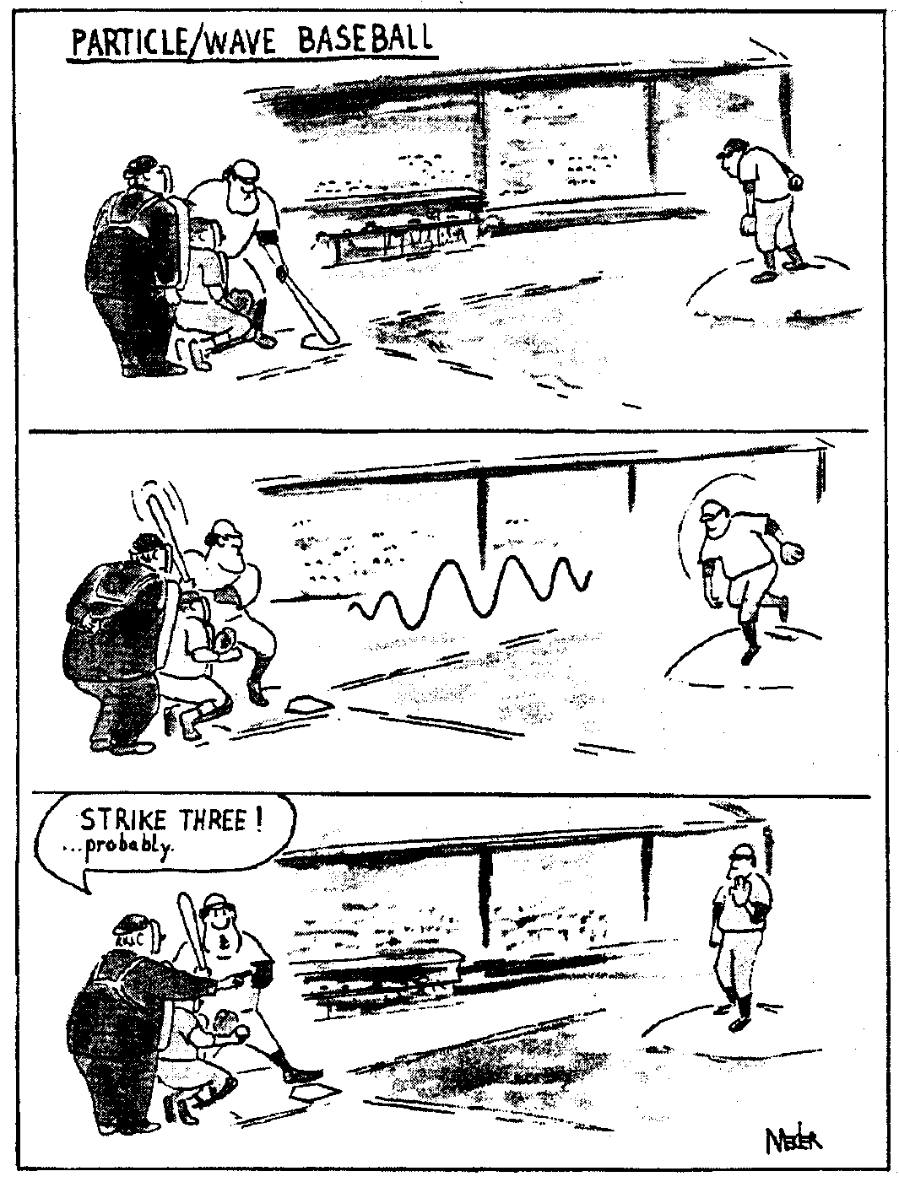
From Marilyn vos Savant: The answer was “uncertainty principle”. Here are some questions:

What was Heisenberg’s justification for prenuptial agreements? Karl Hester, Seattle, Washington.

What underlies the rhythm method of birth control? Wayne Wilkinson, New Orleans, La

What’s the name for the fear of a husband who can’t remember if today is the birthday of his wife or girlfriend? Gerald Swick, Clarksburg, W. Va.

Heisenberg might have slept here. -- Anonymous

Planck's constant is a measure of the “graininess” of the universe. Think of the universe as a sort of magazine photograph. When you do your normal look at a magazine picture, you see a nice sharp image, but if you magnify it – look at it close up - you find that it is made up of bunches of little dots. The closer you get to the picture, the more you notice the dots. You can still make out the subject of the picture, but you have to work at it. As you get closer and closer, the picture gets grainier and grainier – harder and harder to make out. Eventually all you see are these big old dots that just lie there, not making much sense. The picture is gone. In fact, beyond these little dots, there is nothing that can be known. Turns out the universe is the same way.

Heisenberg had discovered the uncertainty principle.

Uncertainty principle ≡ It is impossible to know simultaneously the exact position of an object, such as an electron, and its momentum.

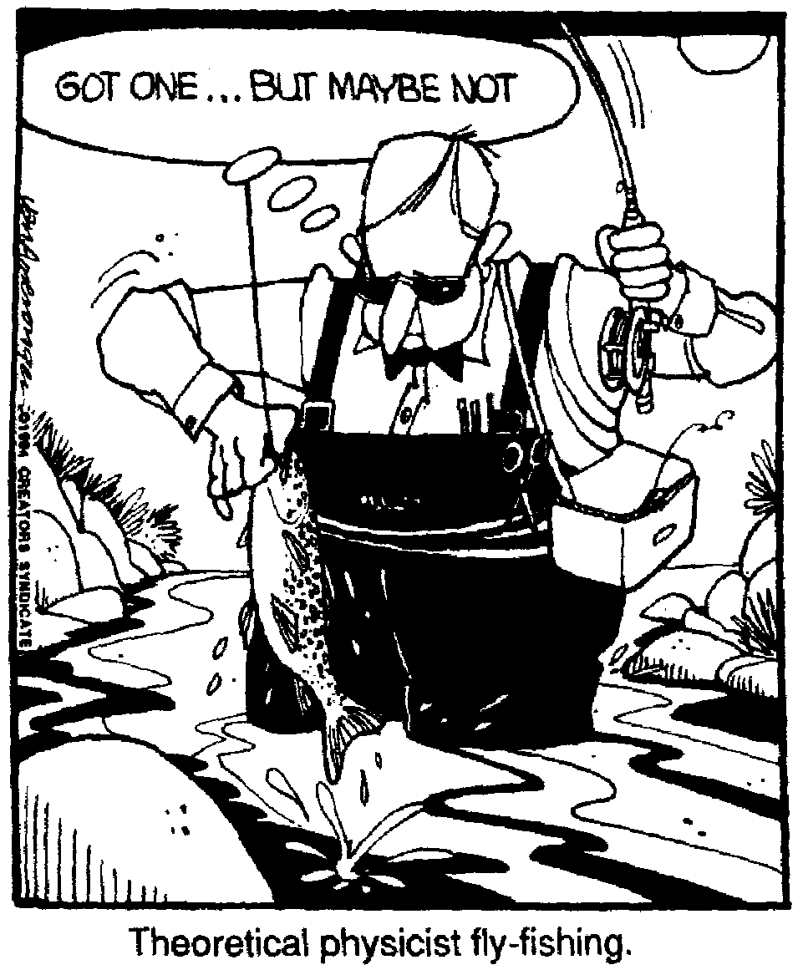
It also was learned that the act of measuring a quantity would change the quantity. This makes it even more unlikely that anything can be truly known.

Einstein had trouble accepting the uncertainty principle. He recognized that quantum mechanics worked, but felt that the uncertainty was a result of the lack of refinement in the theory and that, with a little work, the uncertainty would vanish and we would be able to truly know some ultimate things. He believed that the laws of the universe are simple, elegant, and beautiful – like special relativity. Quantum mechanics was none of those things. Thus he opposed it, mainly on philosophical grounds. His really famous quote, which he made about uncertainty, is, "I cannot believe that God plays dice with the universe." Of course Niels Bohr’s answer was, “Who is Einstein to tell God what to do?”

Quantum mechanics is not governed by hard, discrete laws as the rest of physics is, instead it is governed by probability and statistics. When we discuss electrons, we discuss the probability that they will be in a certain place or having a certain energy or momentum. If you deal with a large number of them, you are okay, and can make accurate predictions, but when you deal with just a few or one, then you cannot be certain and your prediction will be unreliable.

Again, it is important to recognize that this uncertainty only happens when we deal with very small events. When we deal with anything material, the numbers of particles are so vast that the probability effect becomes a certainty. Which is why we can get away with ignoring the whole thing -- most of the time.

Bruce Baskir
"Electrons all jumbled like rice?"
Quoth Einstein, "That's too high a price."
In reply, answered God
"Well I don't find it odd.
So shut-up and let me play dice."

Schrodinger's Cat: A really weird outcome of quantum mechanics is that, under certain conditions, matter can exist in more than one state or position at the same time.
This is a wild concept. There is a probability (pretty small and most highly unlikely) that the atoms that make up the seat you sit on could, all at one time, go somewhere else leaving you to fall to the floor. It really could happen. Be pretty cool if it did too don't you think (as long, one needs point out, that it happens to someone else)?

Schrodinger came up with a marvelous way to illustrate the weirdness of this dilemma. In 1926 he proposed a puzzling thought experiment. Imagine that a cat is placed in a sealed box and its fate - whether it lives or dies - depends on whether or not an atom undergoes radioactive decay. The atom is hooked up to a flask of poison gas. If the atom decays, the gas is released and the cat croaks. We cannot predict what the individual atom will do - decay or not decay, so we consider its probability of decaying. This probability is, let us say, 50 – 50. The presence of the atom's decayed and undecayed quantum states translates into a cat that is both dead and alive at the same time - a highly counterintuitive idea. So is the cat dead or is it living? If you open the box, the cat will automatically be killed (by making our measurement we have changed the state), so there is no way to know what the cat's state is or was or will be.

We get around this by defining the cat’s state as being both alive and dead.

When we observe felines, we don't expect our observations to influence whether the kitty dies or stays alive--or to see one of the critters both dead and alive. But you must remember that we don't live in a quantum world (well, actually we do, but we aren't aware of it because the graininess of the quantum is far smaller than our threshold of noticing things).

The Cat in the Tree
by Peter Price
Another great Dane has made free
With a question of Be or Not be.
Now might Schr’dinger's puss,
In descending by Schuss,
Leave one track on each side of a tree?

The quantum mechanical universe is like so strange, you know what the Physics Kahuna means? For example, take your largest atom. This would be, of course, good old cesium, which is a really nasty, highly reactive alkaline metal. Cesium atoms are big because the outermost electron is not very tightly held, so the electron's orbital is quite large. A cesium atom is about 6.68 angstroms across (0.0000000263 inch), which is not all that more spectacularly bigger than many other atoms. But this is the atom in its ground state, when it is unexcited. What happens when the atom absorbs energy? Well, them atoms can get a whole bunch bigger when they absorb photons of energy -- electrons can jump into a higher energy quantum level, which effectively makes the atom larger. Out there in its higher orbital, the electron can be easily lost, leaving the atom smaller than a normal one. Or the energized electron can also re-emit the light photon (falling back to a lower excited state), restoring the atom to normal size. In the real world, energized atoms almost always emit a photon or lose their outer electron within a fraction of a second. But it's theoretically possible for an atom to be energized to any size, even as large as the whole universe. Now that, the Physics Kahuna must tell you, is weird.

Quantum mechanics has had a huge effect on our perception of the universe. It effectively tossed out Newton’s idea of a clockwork universe. We now realize that the universe is a place full of uncertainties and things that we cannot know or even find out. Not only do we have trouble figuring out the location of an electron, the darn thing can even be in two places at the same time!

Here’s a Niel’s Bohr story related by a physics professor, one Ed Schweber. One of his professors when he was in grad school in the early 70's, Aage Peterson, had worked with Bohr early in Peterson's career and toward the end of Bohr's career.

Once Bohr, Peterson and some colleagues went to see an American western movie and began talking about the film afterward. What follows is the gist of what transpired. The exact dialog is an approximation. "What did you think?" they asked Bohr and he replied,

"Too Implausible."

"Come on Bohr, its just a movie, you can't subject it to too rigorous an analysis."

Bohr kept responding, "Too implausible."

Finally they relented. O.K. Bohr, why is it implausible?"

"That a man runs off with a woman - that I can accept - it happens all the time. That the woman had a jealous brother who chased after them - that too I can accept - there certainly are jealous brothers. That the brother caught up with his sister - that too I can accept. One person must have the faster horse and one the slower horse, That the brother caught his sister as they were crossing a bridge - that I can accept as well. The brother has to catch his sister somewhere. And that the bridge collapsed just as everyone was crossing it - even that I can accept. Bridges do collapse and the people on them must have some reason for being there. And you don't make movies of everyday events. But that at the precise moment the bridge collapsed, a movie crew should just happen to have been in the ravine to film it -- too implausible!”

Dear Dr. Science,
When my boss asks me for a "ballpark figure", what figure should I give him?
-----------Pedro Rodriguez, El Paso, Texas

Dr. Science responds:
Your boss is probably more scientifically astute than you are. When he asks you for data in these forms, he's utilizing principles of Statistics. Specifically, he's referring to Indeterminacy and Heisenberg's Uncertainty Principle. These principles are the foundation on which is based the uncertain future of our modern world. So, the next time he asks you for a "guesstimate", round off to the nearest significant figure and show him you've got your head screwed on right, statistically speaking. As for ballparks, tell him you'll have to travel to Denver, Cleveland, Baltimore or Chicago's Wrigley Field. Now those are real ballpark figures. Unless they've raised the price of popcorn over 50 cents, that is.

Dear Doctor Science,
How many electrons can the sixth energy level of an atom hold?
-- David Crowley from Petaluma CA

Dr. Science responds:
It depends on the size of the electrons. Being negatively charged, they have a great deal of excess emotional baggage, a surfeit of unforgiveness that drags them down like a lead overcoat. The only electrons that can mass together and share the same energy level are
those who have truly forgiven other subatomic particles for whatever insults, imagined or real, they've suffered and moved into the glorious freedom that each of us, no matter what our size, enjoys when we've looked the universe square in the eye and said, "Yes, things are OK just the way they are." These atoms and their electrons are unusually stable and are concentrated in small towns in the upper Midwest.

A Really Final Thought From Cecil Adams:

Reader Query:
Cecil, you're my final hope
Of finding out the true Straight Dope
For I have been reading of Schrodinger's cat
But none of my cats are at all like that.
This unusual animal (so it is said)
Is simultaneously live and dead!
What I don't understand is just why he
Can't be one or the other, unquestionably.
My future now hangs in between eigenstates.
In one I'm enlightened, the other I ain't.
If you understand, Cecil, then show me the way
And rescue my psyche from quantum decay.
But if this queer thing has perplexed even you,
Then I will and won't see you in Schrodinger's zoo.

-Randy F., Chicago

Cecil's Reply:

Schrodinger, Erwin! Professor of Physics!
Wrote daring equations! Confounded his critics!
(Not bad, eh? Don't worry. This part of the verse
Starts off pretty good, but it gets a lot worse.)
Win saw that the theory that Newton'd invented
By Einstein's discov'ries had been badly dented.
What now? Wailed his colleagues. Said Erwin, "Don't panic,
No grease monkey I, but a quantum mechanic.
Consider electrons. Now, these teeny articles
Are sometimes like waves, and then sometimes like particles.
If that's not confusing, the nuclear dance
Of electrons and suchlike is governed by chance!
No sweat, though - my theory permits us to judge
Where some of 'em is and the rest of 'em was."
Not everyone bought this. It threatened to wreck
The comforting linkage of cause and effect.
E'en Einstein had doubts, and so Schrodinger tried
To tell him what quantum mechanics implied.
Said Win to Al, "Brother, suppose we've a cat,
And inside a tube we have put that cat at -
Along with a solitaire deck and some Fritos,
A bottle of Night Train, a couple of mosquitoes
(Or something else rhyming) and, oh, if you got 'em,
One vial prussic acid, one decaying ottom
Or atom - whatever - but when it emits,
A trigger device blasts the vial to bits
Which snuffs our poor kitty. The odds of this crime
Are 50 to 50 per hour each time.
The cylinder's sealed. T he hour's passed away. Is
Our pussy still purring - or pushing up daisies?
Now, you'd say the cat either lives or it don't
But quantum mechanics is stubborn and won't.
Statistically speaking, the cat (goes the joke),
Is half a cat breathing and half a cat croaked.
To some this may seem a ridiculous split,
But quantum mechanics must answer, 'Tough ___.
We may not know much, but one thing's fo,sho':
There's things in the cosmos that we cannot know.
Shine light on electrons - you'll cause them to swerve.
The act of observing disturbs the observed -
Which ruins the test. But then if there's no testing
To see if a particle's moving or resting
Why try to conjecture? Pure useless endeavor!
We know probability - certainty, never.'
The effect of this notion? I very much fear
'Twill make doubtful all things that were formerly clear.
Till soon the cat doctors will say in reports,
'We've just flipped a coin and we've learned he's a corpse.'"
So said Herr Erwin. Quoth Albert, "You're nuts.
God doesn't play dice with the universe, putz.
I'll prove it!" he said, and the Lord knows he tried -
In vain - until fin'ly he more or less died.
Win spoke at the funeral: "Listen, dear friends,
Sweet Al was my buddy. I must make amends.
Though he doubted my theory, I'll say of this saint:
Ten-to-one he's in heaven - but five bucks says he ain't."

CECIL ADAMS

Lasers: (Another thing you don’t need to know, but is cool.) One really awesome device which, makes most excellent use of the quantum nature of the atom is your basic laser. The word laser is an acronym. It is taken from Light Amplification by Stimulated Emission of Radiation. The word has given rise to a verb, atoms that emits light when stimulated in a laser are said to lase. There are two types of light emission that your basic atoms can undergo. One type is called spontaneous emission. This is the one we talked about that is involved in ordinary lights – like the old screw in light bulb. The other type is called stimulated emission. Spontaneous emission is an indiscriminate process. Photons are emitted spontaneously, in random directions, without external provocation. Stimulated emission is very different.

The idea of stimulated emission is credited to Albert Einstein. In 1917, he considered what would happen to an atom that had already gotten itself into an excited state if it were to be struck by another photon of the same energy as the original photon (the one that got it all excited to begin with). The master speculated that the excited atom would emit a photon of the same energy and move to a lower energy state. The photon that caused, or stimulated, the emission would not be affected. This process is called stimulated emission. The two photons leaving the atom will be in phase and have the same wavelength. Either of the two photons can now strike other excited atoms – sort of a chain reaction kind of deal - producing even more in-phase photons. . This process can continue, producing a huge cascade of photons, all of the same wavelength and all having their maxima and minima at the same times.

The trick is, of course, to actually make this happen. Einstein only thought it up, but never made it happen (in fairness, the Physics Kahuna must point out that he didn’t try). Here’s what you need to make the thing go: you must first have atoms in the excited state. Next, the photons have to have some sort of a pathway that will allow them to collide with the excited atoms. The invention that does all that is, of course, the good old, trusty laser

The atoms in a laser can be put into the excited state, or pumped, in different ways. An intense flash of light with a wavelength shorter than that of the laser can pump the atoms to the required state. The more energetic photons produced by the flash collide with and excite the lasing atoms. One atom decays to a lower energy state, starting the avalanche. As a result, a brief flash or pulse of laser light is emitted. Alternatively, a continuous electric charge can be applied to hornswaggle the atoms into the necessary excited state. The laser light resulting from this process is continuous rather than pulsed. The helium-neon lasers which the Physics Kahuna employs in his little pathetic laser demonstration bill of fare are continuous lasers. An electric discharge excites the helium atoms. They collide with the neon atoms, pumping them to an excited state and causing them to lase. The photons emitted by atoms are collected by placing a glass tube containing the atoms between two parallel mirrors. One of the mirrors is near 100 percent reflective and reflects most of the light hitting it. The other mirror is only partially reflective. It allows about one percent of the light to pass through.

When a photon strikes an atom in the excited state, it stimulates the atom to make a transition to the lower state. Thus, two photons leave the atom. These photons can strike other atoms and produce more photons, thereby starting the avalanche. Photons that are directed toward the ends of the tube will be reflected back into the gas by the mirrors. The reflected photons reinforce one another with each pass between the mirror and build to a high intensity. The photons that exit the tube through the partially reflecting mirror produce the laser beam. Laser light is highly directional because of the parallel mirrors. The light beam is very small, typically only about 0.5 mm in diameter, so the light is in a tight beam, monochromatic, in phase and has a very high intensity (which is why you should never look into a laser). The light is all of one wavelength, or monocromatic, because the transition of electrons between only one pair of energy levels in one type of atom is involved. All the stimulated photons are emitted in phase with the photons that struck the atoms. This type of light is called coherent light. Coherent light is, of course, light that is of the same frequency, in phase, and traveling in the same direction – your basic laser beam deal.

Many substances--solids, liquids, and gases--can be made to lase this way. Most produce laser light at only one wavelength. For example red is produced by a neon laser, blue by an argon laser, and green by a helium-cadmium laser. The light from some lasers, can even be tuned, or adjusted, over a range of wavelengths.

All lasers are very inefficient. No more than one percent of electrical energy delivered to a laser is converted to light energy. Despite this inefficiency, the unique properties of laser light have led to many applications. Laser beams are narrow and highly directional. They do not spread out over long distances. Surveyors use laser beams for this reason to make measurements. Laser beams are also used to check the straightness of long tunnels and pipes. When astronauts visited the moon, they left a mirror which was used by scientists to reflect a laser beam from Earth. The distance between Earth and the moon was thus accurately determined.

Laser light is used in fiber optics as well. A fiber uses total internal reflection to transmit light over many kilometers with little loss. The laser is switched on and off rapidly, transmitting information through the fiber. In many cities, optical fibers have replaced copper wires for the transmission of telephone calls, computer data, and even television pictures.

The single wavelength of light emitted by lasers makes lasers valuable in spectroscopy. Laser light is used to excite other atoms. The atoms then return to the ground state, emitting characteristic spectra. Samples with extremely small numbers of atoms can be analyzed in this way. In fact, single atoms have been detected by means of laser excitation and even have been held almost motionless by laser beams.

The concentrated power of laser light is used in a variety of ways. In medicine, lasers can be used to repair the retina in an eye or the lens itself. Lasers also can be used in surgery in place of a knife to cut flesh with little loss of blood.

Lasers are used to cut materials such as wood and steel and to weld materials together.

Lasers are also used to read bar codes on price tags on your basic consumer goods in the stores of the world. It is rare to pay for something that has not had its price tag scanned by a laser.

Dear Cecil:
After watching a campy mid-1950s science fiction movie recently, I was left wondering: how radioactive must something be to begin glowing? And could a living creature become that radioactive and survive, even briefly?
--Ranchoth, via AOL

Cecil replies:
Radioactive stuff doesn't glow, muchacho. Hollywood screenwriters just think it does. (Frail creature that I am, I admit to having helped perpetuate this myth.) High-energy radioactive particles sometimes cause other stuff to glow, but that's the exception, not the rule. For example: Cerenkov radiation. Perhaps you've seen depictions of the eerie blue glow emanating from spent nuclear fuel that's stored underwater. That's Cerenkov radiation. It occurs when beta particles (electrons) travel faster than the speed of light.

You reply: Say what? I thought nothing could travel faster than the speed of light.
Not exactly--nothing can travel faster than the speed of light in a vacuum, c. However, in translucent media, notably water, light travels much slower, at maybe 75 percent of c. A beta particle traveling through air, say, moves considerably faster than light traveling through water.
Now suppose a beta particle enters the water. What happens? It throws up a shock wave of photons, much as a boat plowing through water creates a bow wave or a jet creates a sonic boom. It gets a little complicated after that, but basically constructive interference between wave fronts generates visible light. Note that the radioactive stuff isn't what glows, nor does the water glow once the radioactive stuff is removed.
Fluorescence. When certain compounds are struck by radiation, they glow. For instance, glow-in-the-dark watch dials used to be painted with a mixture of radium and zinc sulfide. Radiation from the former caused the latter to fluoresce. There's nothing magical or dangerous about fluorescence; it can be caused by lots of things, including ordinary sunlight. The radioactive material itself emits no visible light. Madame Curie, who discovered radium, talked about watching the stuff glow in the dark, but the light was emitted by minerals mixed up with the radium, not the radium itself.
Bremsstrahlung. When a charged particle speeds up, slows down, or changes direction, it emits bremsstrahlung radiation. Typically bremsstrahlung consists of invisible X rays, but I'm told that under certain circumstances it can be visible, making it the closest thing to a glow arising from radioactivity itself. Even so, an intervening medium is generally required to speed/slow/divert the charged particle.
None of these phenomena is going to make you or any living creature glow. If you were to tarry near a spent fuel canister bathed in Cerenkov radiation, you'd receive a lethal dose in seconds. You wouldn't glow, though; you'd just die. Tragic, but at least we'd put this silly misconception to rest.

--CECIL ADAMS

Dear Cecil:
About 200 years ago Sir Edmund Halley discovered an anomaly in space around the stars of the Pleiades. A hundred years later Friedrich Wilhelm Bessel confirmed Halley's findings. In 1961 Paul Otto Hesse defined and measured this anomaly. It's an energy ring of incredible size, 760 thousand billion miles wide, and is due to intersect the earth just about any minute now. He also calculated that this is part of a 25,000-year-long cycle that our solar system goes through.

It's expected that once we're into the Photon Belt, electricity won't function and there will be three to five days of total darkness. All indigenous cultures and religions prophesy three days of darkness to mark the "end times."

Scientists discussing the Photon Belt have been fired, moved, or denied access to the equipment used to study it. If you cast around on, say, the Internet for information, folks with CIA or NSA credentials likely will show up and say it would be in the best interest of your family if you gave up the quest.

So my question is, what can you tell us about the Photon Belt? Any hard data?
--N. A., Rio Rancho, New Mexico

Cecil replies:
Get off it. Nobody wants hard data. If hard data were the filtering criterion you could fit the entire contents of the Internet on a floppy disk. My mission in life is a little different: you provide the bubble, I provide the pin.

The "photon belt" has been a hot topic in New Age circles since 1991, when a story about it appeared in Australia's Nexus magazine. In 1994 it received a book-length treatment in You Are Becoming a Galactic Human by Virginia Essene and Sheldon Nidle. Essene and Nidle claimed to be "channeling" members of the "Sirian Council," beings from a distant planet.

Exactly when we're going to enter the photon belt is a matter of debate. Originally it was thought that the arrival of the belt would lead to a vast transformation of society starting in 1992. So what did we get instead? Bill Clinton. Not to be critical in any way, but I for one would have expected something a little grander than a hike in the minimum wage.

The next target date was May 5, 1997, though there was to be a long buildup. "Apparently, by the end of Summer [1996]," one newsletter noted, "most of us will be having conversations with Masters, the spiritual hierarchy, and space commanders of all kinds." Don't know about you, but all I've been seeing is more Bill Clinton. As a fallback, some New Agers are saying the photon belt won't get here until 2011.

The question is not whether it's nuts to believe in the photon belt. Of course it's nuts. How many great scientific discoveries do you know of that were channeled from aliens? For the record, however, I feel obliged to say that:

(1) No photon belt or other such region of increased energy has been discovered. Photons in any case are merely particles of electromagnetic energy, which we commonly experience as light. Upon exposure to excess photons the most common transformation of your being is sunburn.
(2) There's no "anomaly" near the Pleiades star cluster. The Pleiades are surrounded by a nebula, or gas cloud. This cloud is composed not of photons but of dust and hydrogen gas.
(3) The earth isn't heading toward the Pleiades but away from them. In the 1850s it was conjectured that the earth orbited the Pleiades, but this has long since been discredited.
(4) Paul Otto Hesse is unknown to astronomers. Someone dug up a reference to a 1986 book by him in German whose title translates as "Judgment Day: A Book to Mankind That Speaks of Things to Come." 'Nuff said.

What puzzled me was where the photon-belt story came from. The 1991 Nexus article was based on a 1981 article in an Australian UFO mag. I spoke to Colin Norris, head of the Australian UFO society that publishes the magazine, and he said it was coauthored by a "middle-aged mother" and a college undergraduate. Norris denied it was a prank, but it seems clear these folks didn't have detailed technical knowledge, unless of course they were on the horn with the guys from Sirius.
So it's a crock. But don't worry. I'm sure your five-day supply of candles will come in handy for something.

STILL WAITING

Dear Cecil:
Just a note--my family and I just came back out of hiding, and boy are we embarrassed. How was Cinco de Mayo?
--Susan Gleason, via the Internet

Cecil replies:
Pretty quiet, and it's been pretty quiet since--although now that you mention it, the power did go out for a couple minutes Saturday night. However, to my way of thinking, the arrival of the Photon Belt ought to be heralded by something a little more impressive than a message saying "RESET" on the microwave. As of this writing (early July, 1997), the New Age crowd had not given up on the Photon Belt, but it sounds like they're getting a little fidgety. PB promoter Sheldon Nidle, trying to buck up the troops in a recent communique, notes that "time is extremely elastic in its properties." Whatever you say, Shel. But to me that sounds an awful lot like, "The check is in the mail."

--CECIL ADAMS

