AP Physics – Momentum AP Wrapup

There are two, and only two, equations that you get to play with:

This is the equation for momentum.

This is the equation for impulse. The equation sheet uses, for some reason, the symbol J for impulse (the Physics Kahuna has never seen this anywhere else. Oh well.)

Here is what you are supposed to be able to do.

A. Systems of Particles, Linear Momentum

- Impulse and Momentum: You should understand impulse and linear momentum so you can:

- Relate mass, velocity, and linear momentum for a moving body, and calculate the total linear momentum of a system of bodies.

Just use the good old momentum equation.

- Relate impulse to the change in linear momentum and the average force acting on a body.

Just use the impulse equation. We did several of these problems. If you have a collision, time, and a force in a problem, think’ impulse’.

- Conservation of Linear Momentum, Collisions

- You should understand linear momentum conservation so you can:

- Identify situations in which linear momentum, or a component of the linear momentum, is conserved.

The momentum of an isolated system (no outside forces) is conserved in any interaction. Period.

- Apply linear momentum conservation to determine the final velocity when two bodies that are moving along the same line, or at right angles, collide and stick together, and calculate how much kinetic energy is lost in such a situation.

This is the good old inelastic collision problem. We’ve done a bunch. If the collision happens at right angles, then you are going to have to look at components of momentum (which you can do since momentum is a vector, right?) Anyway, the idea is that after the collision both bodies have the same velocity. Therefore:

If the two bodies are moving at right angles, then it’s a bit more complicated. The vertical momentum is conserved and the horizontal momentum is conserved, so you can write equations for the conservation of momentum in the x and y directions. Then use these to solve for whatever unknown you’ve been presented with.

- Analyze collisions of particles in one or two dimensions to determine unknown masses or velocities, and calculate how much kinetic energy is lost in a collision.

Pretty much all the problems that you will see will involve finding one unknown velocity. Body A moving at velocity v has an eleastic collision with body A which is at rest. Body B ends up with a velocity of v_{f}, &tc. That sort of thing.

Let’s look at a few test problems. The first one we’ll look at is off 2001 test.
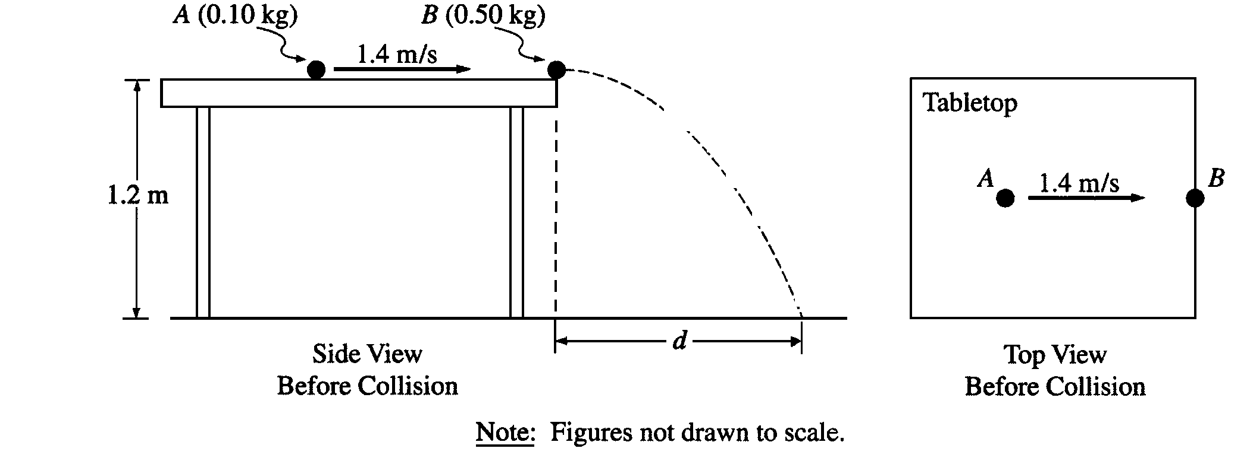
- An incident ball A of mass 0.10 kg is sliding at 1.4 m/s on the horizontal tabletop of negligible friction shown above. It makes a head-on collision with a target ball B of mass 0.50 kg at rest at the edge of the table. As a result of the collision, the incident ball rebounds, sliding backwards at 0.70 m/s immediately after the collision.

(a) Calculate the speed of the 0.50 kg target ball immediately after the collision.

We use conservation of momentum to solve this one.

The tabletop is 1.20 m above a level, horizontal floor. The target ball is projected horizontally and initially strikes the floor at a horizontal displacement d from the point of collision.

(b) Calculate the horizontal displacement d.

This is a projectile motion problem. We know the ball’s horizontal velocity and the height of the table, so we can easily find the horizontal distance it travels as it falls.

Time to fall:
The ball has a horizontal velocity of 0.42 m/s (which we just figured out), so the distance d is simply:

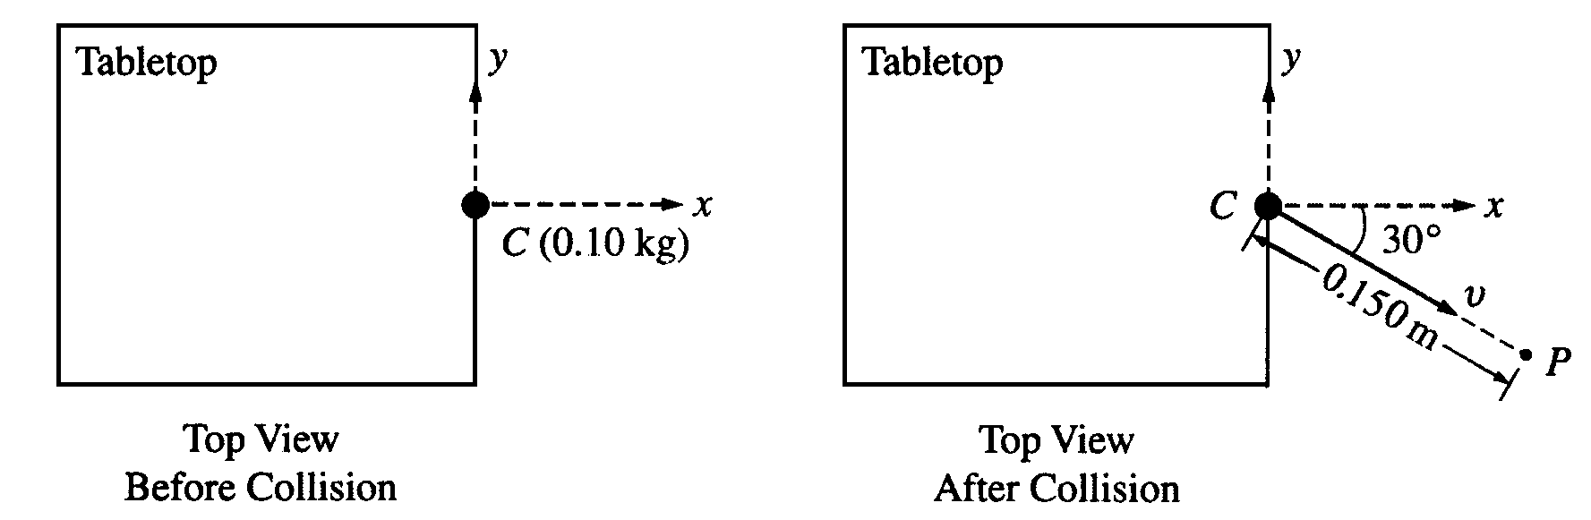
In another experiment on the same table, the target ball B is replaced by target ball C of mass 0.10 kg. The incident ball A again slides at 1.4 m/s, as shown above left, but this time makes a glancing collision with the target ball C that is at rest at the edge of the table. The target ball C strikes the floor at point P, which is at a horizontal displacement of 0.15 m from the point of the collision, and at a horizontal angle of 30° from the + x-axis, as shown above right.

(c) Calculate the speed v of the target ball C immediately after the collision.

This sounds very hard, angles and all that stuff, right? Except we know the distance it traveled (1.5 m) and we know how long it is in the air before it hits – same as the previous problem time. So this is a ridiculously simple problem. Using the horizontal distance and the time to fall we can find the horizontal velocity, which is the velocity it began with, which is the velocity right after the collsion.

Find v:

(d) Calculate the y-component of incident ball A's momentum immediately after the collision.

We know that momentum is conserved in the x and y directions. So we can sum momentum in the y direction. We know that this momentum has to add up to be zero as the ball A had no initial momentum in the y direction.

From 1996:

- Two identical objects A and B of mass M move on a one-dimensional, horizontal air track. Object B initially moves to the right with speed v_{o}. Object A initially moves to the right with speed 3v_{o}, so that it collides with object B. Friction is negligible. Express your answers to the following in terms of M and v_{o}.

  - Determine the total momentum of the system of the two objects.
We simply add up the momentum of each object to get the total momentum.
  - A student predicts that the collision will be totally inelastic (the objects stick together on collision). Assuming this is true, determine the following for the two objects immediately after the collision.

    - The speed.

This is an inelastic collision. It is a simple thing to solve:

    - The direction of motion (left or right).
The combined object moves right. All values are positive.
When the experiment is performed, the student is surprised to observe that the objects separate after the collision and that object B subsequently moves to the right with a speed 2.5 v₀ .

  - Determine the following for object A immediately after the collision.
    - The speed of object A after the collision.

    - The direction of motion (left or right).
Object A move right. All values are positive.
  - Determine the kinetic energy dissipated in the actual experiment.
The kinetic energy dissipated is the change in kinetic energy. So we solve this question by finding the kinetic energy before the collision and the kinetic energy after the collision. The difference in the two is the energy dissipated.

From 1992:
- A 30-kilogram child moving at 4.0 meters per second jumps onto a 50-kilogram sled that is initially at rest on a long, frictionless, horizontal sheet of ice.

  - Determine the speed of the child-sled system after the child jumps onto the sled.

You immediately recognize that this is an inelastic collision.

  - Determine the kinetic energy of the child-sled system after the child jumps onto the sled.

After coasting at constant speed for a short time, the child jumps off the sled in such a way that she is at rest with respect to the ice.

  - Determine the speed of the sled after the child jumps off it.
  - Determine the kinetic energy of the child-sled system when the child is at rest on the ice.

  - Compare the kinetic energies that were determined in parts (b) and (d). If the energy is greater in (d) than it is in (b), where did the increase come from? If the energy is less in (d) than it is in (b), where did the energy go?

The child must decelerate in order to stop. So a force negative to the motion of the sled is applied. This force is applied through a distance resulting in negative work. The sled receives an equal and opposite (positive) force through a distance resulting in positive work. Work is added to the sled, and work is a change in energy (Work energy theorem). So the energy of the sled is increased.

From 1995:

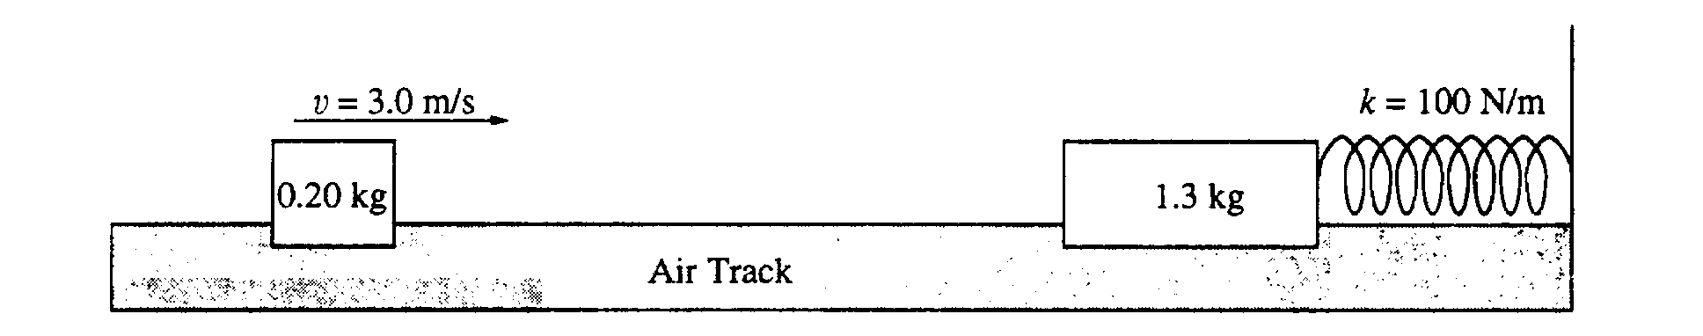
- As shown, a 0.20-kilogram mass is sliding on a horizontal, frictionless air track with a speed of 3.0 meters per second when it instantaneously hits and sticks to a 1.3-kilogram mass initially at rest on the track. The 1.3-kilogram mass is connected to one end of a massless spring, which has a spring constant of 100 Newtons per meter. The other end of the spring is fixed.

  - Determine the following for the 0.20-kilogram mass immediately before the impact.

    - Its linear momentum.
    - Its kinetic energy.
  - Determine the following for the combined masses immediately after the impact.

    - The linear momentum
    - The kinetic energy

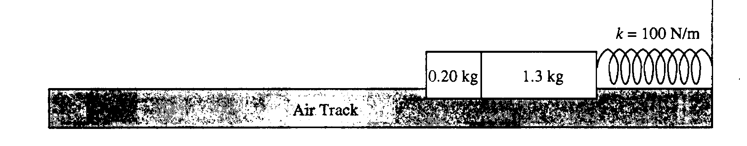
After the collision, the two masses undergo simple harmonic motion about their position at impact.
  - Determine the amplitude of the harmonic motion.
d. Determine the period of the harmonic motion.

From 1994:
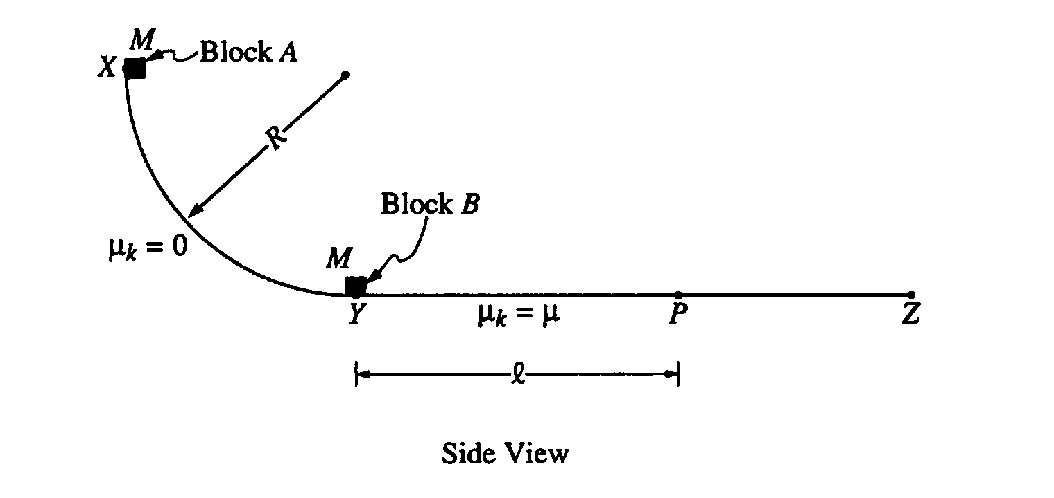
- A track consists of a frictionless arc XY, which is a quarter-circle of radius R, and a rough horizontal section YZ. Block A of mass M is released from rest at point X, slides down the curved section of the track, and collides instantaneously and inelastically with identical block B at point Y. The two blocks move together to the right, sliding past point P, which is a distance l from point Y. The coefficient of kinetic friction between the blocks and the horizontal part of the track is μ. Express your answers in terms of M, l, μ, R, and g.
  - Determine the speed of block A just before it hits block B.
  - Determine the speed of the combined blocks immediately after the collision.
  - Determine the amount of kinetic energy lost due to the collision.
  - The specific heat of the material used to make the blocks is c. Determine the temperature rise that results from the collision in terms of c and the other given quantities. (Assume that no energy is transferred to the track or to the air surrounding the blocks.)
  - Determine the additional thermal energy that is generated as the blocks move from Y to P

Work done by friction = heat generated

