AP Physics – Torque – 3

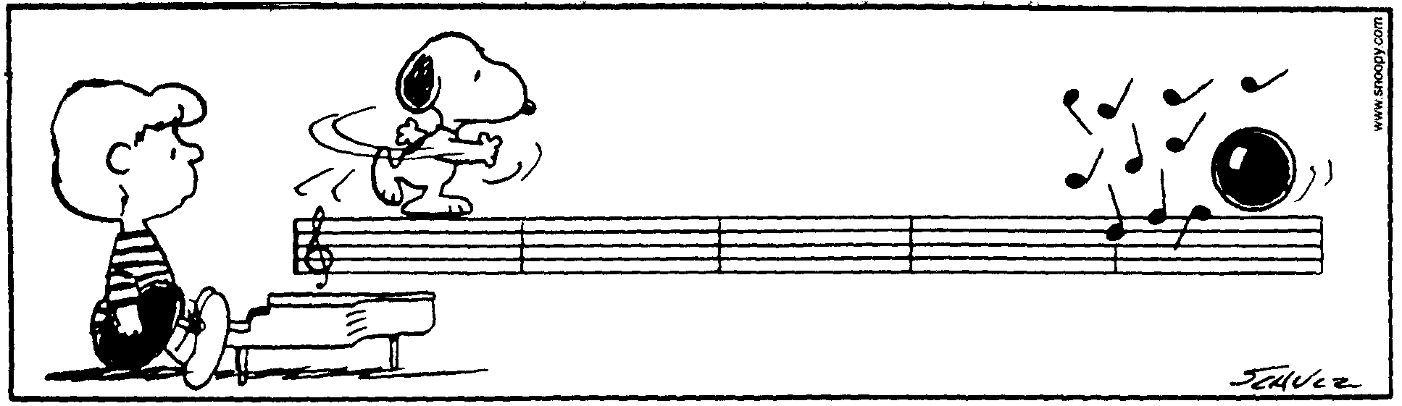
Vant ____________________________________________________________________Per___
Many a man thinks he is buying pleasure, when he is really selling himself to it. -- Ben Franklin
- What would happen to the acceleration of gravity, good old g, if the earth suddenly shrunk to half its current radius?

- Calculate the mean distance from the earth to the sun.

- You weigh 625 N on earth. What would you weigh on Ganymede, a moon of Jupiter? Its mass is 1.5 x 1023 kg and it has a radius of 2.6 x 106 m.

- A 5.10 kg kitty cat is hanging by a rope suspended from a 2.35 kg uniform pipe that is 3.05 m in length. One end of the pipe is attached to a wall, the other end has a cord that supports the outer end of the thing as shown. The angle the cord makes with the pipe is 43.0°. (a) What is the weight of the cat? (b) What is the tension in the cable?

- An asteroid is in a circular orbit around the sun. Its speed is found to be 3.25 x 10⁴ m/s. The mass of the sun is 1.99 x 1030 kg. What is the distance from it to the sun?

- A mouse is sitting on a record player. The mouse is 8.0 cm from the center of the record. Suddenly the record player begins to play at 45 rpm (revolution per minute). The mouse begins to run in place. (a) How fast must it run? The mouse sits down and, amazingly, is able to sit on the record without slipping off. If the mouse is just on the verge of sliding, (b) what is the coefficient of static friction between it and the record?

- What is the linear speed of the tip of the hour hand of a regular clock it the hand is 7.5 cm in length?

- You want to build a pendulum clock that will have a period of 1.50 seconds. How long should the pendulum be?

