AP Physics – Mo’ Nuclear Bidness – 3 Ans
- A bismuth isotope decays into thallium by emitting an alpha particle according to the following equation:
(a) Determine the atomic number Z and the mass number A of the thallium nuclei produced and enter your answers in the spaces provided below. Z = _81______ A _213______
The mass of the alpha particle is 6.64 x 10⁻²⁷ kg. Its measured kinetic energy is 6.09 MeV and its speed is much less than the speed of light.
(b) Determine the momentum of the alpha particle.
(c) Determine the kinetic energy of the recoiling thallium nucleus.
(d) Determine the total energy released during the decay of 1 mole of bismuth 212:
- (a) Calculate the binding energy for He-4. The mass of He-4 is 4.002 60 u. The mass of a proton is 1.007 825 u and the mass of a neutron is 1.008 665 u. (b) explain how this is involved in the release of energy during the process of fission.

- Let us assume that a typical house requires 2 000 kWh for a one month period. Let us also assume that there are 120 khouses in Wyoming. If one fission of a U-235 nucleus releases 208 MeV and 100% of this energy is converted into electricity, how many kg of uranium would be required to supply the energy needs of the people of our beloved state for a year?

Energy from 1 kg of uranium-235:
Total energy requirement:
- Complete the following nuclear reactions and indicate the type of decay reaction:

- What wavelength of light would have to be incident on sodium metal if it is to emit electrons with a maximum speed of 1.00 x 10⁶ m/s?

- A rigid rod of mass m has a length of l. It is suspended from two identical springs of negligible mass as shown in the diagram below. The upper ends of the springs are fixed in place and the springs stretch a distance d under the weight of the suspended rod. (a) determine the spring constant for each spring in terms of the other given quantities and fundamental constants.

(b) As shown below, the upper end of the springs are connected by a circuit branch containing a battery of emf and a switch S, so that a complete circuit is formed with the metal rod and springs. The circuit has a total resistance R, represented by the resistor in the diagram below. The rod is in a uniform magnetic field, directed perpendicular to the page. The upper ends of the springs remain fixed in place and switch S is closed. When the system comes to equilibrium, the rod is lowered an additional distance of . (b) What is the direction of the magnetic field relative to the coordinate axis shown on the right in the diagram? (c) Determine the magnitude field in terms of m, l, d, , , R, and fundamental constants.(d) When the switch is suddenly opened, the rod oscillates. For these oscillations, determine the following quantities in terms of , d, , and fundamental constants. i. The period, ii. The maximum speed of the rod.
(b) Out of the page, Positive z
(c) Gravity displaced the bar a distance d (see above).

Now the magnetic field displaces the bar an extra distance, Δd.

If internal resistance is not mentioned, assume that it is zero.

(d) i. The period.
But there are two springs. Plug in value for k.
    - The maximum speed of the rod.

Use conservation of energy:
Two springs
and

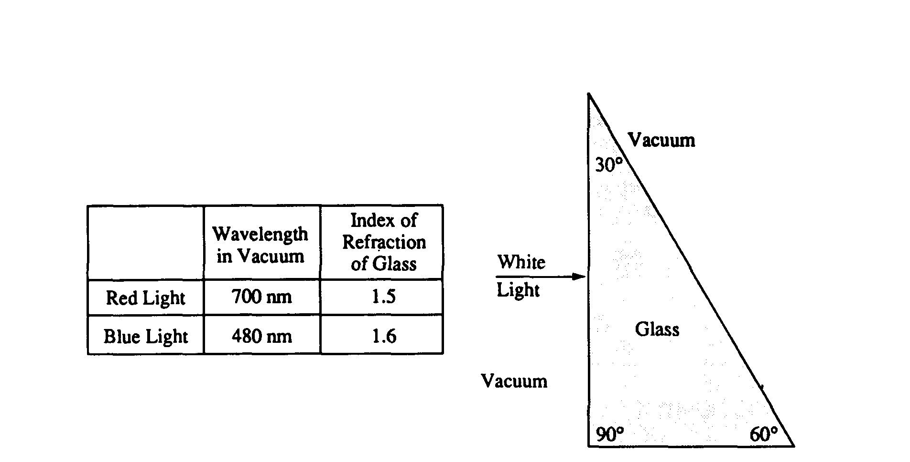
- The glass prism shown below has an index of refraction that depends on the wavelength of the light that enters it. The index of refraction is 1.50 for red light of wavelength 700 nanometers (700 x 10⁻⁹ meter) in vacuum and 1.60 for blue light of wavelength 480 nanometers in vacuum. A beam of white light is incident from the left, perpendicular to the first surface, as shown in the figure, and is dispersed by the prism into its spectral components.
Red
Blue
a. Determine the speed of the blue light in the glass.
b. Determine the wavelength of the red light in the glass.
c. Determine the frequency of the red light in the glass.
- i. What is the angle of refraction for the blue and red light incident on the front surface? ii. Calculate the angle of refraction for the blue and red light incident on the far surface. iii. On the figure above, sketch the approximate paths of both these rays as they pass through the glass and back out into the vacuum. Ignore any reflected light. Clearly show the change in direction of the rays, if any, at each surface and be sure to distinguish carefully any differences between the paths of the red and the blue beams.

i. Zero
ii.

