AP Physics – Thermo - 2


Who’B’do?_________________________________________________________________
When it comes to atoms, language can be used only as in poetry. The poet, too, is not nearly
so concerned with describing facts as with creating images. -- Niels Bohr
- A 148 kg bear runs up a hill that has a slope of 18.0° to the horizontal. The critter travels 1250 m in 105 seconds. (a) How much work did the bear do on itself? (b) How much power did the bear develop?
(a)
(b)
- 3450 J of energy are required to raise the temperature of a chunk of copper from 23.0°C to 315°C. What is the mass of the copper?
- A single pane window is 25 mm thick. It measures 1.2 m by 2.5 m. One side of the window is 25°C and the other side is - 22°C. How much heat is lost through the window in 24 hours?
- Convert 25.6°C to Kelvins.

- A scuba tank contains 2.35 L of air at 22.1°C and 1.00 atm. What is the pressure in the tank if the temperature is increased to 128°C?
- What is the average kinetic energy per molecule of a tank of oxygen gas at 25.0 °C?
- How much heat does it take to melt 1.25 kg of ice?
- How much heat is required to vaporize 7.85 kg of water that is at a temperature of 25.9°C?
- A 40.0 Ω resistor is embedded in 0.200 kg of some substance. The resistor is part of a circuit and has a voltage of 60.0 V applied to it. Find (a) the current in the resistor, (b) the rate at which heat is generated in the resistor, (c) it takes 4.00 minutes to raise the temperature of the substance from 20.0° to 80.0°, calculate the specific heat of the substance.
(a)
(b)
(c)

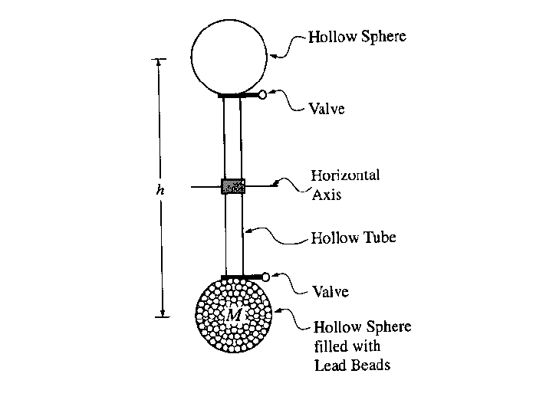
- Students are designing an experiment to demonstrate the conversion of mechanical energy into thermal energy. They have designed the apparatus shown in the figures below. Small lead beads of total mass M and specific heat c fill the lower hollow sphere. The valves between the spheres and the hollow tube can be opened or closed to control the flow of the lead beads. Initially both valves are open.
  - The lower valve is closed and a student turns the apparatus 180º about a horizontal axis, so that the filled sphere is now on top. This elevates the center of mass of the lead beads by a vertical distance h. What minimum amount of work must the student do to accomplish this?
Work is a change in energy. Gravitational PE is changing.
  - The valve is now opened and the lead beads tumble down the hollow tube into the other hollow sphere. If all of the gravitational potential energy is converted into thermal energy in the lead beads, what is the temperature increase of the lead?
  - The values of M, h, and c for the student’s apparatus are M = 3.0 kg, h = 2.00 m and c = 128 J/(kg·⋅K). The students measure the initial temperature of the lead beads and then conduct 100 repetitions of the “elevate and drain” process. Again, assume that all of the gravitational potential energy is converted into thermal energy in the lead beads. Calculate the theoretical cumulative temperature increase after the 100 repetitions.
  - Suppose that the experiment were conducted using smaller reservoirs, so that M was one-tenth as large (but h was unchanged). Would your answers to parts (b) and (c) be changed? If so, in what way, and why? If not, why not?

No, mass has no effect
  - When the experiment is actually done, the temperature increase is less than calculated in part (c). Identify a physical effect that might account for this discrepancy and explain why it lowers the temperature.
Air resistance, or friction, or sound, or ???. Slows the beads reducing their acceleration causing the resulting temperature to be low.

