AP Physics – Review - 2

Who’sa you’sa?_____________________________________________________________________Per__
The real question is not whether machines think but whether men do. -- B. F. Skinner
- How much heat must be added or removed to allow 2 moles of an ideal gas to expand isothermally from 1.0 m³ to 3.0 m³?
- An amount equal to the work done by the gas must be removed.
- An amount equal to the work done by the gas must be added.
- An amount equal to the product of pressure and volume must be added.
- No heat must be added or removed: Q=0
- It is impossible to tell without more information.

- An open tube and a closed tube resonate at a fundamental frequency f. What is the next higher frequency at which each tube will resonate?
Open Tube Closed Tube
(a) f 2 f
(b) 2 f 2 f
(c) 3 f 3 f
(d) 2 f 4 f
(e) 2 f 3 f

- How many electrons are transferren in the process of charging a latex balloon to 1.6 x 10⁻⁸ C? 32
- 1 x 10¹¹
- 2.56 x 10⁻²⁷
- 1 x 10²⁷
- 1 x 10⁻²⁵
- Latex balloons can’t be electrically charged.

- All of the following are true about torque EXCEPT:
- It units are Newton-meters
- It can only be produced by a force.
- Torque is zero unless the force has a component perpendicular to the moment arm.
- A force whole line of action passes through the axis of rotation produces zero torque.
- Torque may be clockwise or counterclockwise, depending on the direction the force points.

- A runner runs the first half of a 10 km race at a steady speed of 5 m/s. Due to fatigue, she slows her pace to a constant 4 m/s for the second half. What is her average speed for the race?
(a) 3.5 m/s (b) 4.4 m/s (c) 4.5 m/s (d) 5.0 m/s (e) 5.5 m/s

- A 500 kg dragster finishes a race and, finding that its brakes have failed completely, engages a parachute from the rear of the vehicle to slow down. Initially, it is traveling at 70 m/s, and in 4 seconds it has slowed down to 30 m/s. What is the average force exerted on the car by the parachute?
(a) 150 N (b) 300 N (c) 500 N (d) 1 000 N (e) 5 000 N

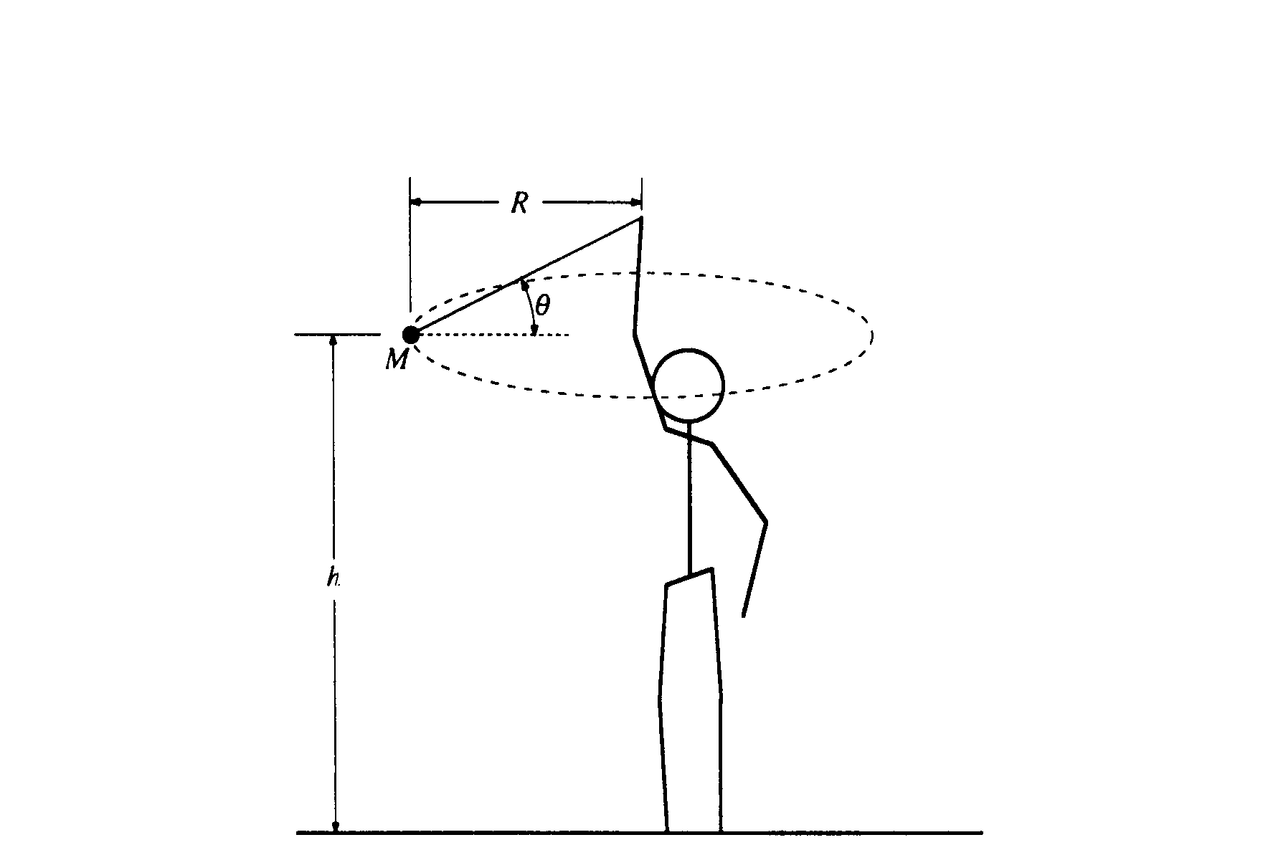
- An object of mass M on a string is whirled with increasing speed in a horizontal circle, as shown. When the string breaks, the object has speed v_{o} and the circular path has radius R and is a height h above the ground. Neglect air friction.
  - Determine the following, expressing all answers in terms of h, v_{o}, and g.
    - The time required for the object to hit the ground after the string breaks.
    - The horizontal distance the object travels from the time the string breaks until it hits the ground
    - The speed of the object just before it hits the ground
  - On the figure below, draw and label all the forces acting on the object when it is in the position shown in the diagram above.
  - Determine the tension in the string just before the string breaks. Express your answer in terms of M, R, v_{o}, and g.
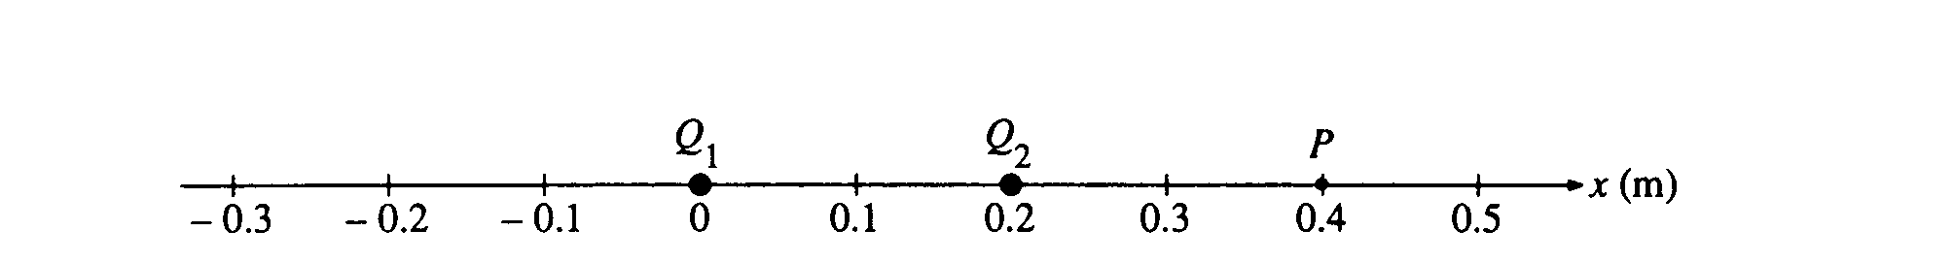
8. Two point charges, Q₁ and Q₂, are located a distance 0.20 meter apart, as shown. Charge Q₁ = +8.0 μC. The net electric field is zero at point P, located 0.40 meter from Q₁ and 0.20 meter from Q₂.
  - Determine the magnitude and sign of charge Q₂.
  - Determine the magnitude and direction of the net force on charge Q₁
  - Calculate the electrostatic potential energy of the system.
  - Determine the coordinate of the point R on the x-axis between the two charges at which the electric potential is zero.
  - How much work is needed to bring an electron from infinity to point R. which was determined in the previous part?

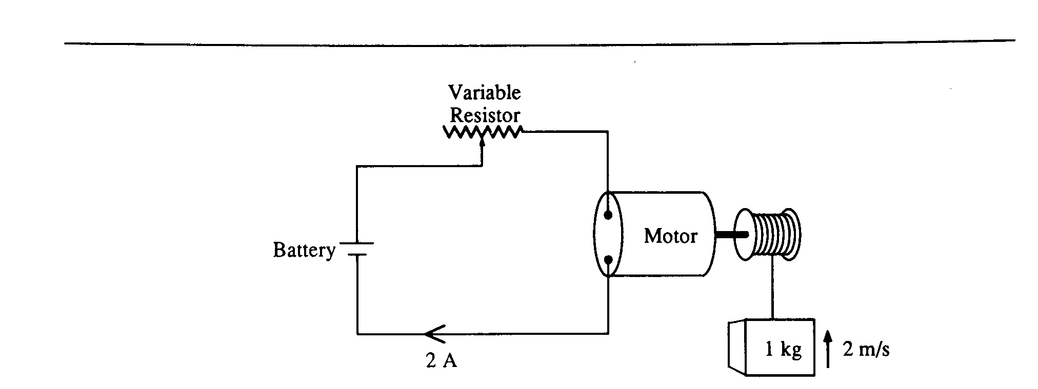
- A series circuit consists of a battery of negligible internal resistance, a variable resistor, and an electric motor of negligible resistance. The current in the circuit is 2 amperes when the resistance in the circuit is adjusted to 10 ohms. Under these conditions the motor lifts a l-kilogram mass vertically at a constant speed of 2 meters per second.
  - Determine the electrical power that is
    - dissipated in the resistor.
    - used by the motor in lifting the mass.
    - supplied by the battery.
  - Determine the potential difference across
    - the resistor.
    - the motor.
    - the battery.
The resistor is now adjusted until the mass rises vertically at a constant speed of 3 meters per second. The voltage drop across the motor is proportional to the speed of the motor, and the current remains constant.
  - Determine the voltage drop across the motor.
  - Determine the new resistance in the circuit.

