AP Physics – Review - 2
- How much heat must be added or removed to allow 2 moles of an ideal gas to expand isothermally from 1.0 m³ to 3.0 m³? 27
- An amount equal to the work done by the gas must be removed.
- An amount equal to the work done by the gas must be added.
- An amount equal to the product of pressure and volume must be added.
- No heat must be added or removed: Q=0
- It is impossible to tell without more information.

- An open tube and a closed tube resonate at a fundamental frequency f. What is the next higher frequency at which each tube will resonate? 28
Open Tube Closed Tube
(a) f 2 f
(b) 2 f 2 f
(c) 3 f 3 f
(d) 2 f 4 f
(e) 2 f 3 f

- How many electrons are transferred in the process of charging a latex balloon to 1.6 x 10⁻⁸ C? 32
- 1 x 10¹¹
- 2.56 x 10⁻²⁷
- 1 x 10²⁷
- 1 x 10⁻²⁵
- Latex balloons can’t be electrically charged.

- All of the following are true about torque EXCEPT: 20
- It units are Newton-meters
- It can only be produced by a force.
- Torque is zero unless the force has a component perpendicular to the moment arm.
- A force whole line of action passes through the axis of rotation produces zero torque.
- Torque may be clockwise or counterclockwise, depending on the direction the force points.

- A runner runs the first half of a 10 km race at a steady speed of 5 m/s. Due to fatigue, she slows her pace to a constant 4 m/s for the second half. What is her average speed for the race? 23
(a) 3.5 m/s (b) 4.4 m/s (c) 4.5 m/s (d) 5.0 m/s (e) 5.5 m/s

- A 500 kg dragster finishes a race and, finding that its brakes have failed completely, engages a parachute from the rear of the vehicle to slow down. Initially, it is traveling at 70 m/s, and in 4 seconds it has slowed down to 30 m/s. What is the average force exerted on the car by the parachute? 12
(a) 150 N (b) 300 N (c) 500 N (d) 1 000 N (e) 5 000 N

- An object of mass M on a string is whirled with increasing speed in a horizontal circle, as shown. When the string breaks, the object has speed v_{o} and the circular path has radius R and is a height h above the ground. (1998 1) Neglect air friction.
  - Determine the following, expressing all answers in terms of h, v_{o}, and g.
    - The time required for the object to hit the ground after the string breaks.
    - The horizontal distance the object travels from the time the string breaks until it hits the ground
    - The speed of the object just before it hits the ground
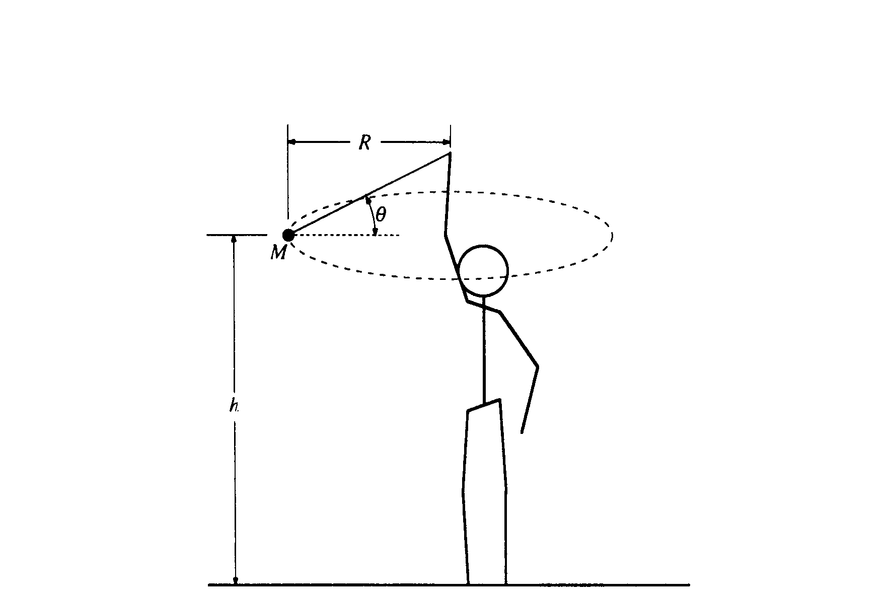
  - On the figure below, draw and label all the forces acting on the object when it is in the position shown in the diagram above.
F_{g}
F_{T}

  - Determine the tension in the string just before the string breaks. Express your answer in terms of M, R, v_{o}, and g.

8. Two point charges, Q₁ and Q₂, are located a distance 0.20 meter apart, as shown. Charge Q₁ = +8.0 μC. The net electric field is zero at point P, located 0.40 meter from Q₁ and 0.20 meter from Q₂.
a. Determine the magnitude and sign of charge Q₂.
The electric field from Q₂ is equal & opposite, so Q₂ must be positive.

b. Determine the magnitude and direction of the net force on charge Q₁
c. Calculate the electrostatic potential energy of the system.
d. Determine the coordinate of the point R on the x-axis between the two charges at which the electric potential is zero.
e. How much work is needed to bring an electron from infinity to point R. which was determined in the previous part?

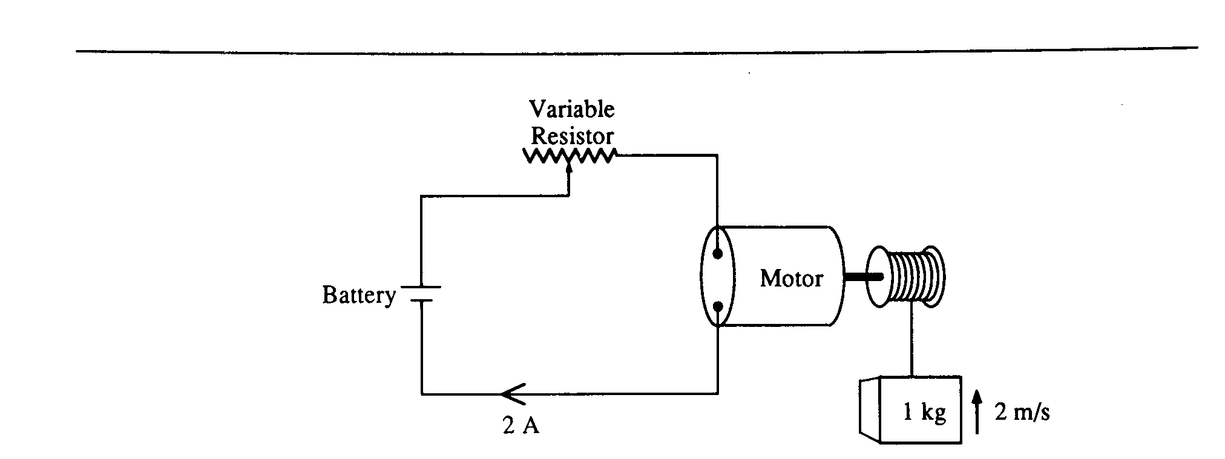
- A series circuit consists of a battery of negligible internal resistance, a variable resistor, and an electric motor of negligible resistance. The current in the circuit is 2 amperes when the resistance in the circuit is adjusted to 10 ohms. Under these conditions the motor lifts a l-kilogram mass vertically at a constant speed of 2 meters per second.
  - Determine the electrical power that is
    - dissipated in the resistor.
    - used by the motor in lifting the mass.
    - supplied by the battery.
  - Determine the potential difference across
    - the resistor.
    - the motor.
    - the battery.
The resistor is now adjusted until the mass rises vertically at a constant speed of 3 meters per second. The voltage drop across the motor is proportional to the speed of the motor, and the current remains constant.
  - Determine the voltage drop across the motor.
  - Determine the new resistance in the circuit.

