AP Physics – Momentum – 2

Repunzle _________________________________________________________________Per___
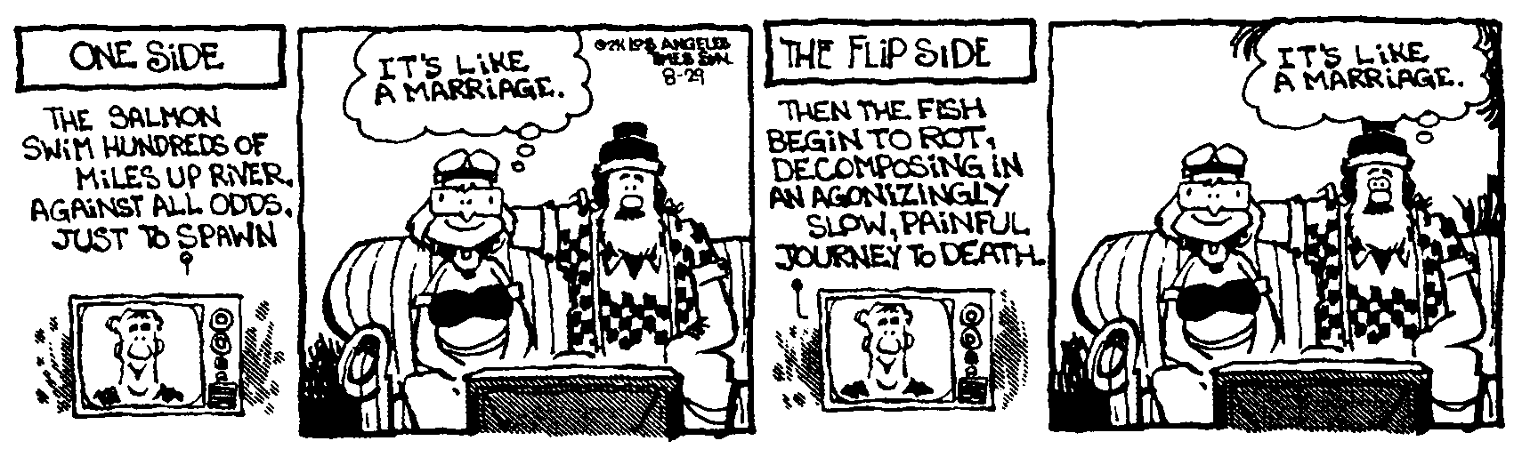
Life is what happens when you're busy making plans......... -John Lennon
- A 15 000 kg railroad car traveling at 2.45 m/s couples with a 12 500 kg car which is at rest. What is the final velocity of the two cars?

- You find yourself stranded out on this impossibly slick ice deal. There is so little friction that you can’t walk at all. No worries, you’ve got this lovely 2.5 kg physics book. You throw it away from yourself giving it a speed of 8.4 m/s. How much time does it take for you to reach the other side of the ice which is like 15.5 m away? Figure your mass at 42.0 kg.

- A 0.20 kg object moves along a straight line. The net force acting on the object varies with the object's displacement as shown in the graph below. The object starts from rest at displacement x = 0 and time t = 0 and is displaced a distance of 20.0 m. Determine each of the following.
(a) The acceleration of the particle when its displacement x is 6.00 m
(b) The time taken for the object to be displaced the first 12.0 m
(c) The amount of work done by the net force in displacing the object the first 12 m
(d) The speed of the object at displacement x = 12.0 m
- The final speed of the object at displacement x = 20.0 m
- The change in the momentum of the object as it is displaced from x = 12.0 m to x = 20.0 m

- The front of 1400 kg car is designed to absorb the shock of a collision by having a “crumple zone” in which the front 1.20 m of the car collapses in absorbing the shock of the collision. If a car traveling 25.0 m/s stops uniformly in 1.20 m, (a) what is the acceleration of the car in g’s? (b) how long does the collision last, (c) What is the magnitude of the average force on the car?

- A 5.00 kg object, object A, moving at 5.50 m/s to the right collides head on with a 3.50 kg object, object B, that is a rest. The 5.00 kg object ends up with a speed of 1.50 m/s in the opposite direction. (a) What is the velocity of the two objects after the collision? (b) How much kinetic energy is transferred to object B during the collision?

