AP Physics – Electric Current - 2

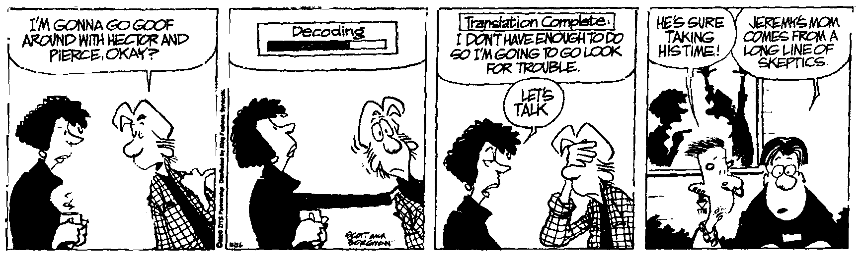
Can thee be?___________________________________________________________________Per__
It doesn't matter how much you want. What really matters is how much you want it. The extent and complexity of the problem does not matter was much as does the willingness to solve it. -- Ralph Marston
- A hot plate has an internal resistance of 22.0 Ω. It operates on 120 V household AC electricity. (a) How much current did it draw? (b) How much power did it develop? (c) If it operated for 15 minutes, how much heat did it develop? (d) If a kWh costs 4.5 cents, how much did it cost to run the thing?

- Examine this useless circuit. What is: (a) the total resistance, ( b) the total current, (c) the voltage drop for the 75.0 Ω resistor?

- What happens to the light intensity of a set of identical lamps in series when you add an additional lamp? How come?

- What happens to the light intensity of a set of identical lamps in parallel when you add an additional lamp? How come?

- (a) Draw a circuit which has a 120.0 Ω resistor in series with three resistors that are in parallel with each other; a 25.0 Ω, 35.0 Ω, and 45.0 Ω resistor. The voltage source is a 9.00 V battery. (b) What is the current for this circuit?

- What is: (a) the current that goes through the 45.0 Ω resistor and (b) what is the total current through the circuit?

- What is (a) the voltage drop across the 75 Ω resistor, (b) the total current supplied by the battery?

- What is (a) the total resistance of the circuit, (b) the total current in the circuit, (c) the power developed in the circuit?

- What is (a) the total resistance of the circuit, (b) the total electric potential in the circuit, (c) the power developed by R₃, the 115 Ω resistor, and (d) the electrical potential provided by the battery?

