10-Page Cancer Spread Project: Group
/25
- Each panel is to be done “professionally”, have 10+ Facts/Information, 1+ Diagram (ie’s: pictures, charts, illustrations, and/or graphs), 1+ Reference (APA), and Color
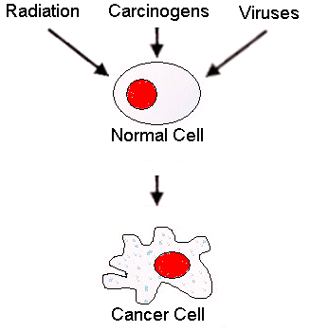
- Originality and creativity will help your overall grade; however, you must retain and
depict the given “Theme”. Panels are to be set for “landscape” only. Panels are not to
be created totally by a computer but instead by hand (may have to use ie’s: ruler and/or
compass). However, anything that you wish to add / attach may be computer generated
and (ie.’s: image(s)/design(s)). Be sure to fill your panel.

- Understandably, you will have to do some research. Feel free to use your notes, text, and/or reputable/credible websites. If you want to use the information you found, be sure to write down where you found it. You are required to at least obtain 1+ reference(s). Please write your reference(s) on the “back” of your panel by using: scribbr.com ; bibme.org ; and/or citationmachine.net (choose APA format; no friend or family references; consulting ok).

- Each panel is to have ~1/4-inch frame around it in order to attach other panels to it. Panels are to be in the same order / configuration as shown on the “Categories and Themes” Chart. This is to be done in class (tba). Be sure your name is clearly/neatly written on the “front” of your panel.

- A copy of the “rubric” will be passed out in order of each member in the group to review the requirements but also to agree which panel you agreed to do. You may have panels checked at a time during or outside of class by the teacher. Failure to do your panel will result in you (not your group) receiving a zero grade.

- If your panel was done exceptionally well (professional w/ extra effort), you may receive extra credit (tba).

Panels: Categories and Themes
(Choose One)

Your Name/Period Here  Sarcoma  Foldable; ie. attach a flip book, accordion, four doors, and/or pyramid, etc…  [10+ facts, 1+ diagram, 1+ APA reference (on back), color] | Your Name/Period Here  Lymphoma  Puzzle; ie. crossword or word search; w/ 15+?’s as a key  [10+ facts, 1+ diagram, 1+ APA reference (on back), color] | Your Name/Period Here  Carcinoma  Cartoon or Comic Strip; ie. serious or humorous; self-made  [10+ facts, 1+ diagram, 1+ APA reference (on back), color]
Your Name/Period Here  Treatments/Support  Advertisement; ie. services you provide at your clinic in a magazine or on a business card  [10+ facts, 1+ diagram, 1+ APA reference (on back), color] | Your Name/Period Here  Cancer  Quiz; ie. include short answer, multiple choice and T/F; w/ 15+?’s as a key  [10+ facts, 1+ diagram, 1+ APA reference (on back), color] | Your Name/Period Here  Carcinogens  Board Game; ie. w/ 15+?’s or clues; ie. like monopoly, clue, or chutes and ladders, etc…  [10+ facts, 1+ diagram, 1+ APA reference (on back), color]
Your Name/Period Here  Malignant Tumors  Show and Tell; ie. choose a type of cancer and trace how it is spread through the body  [10+ facts, 1+ diagram, 1+ APA reference (on back), color] | Your Name/Period Here  Leukemia  VENN Diagram; ie. comparing / contrasting normal and cancerous WBC’s  [10+ facts, 1+ diagram, 1+ APA reference (on back), color] | Your Name/Period Here  Benign Tumors  Poem; ie. rhyming or non-rhyming / fact or fiction / 15+ lines  [10+ facts, 1+ diagram, 1+ APA reference (on back), color]
Your Name/Period Here
Survivorship

Ribbons; ie. draw, color, and label 15+ cancer ribbon types

[10+ facts, 1+ diagram, 1+ APA reference (on back), color]

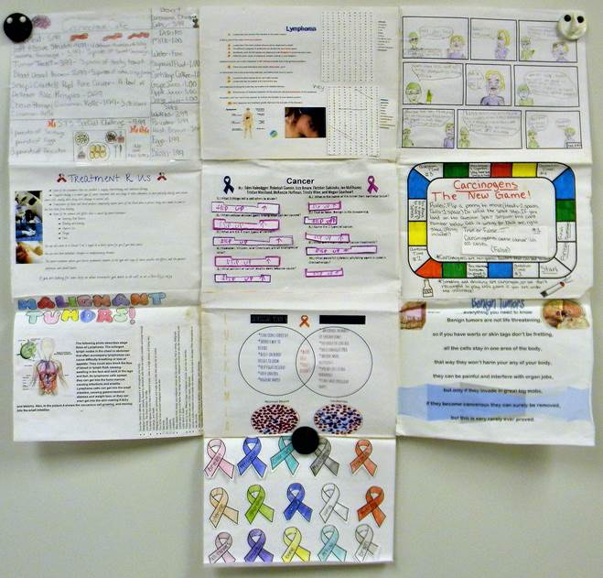

Above Are Average Example / There Are Some Flaws and/or Mistakes But Will Give You the General Idea

(Purposely and Somewhat Out of Focus to
Prevent Plagiarism)

Group Name:
(relating to cancer)
/25
10-Page Cancer Spread Project Rubric

Student  First / Last Name “Neatly”  _______________________________  _______________________________  _______________________________  _______________________________  _______________________________  _______________________________  _______________________________  _______________________________  _______________________________  _______________________________ | Panels  Sarcoma  Lymphoma  Carcinoma  Treatment/Support  Cancer  Carcinogens  Malignant Tumors  Leukemia  Benign Tumors  Survivorship | Grades  1 2 3 4 5  (Foldable)  1 2 3 4 5  (Puzzle as a Key)  1 2 3 4 5  (Cartoon or Comic)  1 2 3 4 5  (Advertisement)  1 2 3 4 5  (Quiz as a Key)  1 2 3 4 5  (Board Game)  1 2 3 4 5  (Show and Tell)  1 2 3 4 5  (VENN Diagram)  1 2 3 4 5  (Poem or Short Story)  1 2 3 4 5  (Ribbons) | Score  x 5 + ____ /25  Extra Credit?  x 5 + ____ /25  Extra Credit?  x 5 + ____ /25  Extra Credit?  x 5 + ____ /25  Extra Credit?  x 5 + ____ /25  Extra Credit?  x 5 + ____ /25  Extra Credit?  x 5 + ____ /25  Extra Credit?  x 5 + ____ /25  Extra Credit?  x 5 + ____ /25  Extra Credit?  x 5 + ____ /25  Extra Credit?

Key:

5 = (A) Panel is excellent with regards to theme, professionalism, research, diagram(s), and color.

4 = (B) Panel is good with regards to theme, professionalism, research, diagram(s), and color.

3 = (C) Panel is average with regards to theme, professionalism, research, diagram(s), and color.

2 = (D) Panel is substandard with regards to theme, professionalism, research, diagram(s), and color.

1 = (F) Panel is poor with regards to theme, professionalism, research, diagram(s), and color.

